Mineral Titles Act 2010
NOTICE OF LAND CEASING TO BE A MINERAL TITLE AREA
Title Type and Number: | Exploration Licence 30090
Area Ceased on: | 02 April 2019
Area: | 15 Blocks, 45.92 km²
Locality: | LAUGHLEN
Name of Applicant(s)/Holder(s): | 100% DAVENPORT RESOURCES LIMITED* [ACN. 153 414 852]
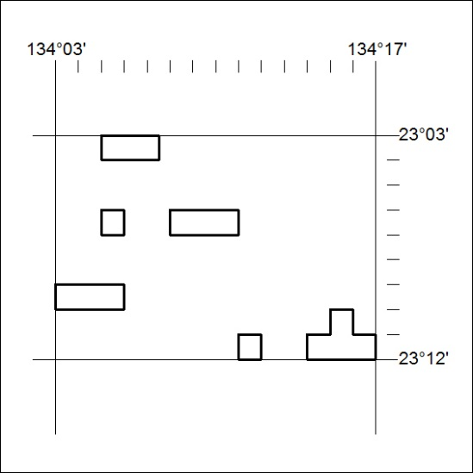

116/19

Mineral Titles Act
NOTICE OF GRANT OF A MINERAL TITLE
Title Type and Number: | Exploration Licence 31939
Granted: | 01 April 2019, for a period of 6 Years
Area: | 6 Blocks, 20.04 km²
Locality: | BATCHELOR
Name of Holder/s: | 100% NT MINING OPERATIONS PTY LTD* [ACN. 136 525 990]
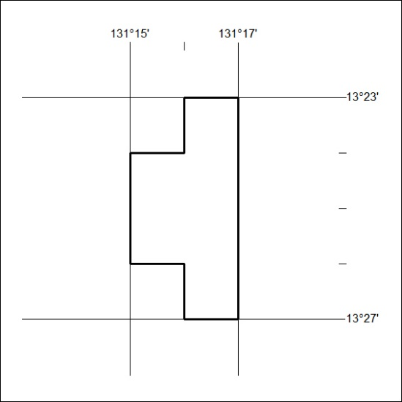
Area granted is indicated above. The titleholder is not permitted to exercise occupational rights on any land that is subject to a development title, or an application for a development title. Any land the subject of a Reserved Land gazettal under the Mineral Titles Act and all land vested in the Commonwealth of Australia is also excluded by description but not excised from the grant area.

117/19

