Mineral Titles Act
NOTICE OF LAND CEASING TO BE A MINERAL TITLE AREA
Title Type and Number: | Exploration Licence 31942
Area Ceased on: | 18 March 2019
Area: | 245 Blocks, 803.29 km²
Locality: | SURPRISE CREEK
Name of Applicant(s)/Holder(s): | 100% EL CARO RESOURCES PTY LTD [ACN. 619 093 819]
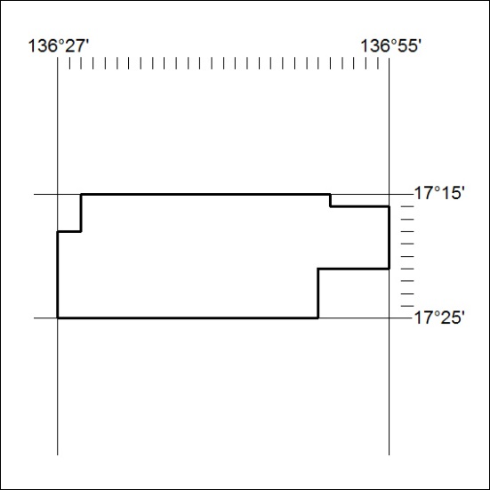

95/19

Mineral Titles Act
NOTICE OF LAND CEASING TO BE A MINERAL TITLE AREA
Title Type and Number: | Exploration Licence 31943
Area Ceased on: | 18 March 2019
Area: | 214 Blocks, 700.65 km²
Locality: | COANJULA
Name of Applicant(s)/Holder(s): | 100% EL CARO RESOURCES PTY LTD [ACN. 619 093 819]
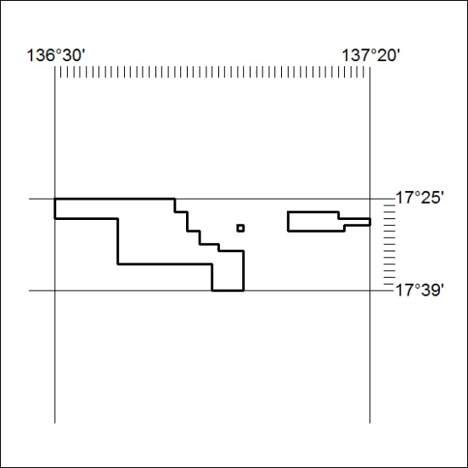

96/19

Mineral Titles Act
NOTICE OF LAND CEASING TO BE A MINERAL TITLE AREA
Title Type and Number: | Exploration Licence 31948
Area Ceased on: | 18 March 2019
Area: | 42 Blocks, 132.44 km²
Locality: | GLEN HELEN
Name of Applicant(s)/Holder(s): | 100% TODD RIVER METALS PTY LTD [ACN. 600 314 038]
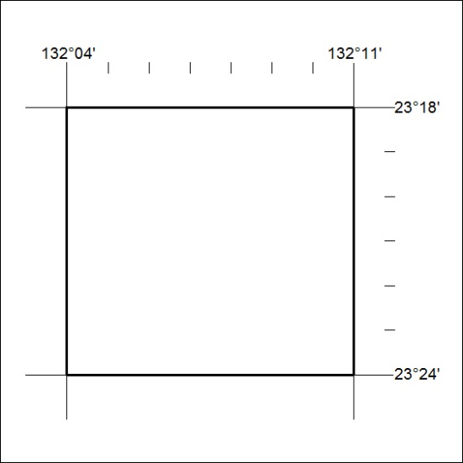

97/19

