Mineral Titles Act
NOTICE OF GRANT OF A MINERAL TITLE
Title Type and Number: | Exploration Licence 31894
Granted: | 08 March 2019, for a period of 6 Years
Area: | 19 Blocks, 63.53 km²
Locality: | BATCHELOR
Name of Holder/s: | 100% NT MINING OPERATIONS PTY LTD* [ACN. 136 525 990]
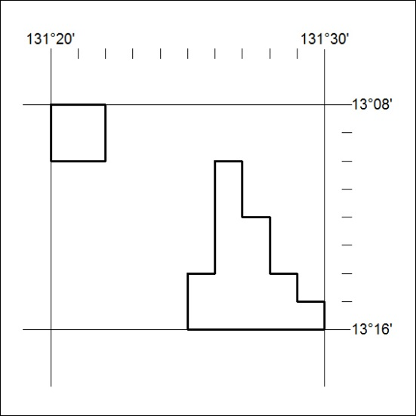
Area granted is indicated above. The titleholder is not permitted to exercise occupational rights on any land that is subject to a development title, or an application for a development title. Any land the subject of a Reserved Land gazettal under the Mineral Titles Act and all land vested in the Commonwealth of Australia is also excluded by description but not excised from the grant area.
75/19

Mineral Titles Act
NOTICE OF GRANT OF A MINERAL TITLE
Title Type and Number: | Exploration Licence 31905
Granted: | 08 March 2019, for a period of 6 Years
Area: | 2 Blocks, 6.69 km²
Locality: | BATCHELOR
Name of Holder/s: | 100% NT MINING OPERATIONS PTY LTD* [ACN. 136 525 990]
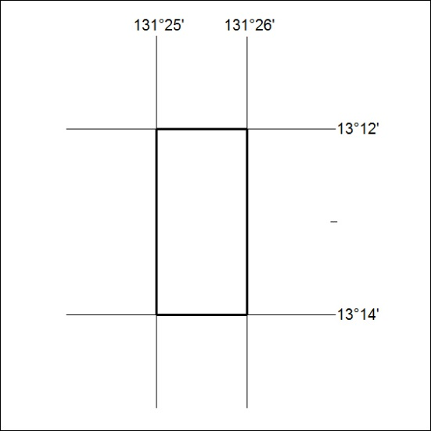
Area granted is indicated above. The titleholder is not permitted to exercise occupational rights on any land that is subject to a development title, or an application for a development title. Any land the subject of a Reserved Land gazettal under the Mineral Titles Act and all land vested in the Commonwealth of Australia is also excluded by description but not excised from the grant area.
76/19

