Mineral Titles Act
NOTICE OF GRANT OF A MINERAL TITLE
Title Type and Number: | Exploration Licence 31941
Granted: | 21 February 2019, for a period of 6 Years
Area: | 17 Blocks, 56.69 km²
Locality: | MARUMBA
Name of Holder/s: | 100% SCRIVEN EXPLORATION PTY LTD [ACN. 006 264 615]
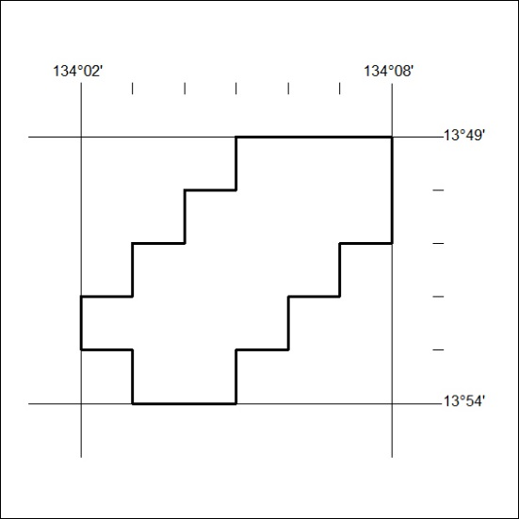
Area granted is indicated above. The titleholder is not permitted to exercise occupational rights on any land that is subject to a development title, or an application for a development title. Any land the subject of a Reserved Land gazettal under the Mineral Titles Act and all land vested in the Commonwealth of Australia is also excluded by description but not excised from the grant area.

57/19

Mineral Titles Act
NOTICE OF GRANT OF A MINERAL TITLE
Title Type and Number: | Extractive Mineral Lease 31838
Granted: | 25 February 2019, for a period of 10 Years
Area: | 10.29 Hectares
Locality: | MANBULLOO
Name of Holder/s: | 100% RELKETY PTY. LIMITED [ACN. 009 647 296]
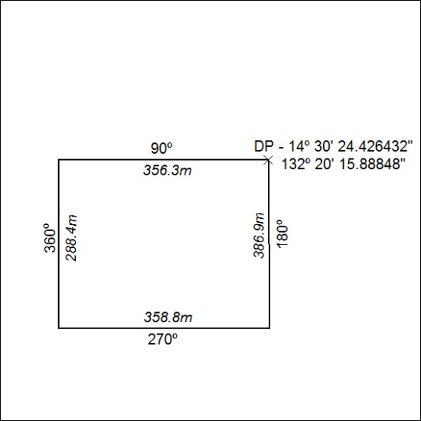

58/19

