Mineral Titles Act
NOTICE OF LAND CEASING TO BE A MINERAL TITLE AREA
Title Type and Number: | Exploration Licence 27995
Area Ceased on: | 05 February 2019
Area: | 15 Blocks, 48.15 km²
Locality: | INNINGARRA
Name of Applicant(s)/Holder(s): | 85% RAMELIUS RESOURCES LIMITED [ACN. 001 717 540], 15% TYCHEAN TANAMI PTY LTD* [ACN. 137 135 847]
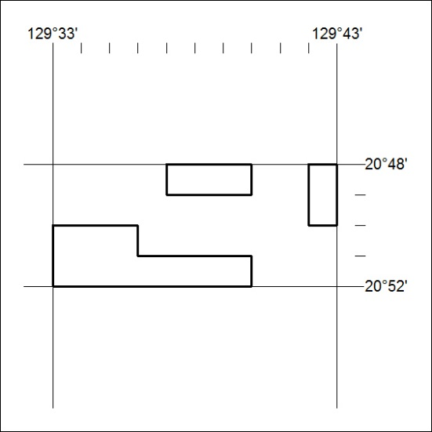

37/19

Mineral Titles Act
NOTICE OF LAND CEASING TO BE A MINERAL TITLE AREA
Title Type and Number: | Exploration Licence 30090
Area Ceased on: | 05 February 2019
Area: | 69 Blocks, 217.90 km²
Locality: | LAUGHLEN
Name of Applicant(s)/Holder(s): | 100% DAVENPORT RESOURCES LIMITED* [ACN. 153 414 852]
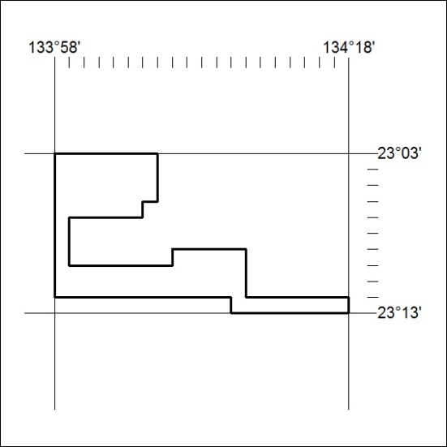

38/19

