Mineral Titles Act
NOTICE OF LAND CEASING TO BE A MINERAL TITLE AREA
Title Type and Number: | Exploration Licence 29787
Area Ceased on: | 13 November 2018
Area: | 14 Blocks, 44.29 km²
Locality: | MT WEDGE
Name of Applicant(s)/Holder(s): | 100% PIPER PRESTON PTY LTD [ACN. 142 962 409]
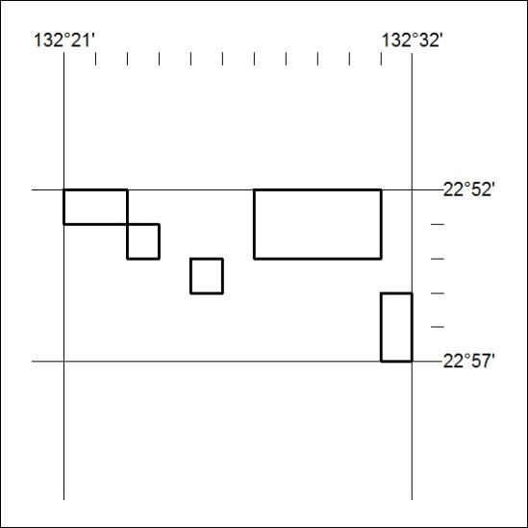

513/18

Mineral Titles Act
NOTICE OF LAND CEASING TO BE A MINERAL TITLE AREA
Title Type and Number: | Exploration Licence 29903
Area Ceased on: | 13 November 2018
Area: | 6 Blocks, 18.99 km²
Locality: | MT WEDGE
Name of Applicant(s)/Holder(s): | 100% PIPER PRESTON PTY LTD [ACN. 142 962 409]
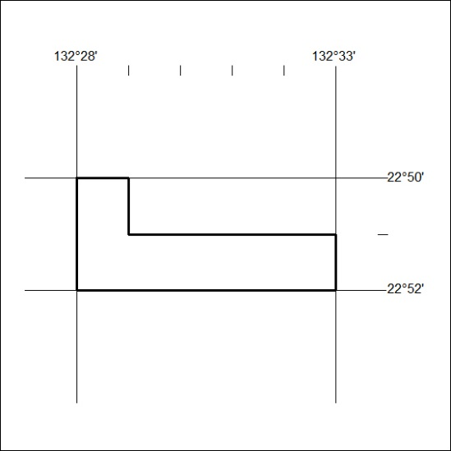

514/18

