Mineral Titles Act
NOTICE OF LAND CEASING TO BE A MINERAL TITLE AREA
Title Type and Number: | Exploration Licence 30181
Area Ceased on: | 04 October 2018
Area: | 22 Blocks, 71.88 km²
Locality: | HELEN
Name of Applicant(s)/Holder(s): | 100% DIAMOND HARD PTY LTD [ACN. 611 193 938]
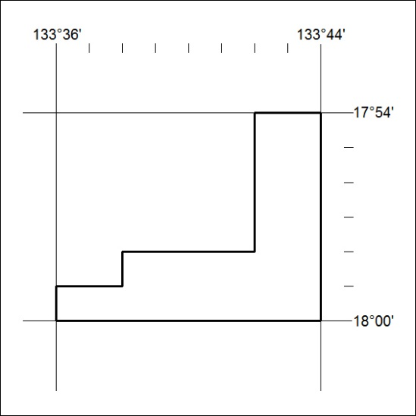

443/18

