Mineral Titles Act
NOTICE OF LAND CEASING TO BE A MINERAL TITLE AREA
Title Type and Number: | Exploration Licence 31459
Area Ceased on: | 31 August 2018
Area: | 240 Blocks, 791.35 km²
Locality: | DALY WATERS
Name of Applicant(s)/Holder(s): | 100% NORTHERN EXPLORATION PTY LTD [ACN. 092 403 506]
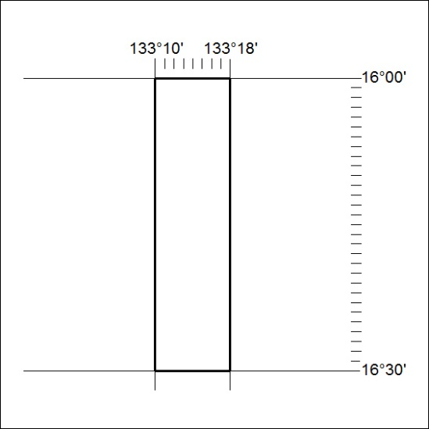

366/18

Mineral Titles Act
NOTICE OF LAND CEASING TO BE A MINERAL TITLE AREA
Title Type and Number: | Exploration Licence 31460
Area Ceased on: | 31 August 2018
Area: | 240 Blocks, 791.35 km²
Locality: | DALY WATERS
Name of Applicant(s)/Holder(s): | 100% NORTHERN EXPLORATION PTY LTD [ACN. 092 403 506]
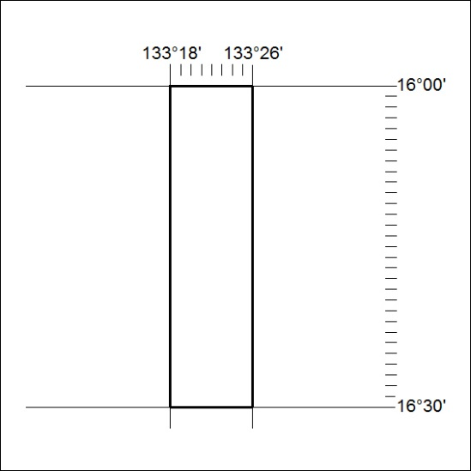

367/18

Mineral Titles Act
NOTICE OF LAND CEASING TO BE A MINERAL TITLE AREA
Title Type and Number: | Exploration Licence 31461
Area Ceased on: | 31 August 2018
Area: | 240 Blocks, 791.35 km²
Locality: | DALY WATERS
Name of Applicant(s)/Holder(s): | 100% NORTHERN EXPLORATION PTY LTD [ACN. 092 403 506]
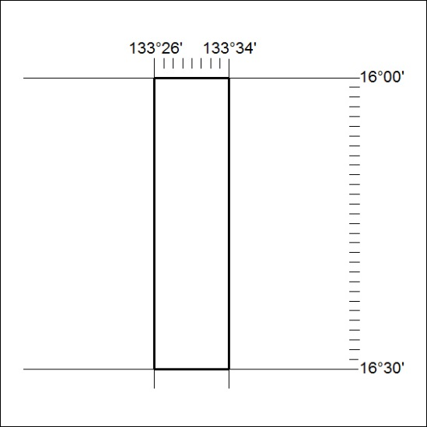

368/18

Mineral Titles Act
NOTICE OF LAND CEASING TO BE A MINERAL TITLE AREA
Title Type and Number: | Exploration Licence 31462
Area Ceased on: | 31 August 2018
Area: | 240 Blocks, 791.35 km²
Locality: | SCARLET HILL
Name of Applicant(s)/Holder(s): | 100% NORTHERN EXPLORATION PTY LTD [ACN. 092 403 506]
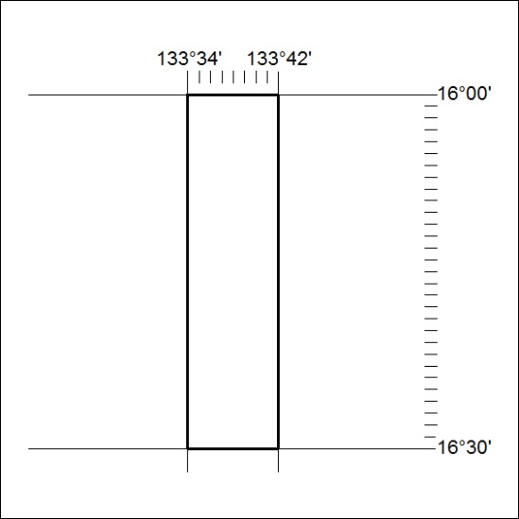

369/18

Mineral Titles Act
NOTICE OF LAND CEASING TO BE A MINERAL TITLE AREA
Title Type and Number: | Exploration Licence 31463
Area Ceased on: | 31 August 2018
Area: | 224 Blocks, 717.91 km²
Locality: | DUNMARRA
Name of Applicant(s)/Holder(s): | 100% NORTHERN EXPLORATION PTY LTD [ACN. 092 403 506]
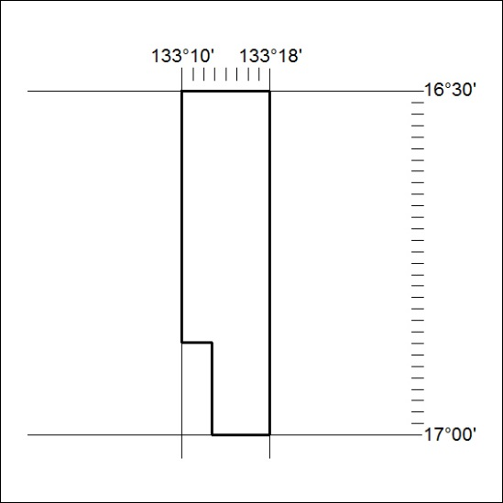

370/18

Mineral Titles Act
NOTICE OF LAND CEASING TO BE A MINERAL TITLE AREA
Title Type and Number: | Exploration Licence 31464
Area Ceased on: | 31 August 2018
Area: | 240 Blocks, 789.31 km²
Locality: | DUNMARRA
Name of Applicant(s)/Holder(s): | 100% NORTHERN EXPLORATION PTY LTD [ACN. 092 403 506]
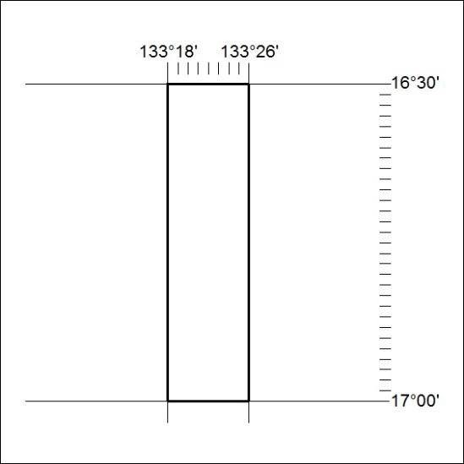

371/18

Mineral Titles Act
NOTICE OF LAND CEASING TO BE A MINERAL TITLE AREA
Title Type and Number: | Exploration Licence 31465
Area Ceased on: | 31 August 2018
Area: | 240 Blocks, 789.31 km²
Locality: | DUNMARRA
Name of Applicant(s)/Holder(s): | 100% NORTHERN EXPLORATION PTY LTD [ACN. 092 403 506]
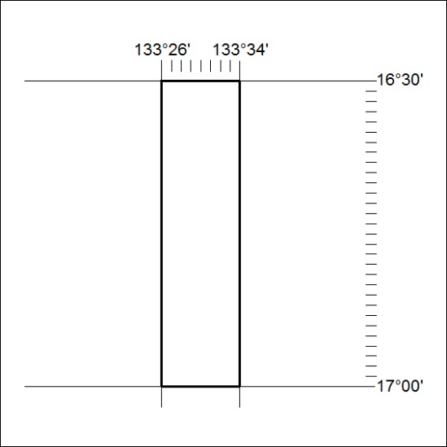

372/18

Mineral Titles Act
NOTICE OF LAND CEASING TO BE A MINERAL TITLE AREA
Title Type and Number: | Exploration Licence 31466
Area Ceased on: | 31 August 2018
Area: | 240 Blocks, 789.31 km²
Locality: | WARRAMBAN
Name of Applicant(s)/Holder(s): | 100% NORTHERN EXPLORATION PTY LTD [ACN. 092 403 506]
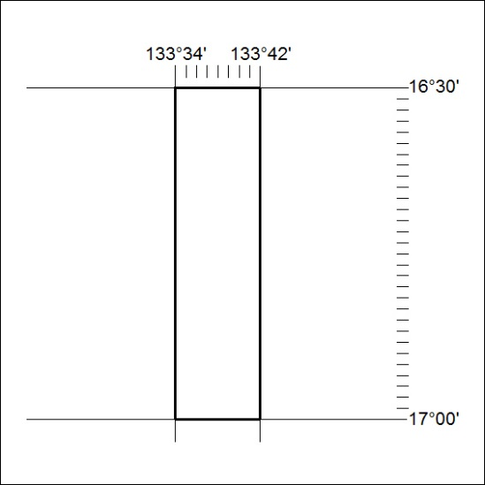

373/18

Mineral Titles Act
NOTICE OF LAND CEASING TO BE A MINERAL TITLE AREA
Title Type and Number: | Exploration Licence 31496
Area Ceased on: | 31 August 2018
Area: | 240 Blocks, 791.35 km²
Locality: | SCARLET HILL
Name of Applicant(s)/Holder(s): | 100% NORTHERN EXPLORATION PTY LTD [ACN. 092 403 506]
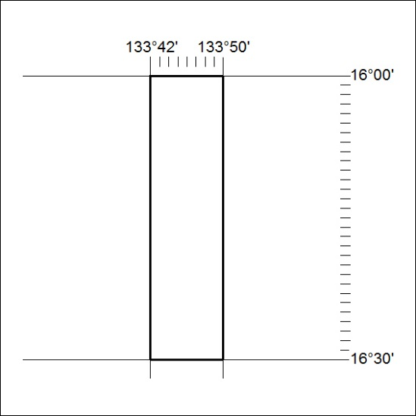

374/18

