Mineral Titles Act
NOTICE OF GRANT OF A MINERAL TITLE
Title Type and Number: | Exploration Licence 31703
Granted: | 08 May 2018, for a period of 6 Years
Area: | 40 Blocks, 131.39 km²
Locality: | MALLAPUNYAH
Name of Holder/s: | 100% TODD RIVER METALS PTY LTD [ACN. 600 314 038]
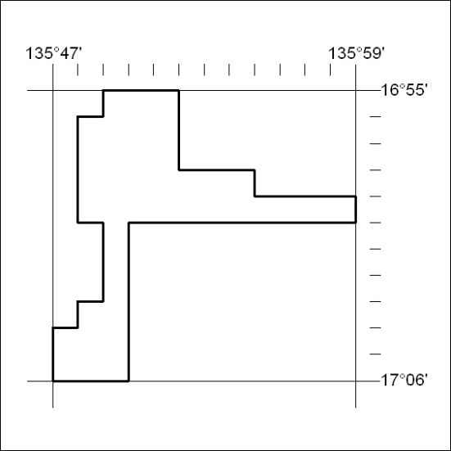
Area granted is indicated above. The titleholder is not permitted to exercise occupational rights on any land that is subject to a development title, or an application for a development title. Any land the subject of a Reserved Land gazettal under the Mineral Titles Act and all land vested in the Commonwealth of Australia is also excluded by description but not excised from the grant area.
178/18

Mineral Titles Act
NOTICE OF GRANT OF A MINERAL TITLE
Title Type and Number: | Exploration Licence 31704
Granted: | 08 May 2018, for a period of 6 Years
Area: | 70 Blocks, 229.65 km²
Locality: | KILGOUR
Name of Holder/s: | 100% TODD RIVER METALS PTY LTD [ACN. 600 314 038]
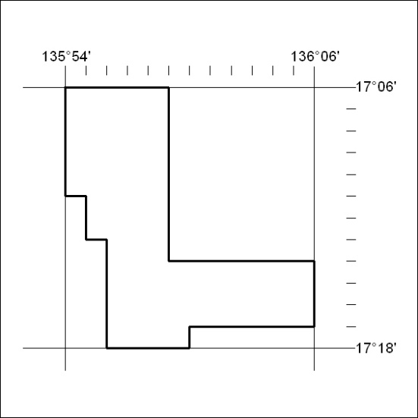
Area granted is indicated above. The titleholder is not permitted to exercise occupational rights on any land that is subject to a development title, or an application for a development title. Any land the subject of a Reserved Land gazettal under the Mineral Titles Act and all land vested in the Commonwealth of Australia is also excluded by description but not excised from the grant area.
179/18

