Corrigendum
Notice Number 155/18 appearing in MN54/18 on 1 May 2018 is hereby cancelled and replaced by the following:

Mineral Titles Act
NOTICE OF LAND CEASING TO BE A MINERAL TITLE
Title Type and Number: | Mineral Authority 29615
Area ceased on: | 30 April 2018
Area: | 28.00 Hectare
Locality: | KOOLPINYAH
Name of Applicants(s)Holder(s): | 100% INNOCENTE TRANSPORT PTY. LIMITED [ACN. 009 609 563]
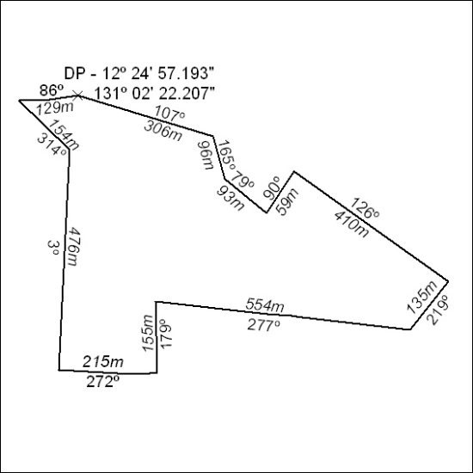

156/18

