# Live Cattle Exports via Darwin Port – NOVEMBER 2017

*Please note: figures are for cattle exported through the Port of Darwin only; some NT cattle are exported through interstate ports.*



## November at a glance

* 19,616 cattle through the Darwin Port during November; 2,147 more than last month and 17,284 less than in November 2016.
* 12,280 NT cattle through the Darwin Port during November; 2,497 more than last month and 14,267 less than in Nov 2016.

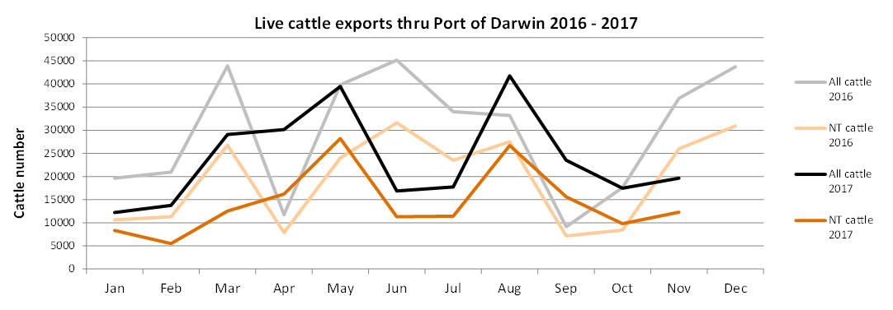

**OTHER LIVESTOCK EXPORTS VIA DARWIN PORT**  
*Includes NT and interstate stock.*



**NATIONAL CATTLE PRICES**

[www.mla.com.au/prices-and-markets](http://www.mla.com.au/prices-and-markets)

**CURRENCY EXCHANGE RATES**

[www.oanda.com/currency/converter](http://www.oanda.com/currency/converter)

**NT CATTLE MOVED INTERSTATE**

