Territory business size
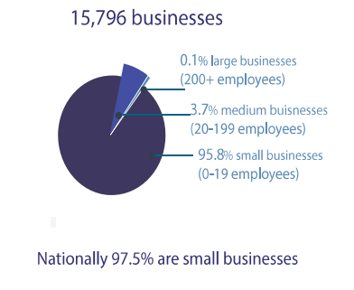
There were 15,796 businesses in the Territory as of June 2022
- 0.1% were large businesses with over 200 employees
- 3.7% were medium businesses with 20-199 employees
- 95.8% were small businesses with 0-19 employees
Nationally 97.5% of businesses were small businesses

Business growth rate
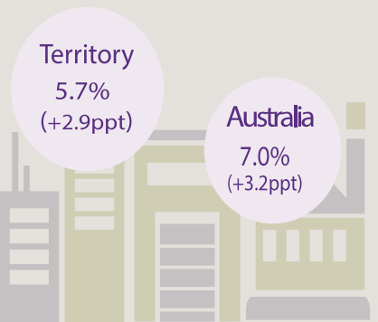
The number of businesses in the Territory increased by 5.7% over the 2021-22 financial year, this was an increase of 2.9 percentage points from the previous year.
Nationally the number of businesses increased by 7.0% over the 2021-22 financial year, this was a 3.2 percentage point increase from the previous year.

Businesses per 1,000 people by jurisdiction
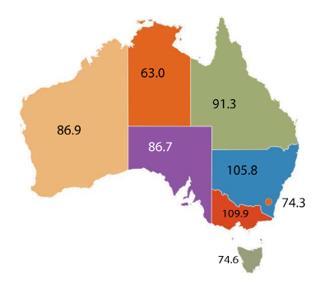
- In WA there were 86.9 businesses per 1,000 people
- In SA there were 86.7 businesses per 1,000 people
- In the NT there were 63 businesses per 1,000 people
- In QLD there were 91.3 businesses per 1,000 people
- In NSW there were 105.8 businesses per 1,000 people
- In VIC there were 109.9 businesses per 1,000 people
- In the ACT there were 74.3 businesses per 1,000 people
- In TAS there were 74.6 businesses per 1,000 people

Sub categories of small businesses
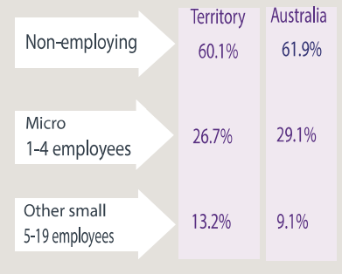
- 60% of Territory small businesses were non-employing, 61.9% nationally
- 26.7% of small businesses were micros businesses employing between 1-4 people, 29.1% nationally
- 13.2% of small businesses were other small businesses employing between 5-19 people, 9.1% nationally

Business entry and exit rates
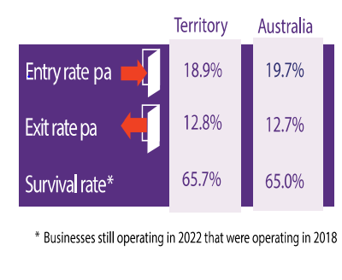
The business entry rate refers to businesses still operating in 2022 that were operating in 2018.
- The business entry rate in the NT was 18.9%, and 19.7% nationally
- The business exit rate in the NT was 12.8%, and 12.7% nationally
- The business survival rate in the NT was 65.7%, and 65% nationally

Businesses by region
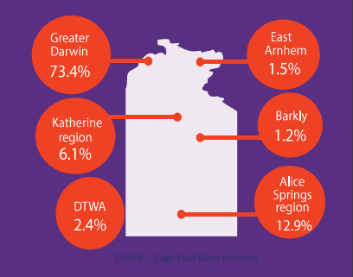
- 73.4% of the Territory’s businesses were in Greater Darwin
- 1.5% of the Territory’s businesses were in East Arnhem
- 6.1% of the Territory’s businesses were in the Katherine region
- 1.2% of the Territory’s businesses were in the Barkly
- 2.4% of the Territory’s businesses were in Daly-Tiwi-West Arnhem
- 12.9% of the Territory’s businesses were in the Alice Springs region

Businesses by industry
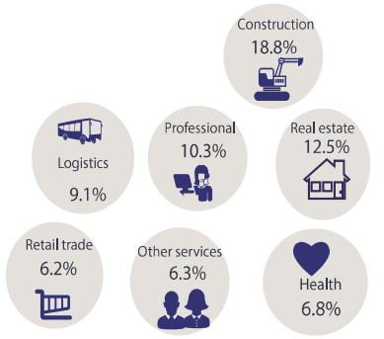
- 18.8% of businesses were in the construction industry
- 12.5% of businesses were in the real estate industry
- 10.3% of businesses were in the professional industry
- 9.1% of businesses were in the logistics industry
- 6.8% of businesses were in the health industry
- 6.3% of businesses were in the other services industry
- 6.2% of businesses were in the retail trade industry

Business by turnover
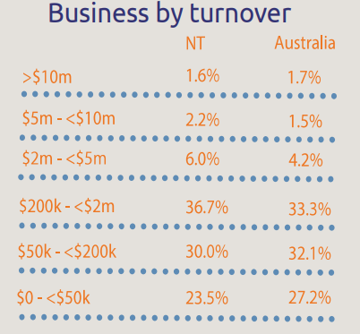
- 1.6% of Territory businesses had above a $10 million turnover, 1.7% nationally
- 2.2% of Territory businesses had a turnover between $5 million and $10 million, 1.5% nationally
- 6% of Territory businesses had a turnover between $2 million and $5 million, 4.2% nationally
- 36.7% of Territory businesses had a turnover between $200 thousand and $2 million, 33.3% nationally
- 30% of Territory businesses had a turnover between $50 thousand and $200 thousand, 32.1% nationally
- 23.5% of Territory businesses had a turnover between $0 and $50 thousand, 27.2% nationally

Employing businesses by industry
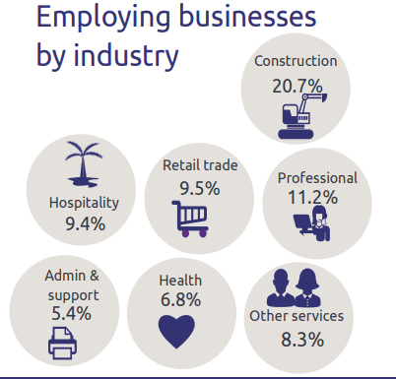
- 20.7% of employing businesses were in the construction industry
- 11.2% of employing businesses were in the professional industry
- 9.5% of employing businesses were in the retail trade industry
- 9.4% of businesses were in the hospitality industry
- 8.3% of businesses were in the other services industry
- 6.8% of businesses were in the health industry
- 5.4% of businesses were in the admin and support industry

Department of Industry, Tourism and Trade
w: industry.nt.gov.au
t: 08 8999 5139

