Mineral Titles Act 2010
NOTICE OF LAND CEASING TO BE A MINERAL TITLE AREA
Title Type and Number: | Extractive Mineral Permit 28000
Area ceased on: | 31 October 2022
Area: | 40.00 Hectare
Locality: | MARANBOY
Name of Applicants(s)Holder(s): | 100% D&S SAND, SOIL & GRAVEL PTY LTD [ACN. 645 168 752]
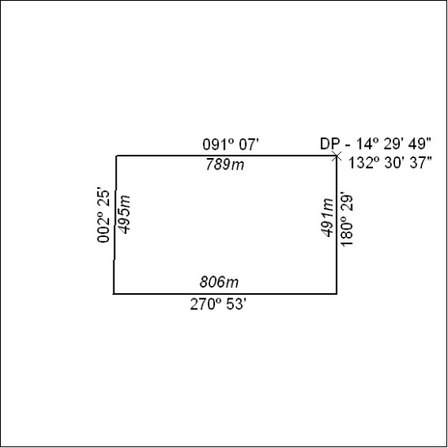

367/22

Mineral Titles Act
NOTICE OF GRANT OF A MINERAL TITLE
Title Type and Number: | Exploration Licence 33098
Granted: | 31 October 2022, for a period of 6 Years
Area: | 250 Blocks, 769.53 km²
Locality: | BUSHY PARK
Name of Holder/s: | 100% TNG LIMITED [ACN. 000 817 023]
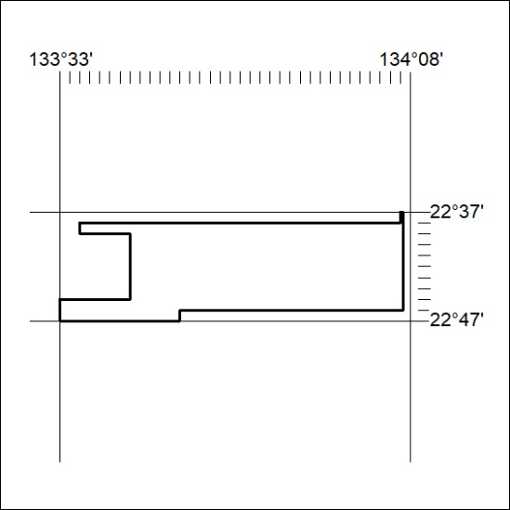
Area granted is indicated above. The titleholder is not permitted to exercise occupational rights on any land that is subject to a development title, or an application for a development title. Any land the subject of a Reserved Land gazettal under the Mineral Titles Act and all land vested in the Commonwealth of Australia is also excluded by description but not excised from the grant area.

368/22

Mineral Titles Act
NOTICE OF GRANT OF A MINERAL TITLE
Title Type and Number: | Exploration Licence 33099
Granted: | 31 October 2022, for a period of 6 Years
Area: | 250 Blocks, 782.70 km²
Locality: | BUSHY PARK
Name of Holder/s: | 100% TNG LIMITED [ACN. 000 817 023]
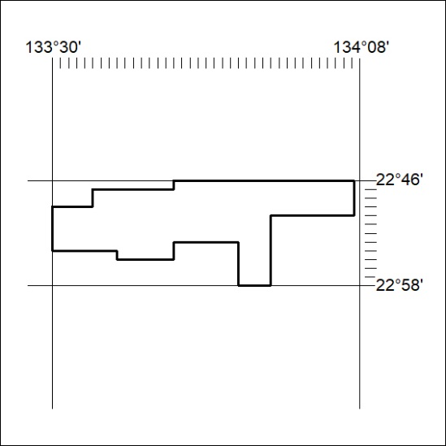
Area granted is indicated above. The titleholder is not permitted to exercise occupational rights on any land that is subject to a development title, or an application for a development title. Any land the subject of a Reserved Land gazettal under the Mineral Titles Act and all land vested in the Commonwealth of Australia is also excluded by description but not excised from the grant area.
369/22

Mineral Titles Act
NOTICE OF GRANT OF A MINERAL TITLE
Title Type and Number: | Exploration Licence 33100
Granted: | 31 October 2022, for a period of 6 Years
Area: | 113 Blocks, 357.40 km²
Locality: | BUSHY PARK
Name of Holder/s: | 100% TNG LIMITED [ACN. 000 817 023]
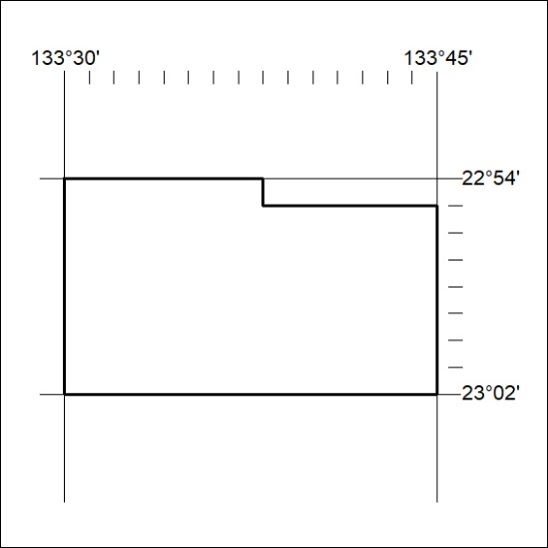
Area granted is indicated above. The titleholder is not permitted to exercise occupational rights on any land that is subject to a development title, or an application for a development title. Any land the subject of a Reserved Land gazettal under the Mineral Titles Act and all land vested in the Commonwealth of Australia is also excluded by description but not excised from the grant area.

370/22

Mineral Titles Act
NOTICE OF GRANT OF A MINERAL TITLE
Title Type and Number: | Exploration Licence 33104
Granted: | 31 October 2022, for a period of 6 Years
Area: | 250 Blocks, 791.48 km²
Locality: | DELNY
Name of Holder/s: | 100% TNG LIMITED [ACN. 000 817 023]
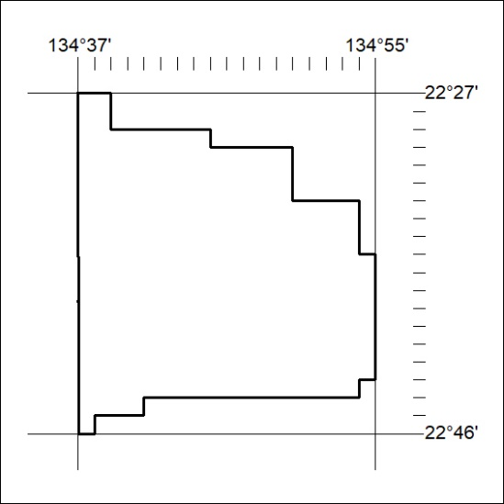
Area granted is indicated above. The titleholder is not permitted to exercise occupational rights on any land that is subject to a development title, or an application for a development title. Any land the subject of a Reserved Land gazettal under the Mineral Titles Act and all land vested in the Commonwealth of Australia is also excluded by description but not excised from the grant area.
371/22

Mineral Titles Act
NOTICE OF GRANT OF A MINERAL TITLE
Title Type and Number: | Exploration Licence 33105
Granted: | 31 October 2022, for a period of 6 Years
Area: | 250 Blocks, 788.42 km²
Locality: | DNEIPER
Name of Holder/s: | 100% TNG LIMITED [ACN. 000 817 023]
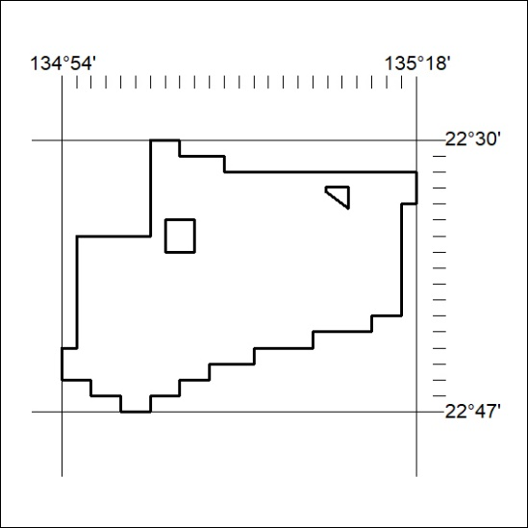
Area granted is indicated above. The titleholder is not permitted to exercise occupational rights on any land that is subject to a development title, or an application for a development title. Any land the subject of a Reserved Land gazettal under the Mineral Titles Act and all land vested in the Commonwealth of Australia is also excluded by description but not excised from the grant area.

372/22

