Mineral Titles Act
NOTICE OF GRANT OF A MINERAL TITLE
Title Type and Number: | Exploration Licence 33128
Granted: | 23 August 2022, for a period of 6 Years
Area: | 200 Blocks, 652.49 km²
Locality: | BLOODWOOD CREEK
Name of Holder/s: | 100% CHASE MINING CORPORATION LIMITED [ACN. 118 788 846]
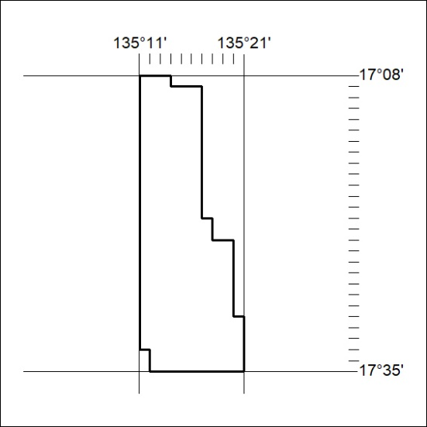
Area granted is indicated above. The titleholder is not permitted to exercise occupational rights on any land that is subject to a development title, or an application for a development title. Any land the subject of a Reserved Land gazettal under the Mineral Titles Act and all land vested in the Commonwealth of Australia is also excluded by description but not excised from the grant area.
299/22

Mineral Titles Act
NOTICE OF GRANT OF A MINERAL TITLE
Title Type and Number: | Exploration Licence 33129
Granted: | 23 August 2022, for a period of 6 Years
Area: | 200 Blocks, 654.82 km²
Locality: | MONGALA
Name of Holder/s: | 100% CHASE MINING CORPORATION LIMITED [ACN. 118 788 846]
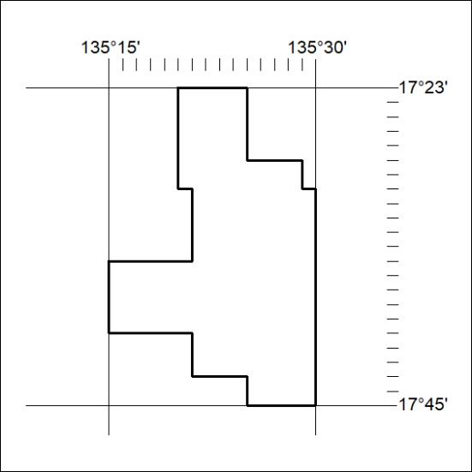
Area granted is indicated above. The titleholder is not permitted to exercise occupational rights on any land that is subject to a development title, or an application for a development title. Any land the subject of a Reserved Land gazettal under the Mineral Titles Act and all land vested in the Commonwealth of Australia is also excluded by description but not excised from the grant area.
300/22

Mineral Titles Act
NOTICE OF GRANT OF A MINERAL TITLE
Title Type and Number: | Exploration Licence 33130
Granted: | 24 August 2022, for a period of 6 Years
Area: | 200 Blocks, 655.74 km²
Locality: | BLOODWOOD CREEK
Name of Holder/s: | 100% CHASE MINING CORPORATION LIMITED [ACN. 118 788 846]
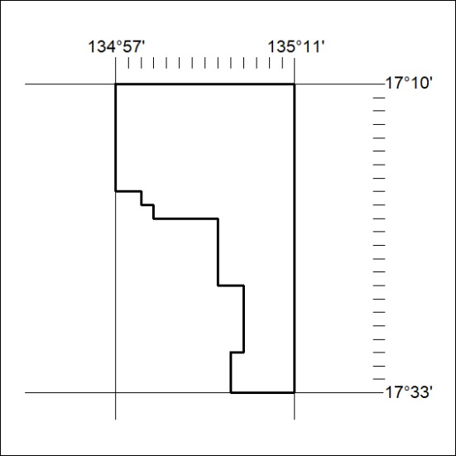
Area granted is indicated above. The titleholder is not permitted to exercise occupational rights on any land that is subject to a development title, or an application for a development title. Any land the subject of a Reserved Land gazettal under the Mineral Titles Act and all land vested in the Commonwealth of Australia is also excluded by description but not excised from the grant area.
301/22

Mineral Titles Act
NOTICE OF GRANT OF A MINERAL TITLE
Title Type and Number: | Exploration Licence 33077
Granted: | 25 August 2022, for a period of 6 Years
Area: | 184 Blocks, 587.65 km²
Locality: | SANDOVER
Name of Holder/s: | 100% RIO TINTO EXPLORATION PTY LIMITED [ACN. 000 057 125]
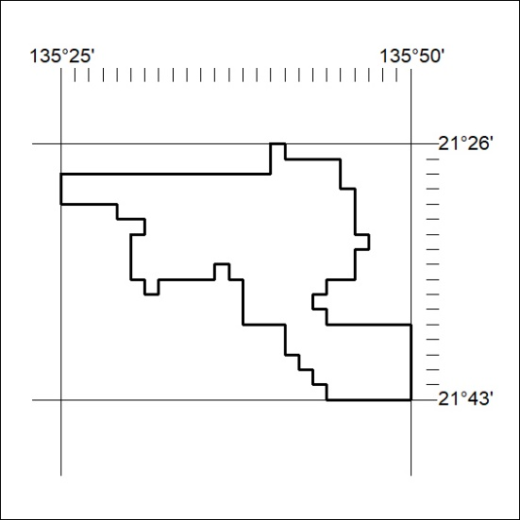
Area granted is indicated above. The titleholder is not permitted to exercise occupational rights on any land that is subject to a development title, or an application for a development title. Any land the subject of a Reserved Land gazettal under the Mineral Titles Act and all land vested in the Commonwealth of Australia is also excluded by description but not excised from the grant area.
302/22

