Mineral Titles Act
NOTICE OF GRANT OF A MINERAL TITLE
Title Type and Number: | Exploration Licence 32889
Granted: | 18 July 2022, for a period of 6 Years
Area: | 248 Blocks, 807.37 km²
Locality: | BAUHINIA DOWNS
Name of Holder/s: | 100% GEMPART (NT) PTY LTD* [ACN. 081 859 896]
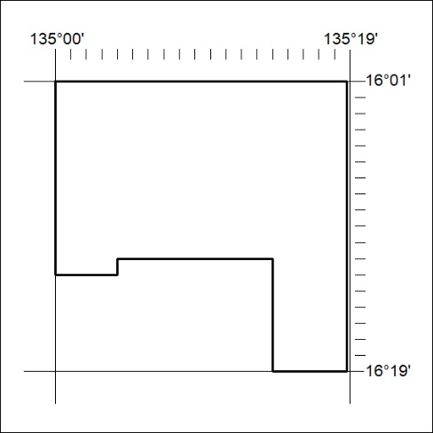
Area granted is indicated above. The titleholder is not permitted to exercise occupational rights on any land that is subject to a development title, or an application for a development title. Any land the subject of a Reserved Land gazettal under the Mineral Titles Act and all land vested in the Commonwealth of Australia is also excluded by description but not excised from the grant area.

246/22

Mineral Titles Act
NOTICE OF GRANT OF A MINERAL TITLE
Title Type and Number: | Exploration Licence 33010
Granted: | 18 July 2022, for a period of 6 Years
Area: | 102 Blocks, 323.40 km²
Locality: | NAPPERBY
Name of Holder/s: | 100% RECHARGE MINERALS PTY LTD [ACN. 654 924 713]
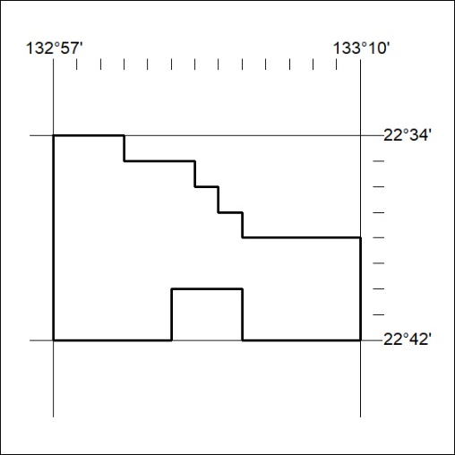
Area granted is indicated above. The titleholder is not permitted to exercise occupational rights on any land that is subject to a development title, or an application for a development title. Any land the subject of a Reserved Land gazettal under the Mineral Titles Act and all land vested in the Commonwealth of Australia is also excluded by description but not excised from the grant area.

247/22

