Mineral Titles Act 2010
NOTICE OF LAND CEASING TO BE A MINERAL TITLE APPLICATION AREA
Title Type and Number: | Exploration Licence 33021
Area Ceased on: | 01 April 2022
Area: | 32 Blocks, 102.55 km²
Locality: | CRAWFORD
Name of Applicant(s)/Holder(s): | 100% ENIGMA MINING LIMITED [ACN. 009 225 558]
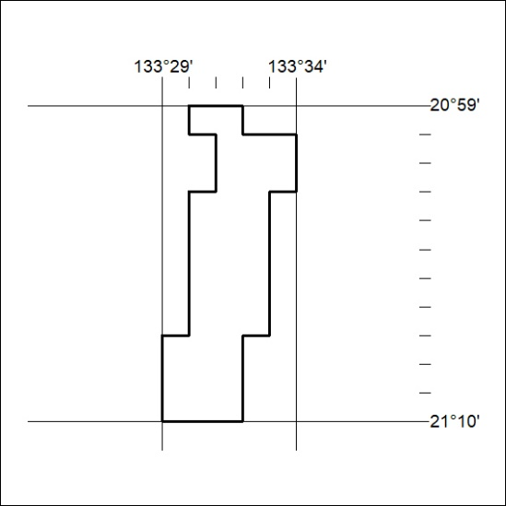

82/22

Mineral Titles Act 2010
NOTICE OF LAND CEASING TO BE A MINERAL TITLE APPLICATION AREA
Title Type and Number: | Exploration Licence 33022
Area Ceased on: | 01 April 2022
Area: | 116 Blocks, 372.33 km²
Locality: | NUMAGALONG
Name of Applicant(s)/Holder(s): | 100% ENIGMA MINING LIMITED [ACN. 009 225 558]
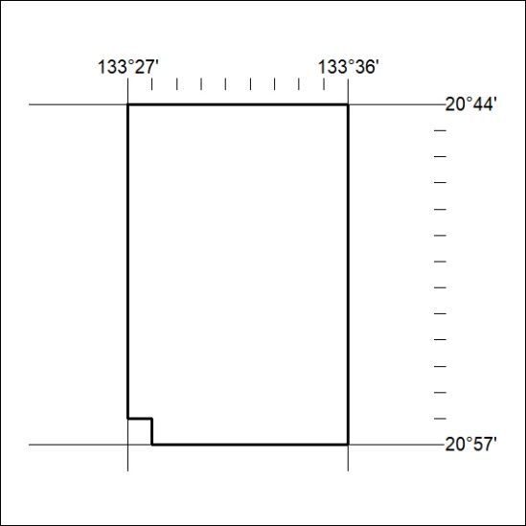

83/22

