Mineral Titles Act 2010
NOTICE OF LAND CEASING TO BE A MINERAL TITLE AREA
Title Type and Number: | Exploration Licence 31794
Area Ceased on: | 28 February 2022
Area: | 110 Blocks, 347.50 km²
Locality: | LEISLER
Name of Applicant(s)/Holder(s): | 100% CASTILE RESOURCES LTD* [ACN. 124 314 085]
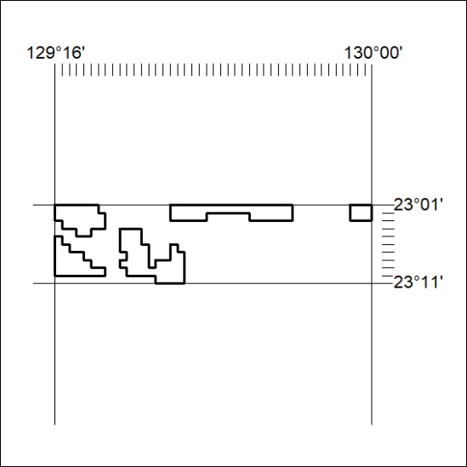

48/22

