Mineral Titles Act 2010
NOTICE OF LAND CEASING TO BE A MINERAL TITLE AREA
Title Type and Number: | Exploration Licence 31492
Area Ceased on: | 18 November 2021
Area: | 20 Blocks, 66.42 km²
Locality: | MOROAK
Name of Applicant(s)/Holder(s): | 100% MOROAK RESOURCES PTY LTD [ACN. 616 553 014]
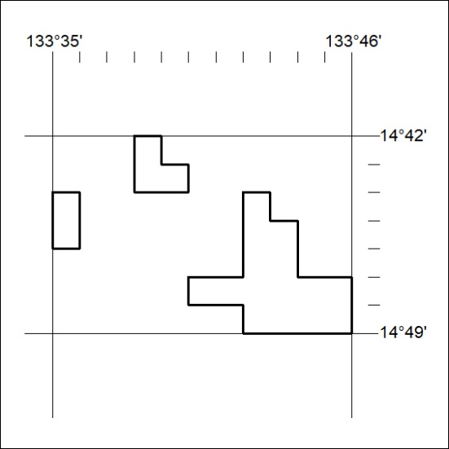

429/21

Mineral Titles Act
NOTICE OF GRANT OF A MINERAL TITLE
Title Type and Number: | Exploration Licence 32705
Granted: | 16 November 2021, for a period of 6 Years
Area: | 25 Blocks, 79.30 km²
Locality: | JINKA
Name of Holder/s: | 100% BURGEO PTY LTD [ACN. 648 965 431]
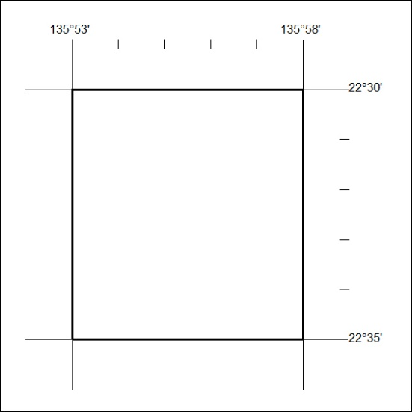
Area granted is indicated above. The titleholder is not permitted to exercise occupational rights on any land that is subject to a development title, or an application for a development title. Any land the subject of a Reserved Land gazettal under the Mineral Titles Act and all land vested in the Commonwealth of Australia is also excluded by description but not excised from the grant area.

430/21

