Mineral Titles Act 2010
NOTICE OF LAND CEASING TO BE A MINERAL TITLE APPLICATION AREA
Title Type and Number: | Exploration Licence 5840
Area Ceased on: | 18 October 2021
Area: | 406 Blocks, 1361.31 km²
Locality: | MILINGIMBI
Name of Applicant(s)/Holder(s): | 100% RIO TINTO EXPLORATION PTY LIMITED [ACN. 000 057 125]
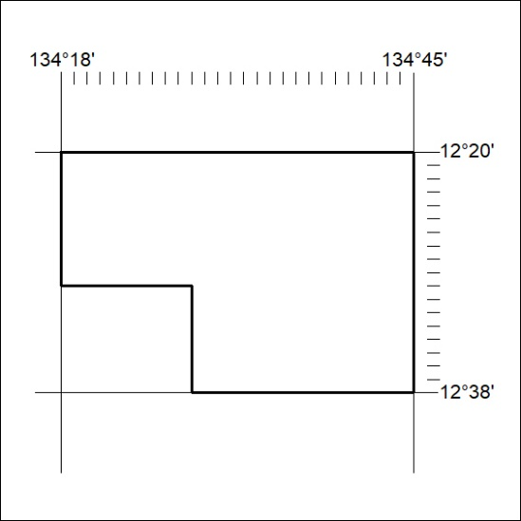

390/21

Mineral Titles Act 2010
NOTICE OF LAND CEASING TO BE A MINERAL TITLE APPLICATION AREA
Title Type and Number: | Exploration Licence 5841
Area Ceased on: | 18 October 2021
Area: | 401 Blocks, 1342.99 km²
Locality: | CADELL
Name of Applicant(s)/Holder(s): | 100% RIO TINTO EXPLORATION PTY LIMITED [ACN. 000 057 125]
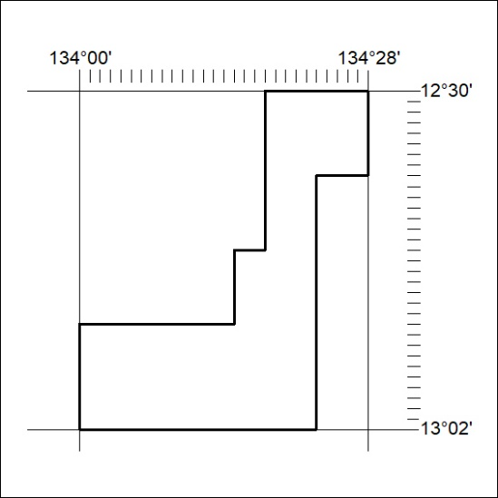

391/21
Mineral Titles Act 2010
NOTICE OF LAND CEASING TO BE A MINERAL TITLE APPLICATION AREA
Title Type and Number: | Exploration Licence 5842
Area Ceased on: | 18 October 2021
Area: | 473 Blocks, 1580.90 km²
Locality: | WILTON RIVER
Name of Applicant(s)/Holder(s): | 100% RIO TINTO EXPLORATION PTY LIMITED [ACN. 000 057 125]
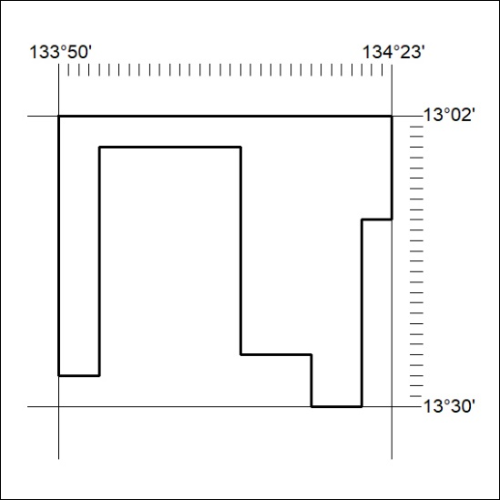

392/21

Mineral Titles Act 2010
NOTICE OF LAND CEASING TO BE A MINERAL TITLE AREA
Title Type and Number: | Exploration Licence 30655
Area Ceased on: | 19 October 2021
Area: | 138 Blocks, 451.20 km²
Locality: | NAPIER
Name of Applicant(s)/Holder(s): | 100% MARTIN Anthony Ernest
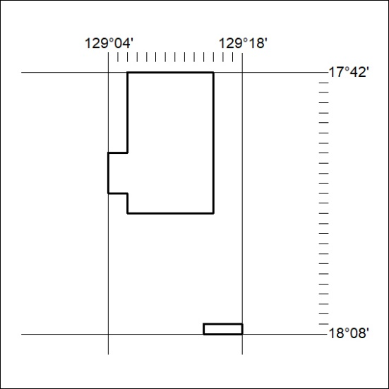

392/21
Mineral Titles Act 2010
NOTICE OF LAND CEASING TO BE A MINERAL TITLE AREA
Title Type and Number: | Exploration Licence 30729
Area Ceased on: | 19 October 2021
Area: | 108 Blocks, 341.85 km²
Locality: | CAREY
Name of Applicant(s)/Holder(s): | 100% PRODIGY GOLD NL* [ACN. 009 127 020]
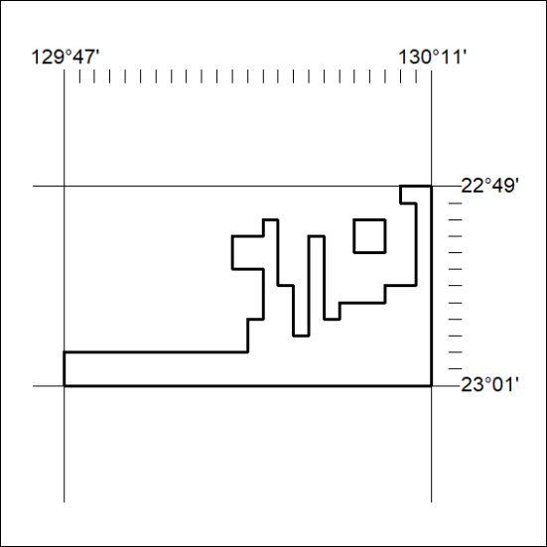

393/21

Mineral Titles Act 2010
NOTICE OF LAND CEASING TO BE A MINERAL TITLE AREA
Title Type and Number: | Exploration Licence 30732
Area Ceased on: | 19 October 2021
Area: | 116 Blocks, 366.11 km²
Locality: | KUTA KUTA
Name of Applicant(s)/Holder(s): | 100% PRODIGY GOLD NL* [ACN. 009 127 020]
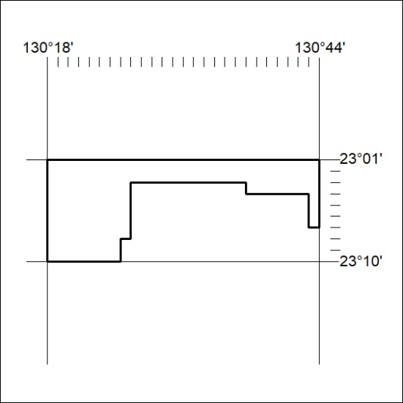

394/21
Mineral Titles Act 2010
NOTICE OF LAND CEASING TO BE A MINERAL TITLE AREA
Title Type and Number: | Exploration Licence 30733
Area Ceased on: | 19 October 2021
Area: | 69 Blocks, 218.18 km²
Locality: | KUTA KUTA
Name of Applicant(s)/Holder(s): | 100% PRODIGY GOLD NL* [ACN. 009 127 020]
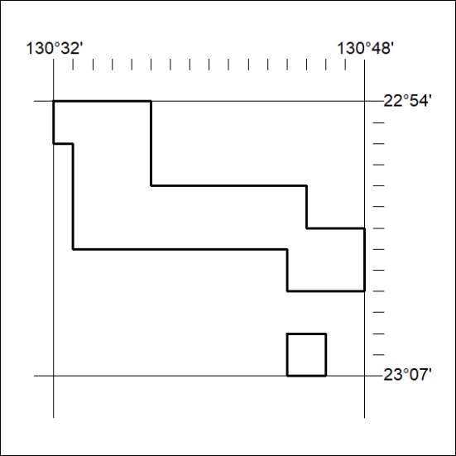

395/21

Mineral Titles Act 2010
NOTICE OF LAND CEASING TO BE A MINERAL TITLE AREA
Title Type and Number: | Exploration Licence 30740
Area Ceased on: | 19 October 2021
Area: | 74 Blocks, 225.13 km²
Locality: | LIEBIG
Name of Applicant(s)/Holder(s): | 100% PRODIGY GOLD NL* [ACN. 009 127 020]
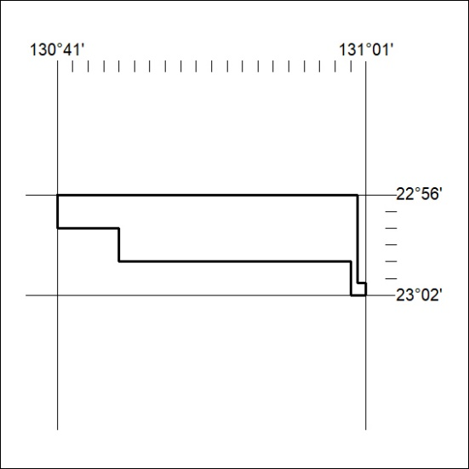

396/21
Mineral Titles Act 2010
NOTICE OF LAND CEASING TO BE A MINERAL TITLE AREA
Title Type and Number: | Exploration Licence 31234
Area Ceased on: | 18 October 2021
Area: | 23 Blocks, 72.66 km²
Locality: | LEISLER
Name of Applicant(s)/Holder(s): | 100% IGO LIMITED* [ACN. 092 786 304]
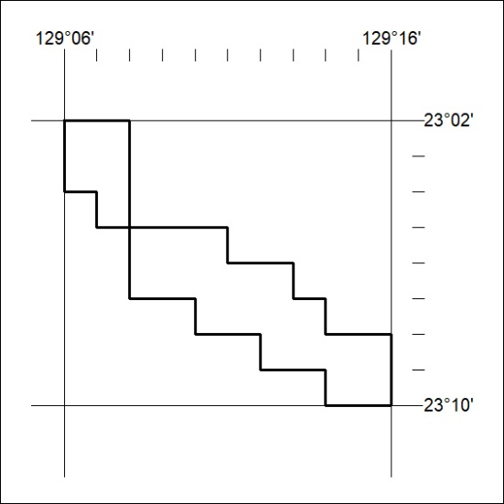

397/21

