Mineral Titles Act 2010
NOTICE OF LAND CEASING TO BE A MINERAL TITLE APPLICATION AREA
Title Type and Number: | Exploration Licence 32572
Area Ceased on: | 08 September 2021
Area: | 124 Blocks, 382.87 km²
Locality: | ADAM
Name of Applicant(s)/Holder(s): | 100% PLUTONIC LIMITED [ACN. 632 991 167]
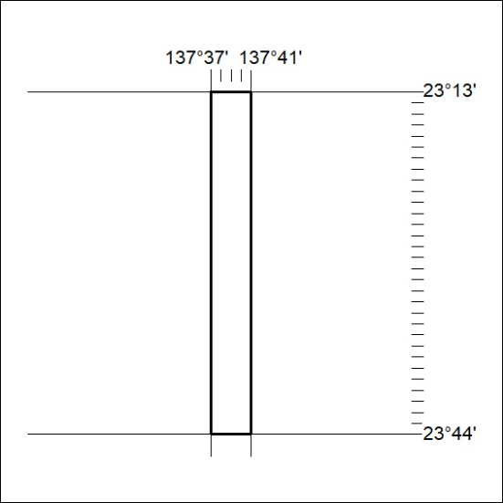

345/21

Mineral Titles Act 2010
NOTICE OF LAND CEASING TO BE A MINERAL TITLE APPLICATION AREA
Title Type and Number: | Exploration Licence 32634
Area Ceased on: | 08 September 2021
Area: | 139 Blocks, 438.40 km²
Locality: | MT BARRINGTON
Name of Applicant(s)/Holder(s): | 100% PLUTONIC LIMITED [ACN. 632 991 167]
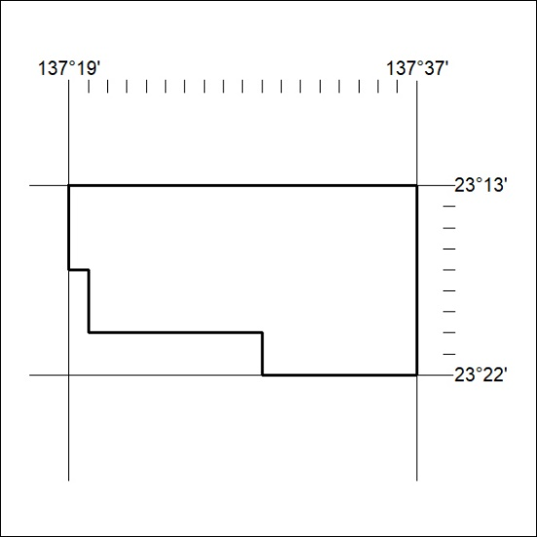

346/21

