Mineral Titles Act 2010
NOTICE OF LAND CEASING TO BE A MINERAL TITLE AREA
Title Type and Number: | Extractive Mineral Permit 30369
Area ceased on: | 26 August 2021
Area: | 75.00 Hectare
Locality: | NOONAMAH
Name of Applicants(s)Holder(s): | 100% EAST ARM CIVIL PTY LTD [ACN. 073 382 251]
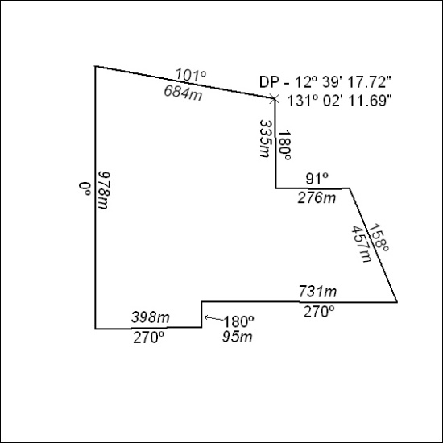

328/21

Mineral Titles Act
NOTICE OF GRANT OF A MINERAL TITLE
Title Type and Number: | Exploration Licence 32648
Granted: | 25 August 2021, for a period of 6 Years
Area: | 173 Blocks, 561.62 km²
Locality: | BARKLY
Name of Holder/s: | 100% NEWCREST OPERATIONS LIMITED [ACN. 009 221 505]
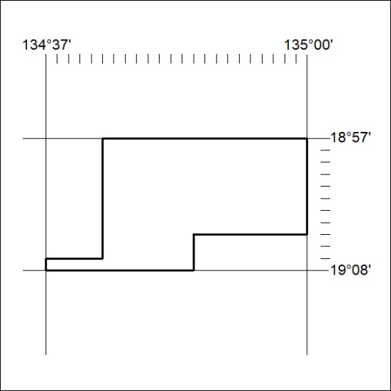
Area granted is indicated above. The titleholder is not permitted to exercise occupational rights on any land that is subject to a development title, or an application for a development title. Any land the subject of a Reserved Land gazettal under the Mineral Titles Act and all land vested in the Commonwealth of Australia is also excluded by description but not excised from the grant area.

329/21

Mineral Titles Act
NOTICE OF GRANT OF A MINERAL TITLE
Title Type and Number: | Exploration Licence 32649
Granted: | 25 August 2021, for a period of 6 Years
Area: | 55 Blocks, 154.58 km²
Locality: | FREWENA
Name of Holder/s: | 100% NEWCREST OPERATIONS LIMITED [ACN. 009 221 505]
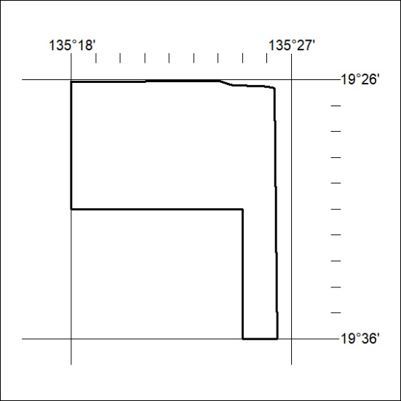
Area granted is indicated above. The titleholder is not permitted to exercise occupational rights on any land that is subject to a development title, or an application for a development title. Any land the subject of a Reserved Land gazettal under the Mineral Titles Act and all land vested in the Commonwealth of Australia is also excluded by description but not excised from the grant area.
330/21

Mineral Titles Act
NOTICE OF GRANT OF A MINERAL TITLE
Title Type and Number: | Exploration Licence 32650
Granted: | 25 August 2021, for a period of 6 Years
Area: | 50 Blocks, 153.04 km²
Locality: | FREWENA
Name of Holder/s: | 100% NEWCREST OPERATIONS LIMITED [ACN. 009 221 505]
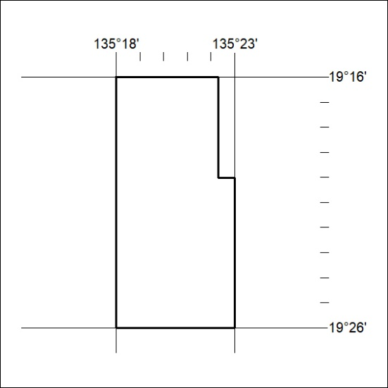
Area granted is indicated above. The titleholder is not permitted to exercise occupational rights on any land that is subject to a development title, or an application for a development title. Any land the subject of a Reserved Land gazettal under the Mineral Titles Act and all land vested in the Commonwealth of Australia is also excluded by description but not excised from the grant area.
331/21

Mineral Titles Act
NOTICE OF GRANT OF A MINERAL TITLE
Title Type and Number: | Exploration Licence 32651
Granted: | 25 August 2021, for a period of 6 Years
Area: | 44 Blocks, 126.75 km²
Locality: | FREWENA
Name of Holder/s: | 100% NEWCREST OPERATIONS LIMITED [ACN. 009 221 505]
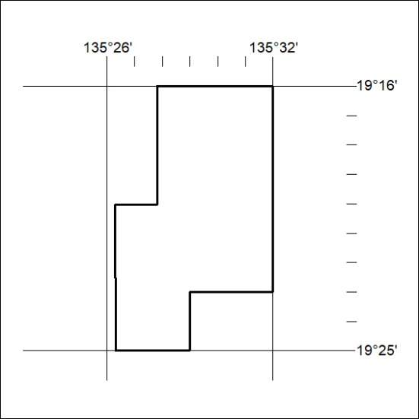
Area granted is indicated above. The titleholder is not permitted to exercise occupational rights on any land that is subject to a development title, or an application for a development title. Any land the subject of a Reserved Land gazettal under the Mineral Titles Act and all land vested in the Commonwealth of Australia is also excluded by description but not excised from the grant area.
332/21

Mineral Titles Act
NOTICE OF GRANT OF A MINERAL TITLE
Title Type and Number: | Exploration Licence 32652
Granted: | 25 August 2021, for a period of 6 Years
Area: | 109 Blocks, 327.13 km²
Locality: | WONARAH
Name of Holder/s: | 100% NEWCREST OPERATIONS LIMITED [ACN. 009 221 505]
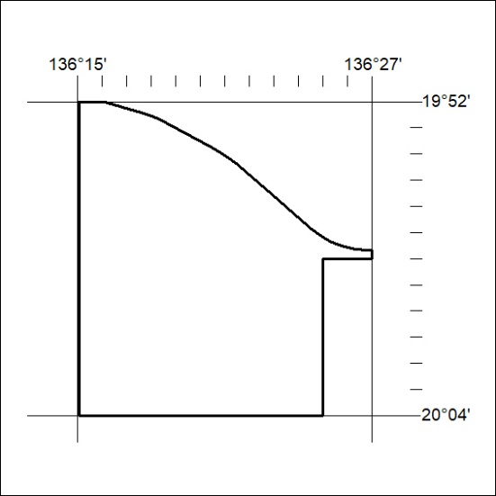
Area granted is indicated above. The titleholder is not permitted to exercise occupational rights on any land that is subject to a development title, or an application for a development title. Any land the subject of a Reserved Land gazettal under the Mineral Titles Act and all land vested in the Commonwealth of Australia is also excluded by description but not excised from the grant area.
333/21

Mineral Titles Act
NOTICE OF GRANT OF A MINERAL TITLE
Title Type and Number: | Exploration Licence 32653
Granted: | 25 August 2021, for a period of 6 Years
Area: | 53 Blocks, 140.26 km²
Locality: | WONARAH
Name of Holder/s: | 100% NEWCREST OPERATIONS LIMITED [ACN. 009 221 505]
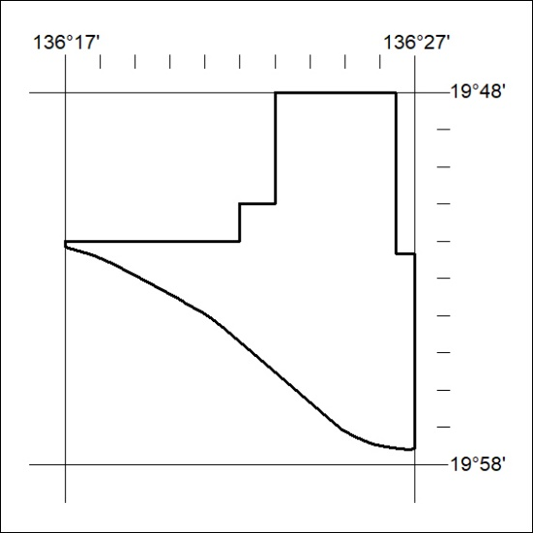
Area granted is indicated above. The titleholder is not permitted to exercise occupational rights on any land that is subject to a development title, or an application for a development title. Any land the subject of a Reserved Land gazettal under the Mineral Titles Act and all land vested in the Commonwealth of Australia is also excluded by description but not excised from the grant area.
334/21

Mineral Titles Act
NOTICE OF GRANT OF A MINERAL TITLE
Title Type and Number: | Exploration Licence 32654
Granted: | 25 August 2021, for a period of 6 Years
Area: | 108 Blocks, 348.09 km²
Locality: | COOLIBAH
Name of Holder/s: | 100% NEWCREST OPERATIONS LIMITED [ACN. 009 221 505]
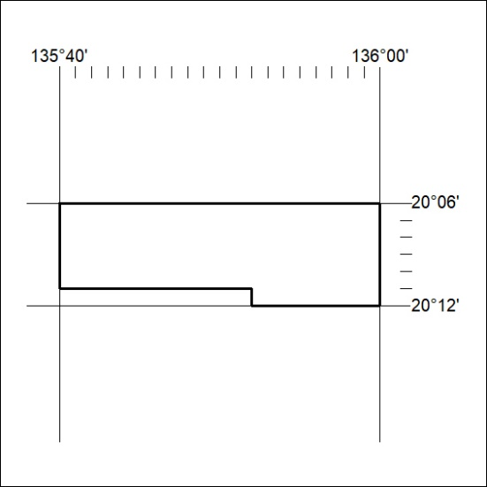
Area granted is indicated above. The titleholder is not permitted to exercise occupational rights on any land that is subject to a development title, or an application for a development title. Any land the subject of a Reserved Land gazettal under the Mineral Titles Act and all land vested in the Commonwealth of Australia is also excluded by description but not excised from the grant area.
335/21

