Mineral Titles Act
NOTICE OF GRANT OF A MINERAL TITLE
Title Type and Number: | Extractive Mineral Permit 32515
Granted: | 25 June 2021, for a period of 5 Years
Area: | 4.00 Hectares
Locality: | ALICE SPRINGS
Name of Holder/s: | 100% P.F. & C.J. BROWN PTY. LTD. [ACN. 009 652 868]
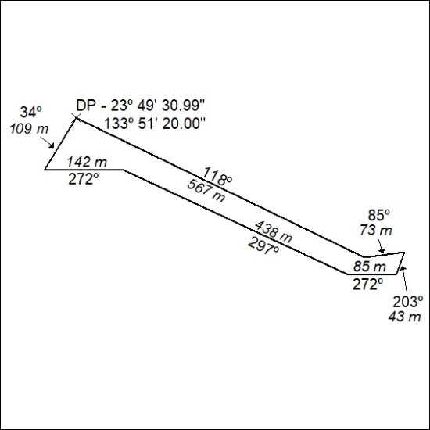

272/21

Mineral Titles Act
NOTICE OF GRANT OF A MINERAL TITLE
Title Type and Number: | Mineral Authority 32516
Granted: | 25 June 2021, for a period of 5 Years
Area: | 4.00 Hectares
Locality: | ALICE SPRINGS
Name of Holder/s: | 100% P.F. & C.J. BROWN PTY. LTD. [ACN. 009 652 868]
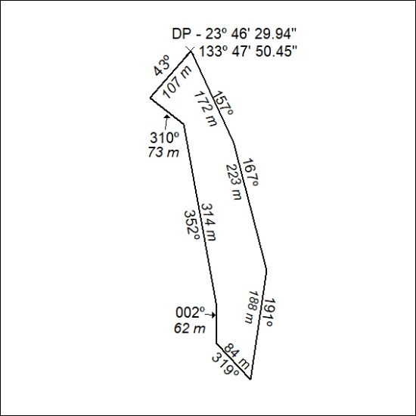

273/21

