Mineral Titles Act 2010
NOTICE OF LAND CEASING TO BE A MINERAL TITLE AREA
Title Type and Number: | Exploration Licence 31350
Area Ceased on: | 16 June 2021
Area: | 53 Blocks, 175.30 km²
Locality: | TIPPERARY
Name of Applicant(s)/Holder(s): | 100% NEWMONT EXPLORATION PTY LTD* [ACN. 006 306 690]
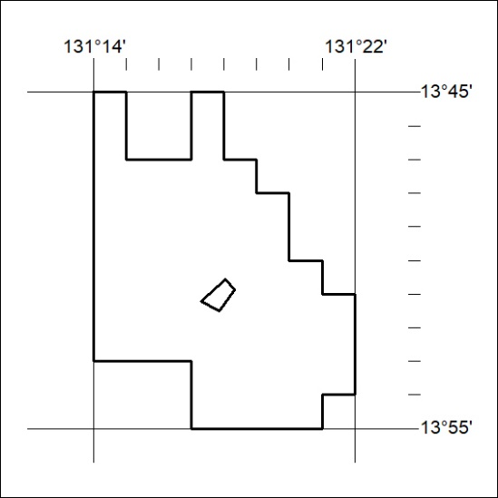

212/21

Mineral Titles Act
NOTICE OF GRANT OF A MINERAL TITLE
Title Type and Number: | Extractive Mineral Exploration Licence 32610
Granted: | 16 June 2021, for a period of 2 Years
Area: | 4 Blocks, 8.56 km²
Locality: | MARY RIVER
Name of Holder/s: | 100% CABOT MELISSA
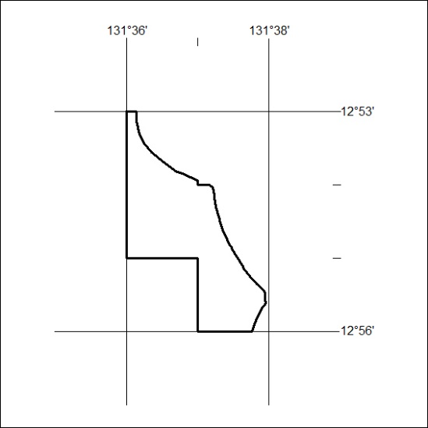
Area granted is indicated above. The titleholder is not permitted to exercise occupational rights on any land that is subject to a development title, or an application for a development title. Any land the subject of a Reserved Land gazettal under the Mineral Titles Act and all land vested in the Commonwealth of Australia is also excluded by description but not excised from the grant area.

213/21

Mineral Titles Act
NOTICE OF GRANT OF A MINERAL TITLE
Title Type and Number: | Extractive Mineral Exploration Licence 32611
Granted: | 16 June 2021, for a period of 2 Years
Area: | 4 Blocks, 13.39 km²
Locality: | MARY RIVER
Name of Holder/s: | 100% CABOT MELISSA
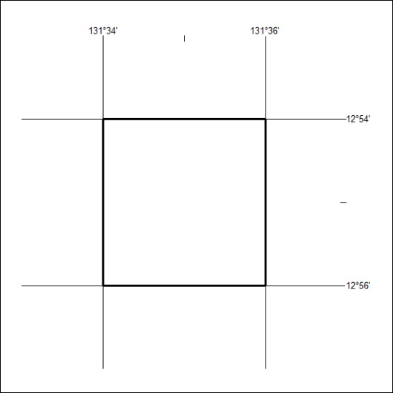
Area granted is indicated above. The titleholder is not permitted to exercise occupational rights on any land that is subject to a development title, or an application for a development title. Any land the subject of a Reserved Land gazettal under the Mineral Titles Act and all land vested in the Commonwealth of Australia is also excluded by description but not excised from the grant area.
214/21

Mineral Titles Act
NOTICE OF GRANT OF A MINERAL TITLE
Title Type and Number: | Extractive Mineral Exploration Licence 32612
Granted: | 16 June 2021, for a period of 2 Years
Area: | 4 Blocks, 12.44 km²
Locality: | MARY RIVER
Name of Holder/s: | 100% CABOT MELISSA
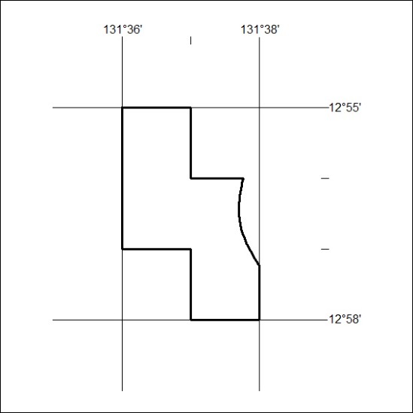
Area granted is indicated above. The titleholder is not permitted to exercise occupational rights on any land that is subject to a development title, or an application for a development title. Any land the subject of a Reserved Land gazettal under the Mineral Titles Act and all land vested in the Commonwealth of Australia is also excluded by description but not excised from the grant area.

215/21

Mineral Titles Act
NOTICE OF GRANT OF A MINERAL TITLE
Title Type and Number: | Extractive Mineral Exploration Licence 32613
Granted: | 16 June 2021, for a period of 2 Years
Area: | 4 Blocks, 13.39 km²
Locality: | MARY RIVER
Name of Holder/s: | 100% CABOT MELISSA
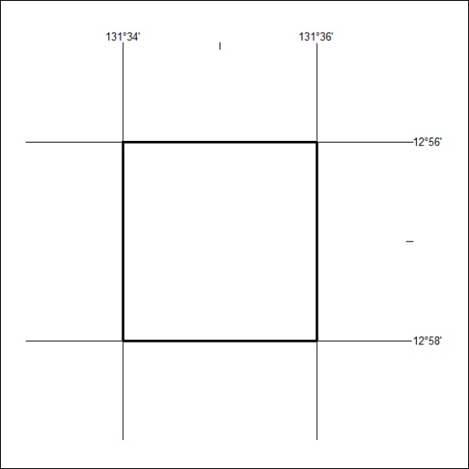
Area granted is indicated above. The titleholder is not permitted to exercise occupational rights on any land that is subject to a development title, or an application for a development title. Any land the subject of a Reserved Land gazettal under the Mineral Titles Act and all land vested in the Commonwealth of Australia is also excluded by description but not excised from the grant area.

216/21

