|  |  |  |
| --- | --- | --- |
| **NT Agriculture, Forestry and Fishing Projects**  The map provides the location of major agriculture, forestry and fishing projects in the Northern Territory | * The Northern Territory has a land mass of 1 348 199 km2, the third largest Australian jurisdiction * The NT has a small and sparsely distributed population of 246,500 , accounting for about 1.0% of the Australian resident population * The NT civilian population (15+ years) is 188,963 persons, with a labour force of 137,744 persons, including 129,212 people employed * The NT is characterised by a young population, with a median age of 34 years compared to 37 years nationally * 30.3% of the resident NT population are Aboriginal and/or Torres Strait Islander * More than half of the NT’s population reside in the Greater Darwin region, the main hub of economic activity * The NT has considerable onshore and offshore energy resources, in addition to existing and prospective mineral, agriculture, aquaculture and horticulture projects. * The NT’s developing economic infrastructure connects regions and key markets through roads, ports, international airport, gas pipeline and Darwin to Adelaide railway * Economic output (GSP) in 2019-20 was $26.1 billion, a 5.3% increase from 2018-19. | **NT Mining and Energy Projects**  The map outlines the major mining and eneryg projects in the Northern Territory |
| * The NT’s five largest industries by output are mining; public administration and safety; health care and social assistance; construction; education and training; comprising a combined 58% of total NT GSP * The Defence presence (air force, army, and navy) in the region plays a significant role * Tourism activity is an expanding sector with significant tourism economy and assets such as the world-famous Kakadu National Park, Uluru, Katherine Gorge; and other national parks. |
| * The NT is an open, trade-oriented economy * Key exports include LNG, live animals, and mineral ores and concentrates * Over 80% of NT exports go to Japan, China, Thailand, and Indonesia * Key imports include iron, steel and aluminium structures, pipes of iron or steel, and refined petroleum * The NT’s major import partners are from Singapore, Switzerland, and Malaysia. |

Greater Darwin includes Darwin city, Darwin suburbs, Palmerston, Litchfield. It has an area of 3164 square kilometres, a population of 147231, number of businesses are 11025, and key industries are retail/wholesale; and manufacturing.
Daly-Tiwi-West Arnhem has an area of 112251 square kilometres, a population of 17909, number of businesses are 361, and key industries are agriculture/fishing; and mining; 
East Arnhem has an area of 33596 square kilometres, population of 14565, number of businesses are 266, and key industries are agriculture/fishing; mining; and tourism; 
Barkly has an area of 303295 square kilometres, population of 6142, number of businesses are 213, and key industries are agriculture, tourism; and government services.
Alice Springs has an area of 569566 square kilometres, population is 39391, number of businesses is 2139, and key industries agriculture, tourism; cattle; and mining.
Katherine, also called Big Rivers, has an area of 326327 square kilometres, population is 20905, number of businesses are 943, and key industries are agriculture, tourism, cattle; fishing; and mining.
Regions are classified according to the Australian Statistical Geography Standard Statistical Area level 3

Please read in outline view for best navigational experience.

# Introduction

The Territory’s economy, while relatively small compared to other Australian jurisdictions, is vibrant and has an abundance of mineral and energy resources. Its close proximity to Asia, the fastest growing region of the global economy, and a renewed focus of developing northern Australia, provide many potential business opportunities for Territory businesses.

# Gross state product (GSP)

The NT’s 10-year average annual economic (GSP) growth rate (2009-10 to 2019-20) was 2.5%. In 2019-20, NT GSP (inflation adjusted) increased by 5.3% to $26.1 billion, driven by a fall in business investment, and consumption, but partly offset by rising exports (Chart 1). In 2019-20, total investment in the NT was valued at $4.5 billion, a decrease of 19.7% compared to 2018-19.

Private investment is the largest component of total investment, about 70% ($3.1 billion). Private investment decreased by 20.2% over 2019-20 (Chart 2). This decrease was largely driven by a 41.1% fall in non-dwelling construction activities (business investment). In the NT economy, large projects have a considerable impact on investment and generate high levels of economic growth, but large fluctuations in investment.

Nationally, Gross Domestic Product (GDP) decreased by 0.2% in 2019-20. NT GSP accounts for 1.3% of Australian GDP.

**Chart 1: State and Territory Real GSP 2019-20**

Australian gross domestic product in 2018-19 was $1.9 trillion
Northern Territory gross state product was $26 billion
Queensland gross state product was $364 billion
New South Wales gross state product was $625 billion
Australian Capital Territory gross state product was $41 billion
Victoria gross state product was $459 billion
Tasmania gross state product was $32 billion
South Australia gross state product was $108 billion
Western Australia gross state product was $292 billion
Source is Australian Burea of Statistics Catalogue Number 5220.0

*Source: ABS Cat. No. 5220.0*

**Chart 2: GSP vs SFD Growth**

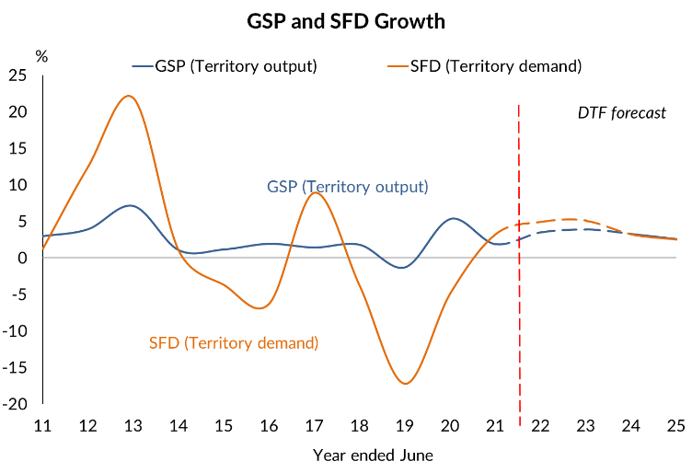

*Source: ABS Cat. No. 5220.0, DTF*

Private business investment ($2.4 billion), the key driver of investment ($4.5 billion), comprised about 77% of the total private investment ($3.2 billion) and 54% of the total investment in 2019-20.

NT economic growth is estimated to decrease by 0.1% in 2020-21 before rising by 1.5% in 2021-22 (Department of Treasury and Finance Budget estimates). This is largely due exports plateauing, and COVID‑19 affecting domestic consumption and investment activity. Deloitte Access Economics forecasts the NT economy to grow by 1.9% in 2020-21 and by 3.5% in 2021‑22. National GDP decline by 0.2% in 2019‑20 and is forecast to rebound by 0.75% in 2020-21 (Australian Economic and Fiscal Update December Qtr. 2020).

In the December quarter, 2020 NT SFD increased 4.8%. NT State Final Demand (SFD), total domestic expenditure within the local economy, was $23.9 billion (seasonally adjusted and inflation adjusted) in 2020 (Chart 3). For the same period in the previous year, SFD was $24.0 billion. Consumption (public and private consumption), the largest component of SFD, comprised 81.1% of domestic demand.

SFD growth is expected to increase as the economy recovers for the effects of COVID‑19, driving private sector investment and private consumption (Chart 4). Growth in 2020-21 is underpinned by international exports and is supported by private consumption and housing investment.

**Chart 3: NT SFD, inflation adjusted**

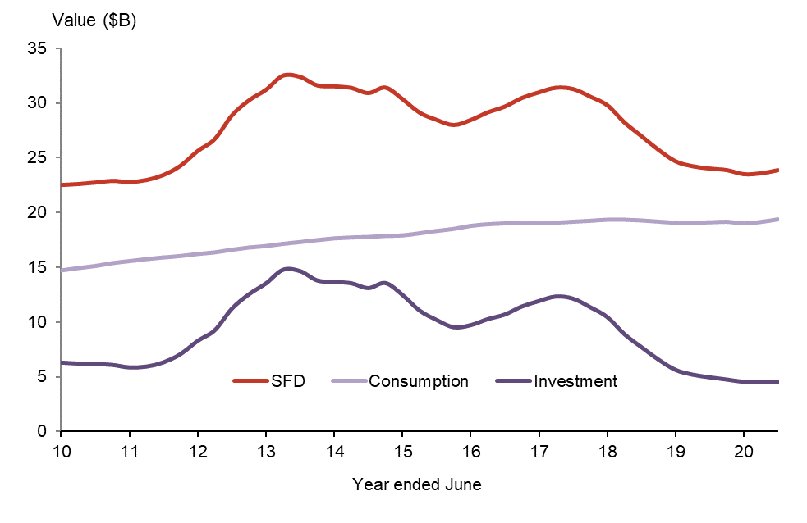

*Source: ABS Cat. No. 5220.0, DTF*

**Chart 4: State final demand: YoY % change**

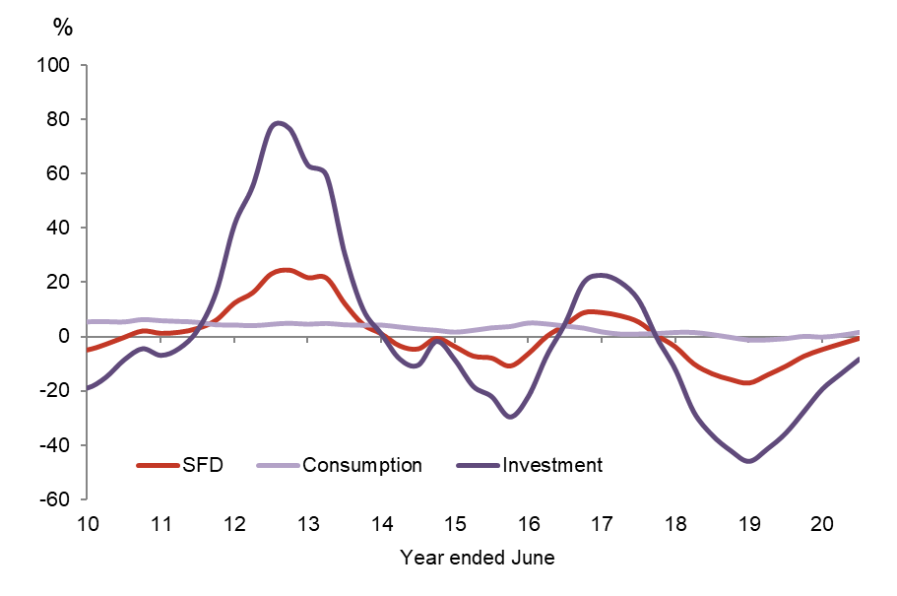

*Source: ABS Cat. No. 5206.0*

| **NT SFD component** | **Proportion of SFD in the year to Dec 2020** | | |
| --- | --- | --- | --- |
|  | **Dec 2020** | **Dec 2019** | **Annual change** |
| Private consumption | 44.8% | 44.7% | Increase |
| Public consumption | 36.0% | 34.7% | Increase |
| Private investment | 13.7% | 14.3% | Decrease |
| Public investment | 5.4% | 6.5% | Decrease |

# International trade

In 2020, the value of NT goods exported fell to $10.7 billion. This represents a 9.2% decrease on the same time last year, which is attributed to less export activity to Japan, China, and Taiwan. (Chart 5).

The value of goods imported has dropped 43.1% to $989 million when compared to the same time last year.

The NT’s trade surplus sits at $9.7 billion in 2020, which is near record highs.

The NT contributed about 2.9% of Australia’s goods exports, and around 0.3% of imports in 2020.

A significant proportion of imports to the NT come from other Australian jurisdictions and is treated as the balancing item in the GSP accounts.

**Chart 5: NT International Trade**

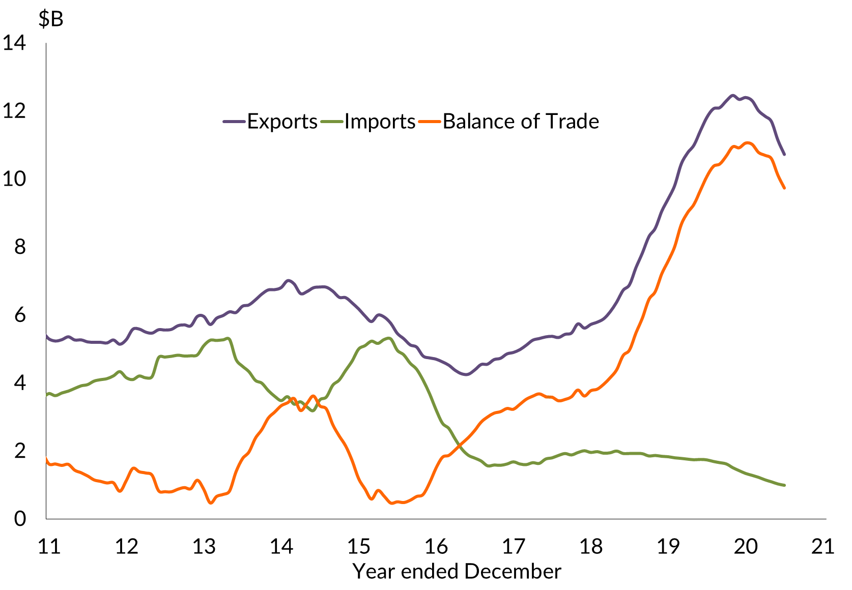

*Source: ABS Cat. No. 5368.0*

**Chart 6: NT International Trade**

A very large portion of trade is with Asia, primarily Japan, China, Korea and Taiwan.

Regional breakdowns:  
Asia includes Southern and Central Asia, Middle East, North East Asia, and South East Asia  
Europe includes North-West Europe and Southern and Eastern Europe  
Americas includes North America, South America, Central America and the Caribbean  
Other (a) includes Africa (North Africa, Central and West Africa, and Southern and East Africa) and Oceania (Antarctica and Pacific Island countries and territories)

Major NT imports from overseas are petroleum, transport equipment, and road vehicles.

The NT’s major exports to overseas are LNG, live animals, and mineral ores and concentrates.

The majority of NT exports are destined for North and South East Asia (Japan and China are key export partners) while the main import partners in 2019-20 were Singapore, Malaysia and China.

# Population

As at September 2020, the NT’s resident population was 246,500, an increase of 0.2% in annual terms (Chart 7). Natural increase and net overseas migration added to the population while net interstate migration detracted from population growth. NT population has marginally declined over the past year.

The population of Australia in September 2020 was 25 693 059 people. The NT population comprised 1.0% of the national population.

The estimated resident Aboriginal and Torres Strait Islander population of the NT in June 2016 was 74,546 persons, comprising around 30.3% of the NT resident population. Around 49.5% of the Indigenous population were females. Nationally, the Indigenous population accounts for 3.3% of the total population.

The NT population is relatively young (median age of 34 years compared to 37 years nationally) with a higher male-to-female sex ratio 109.9 males per 100 females compared to 98.4 males per 100 females nationally. **Chart 7: Northern Territory Population**

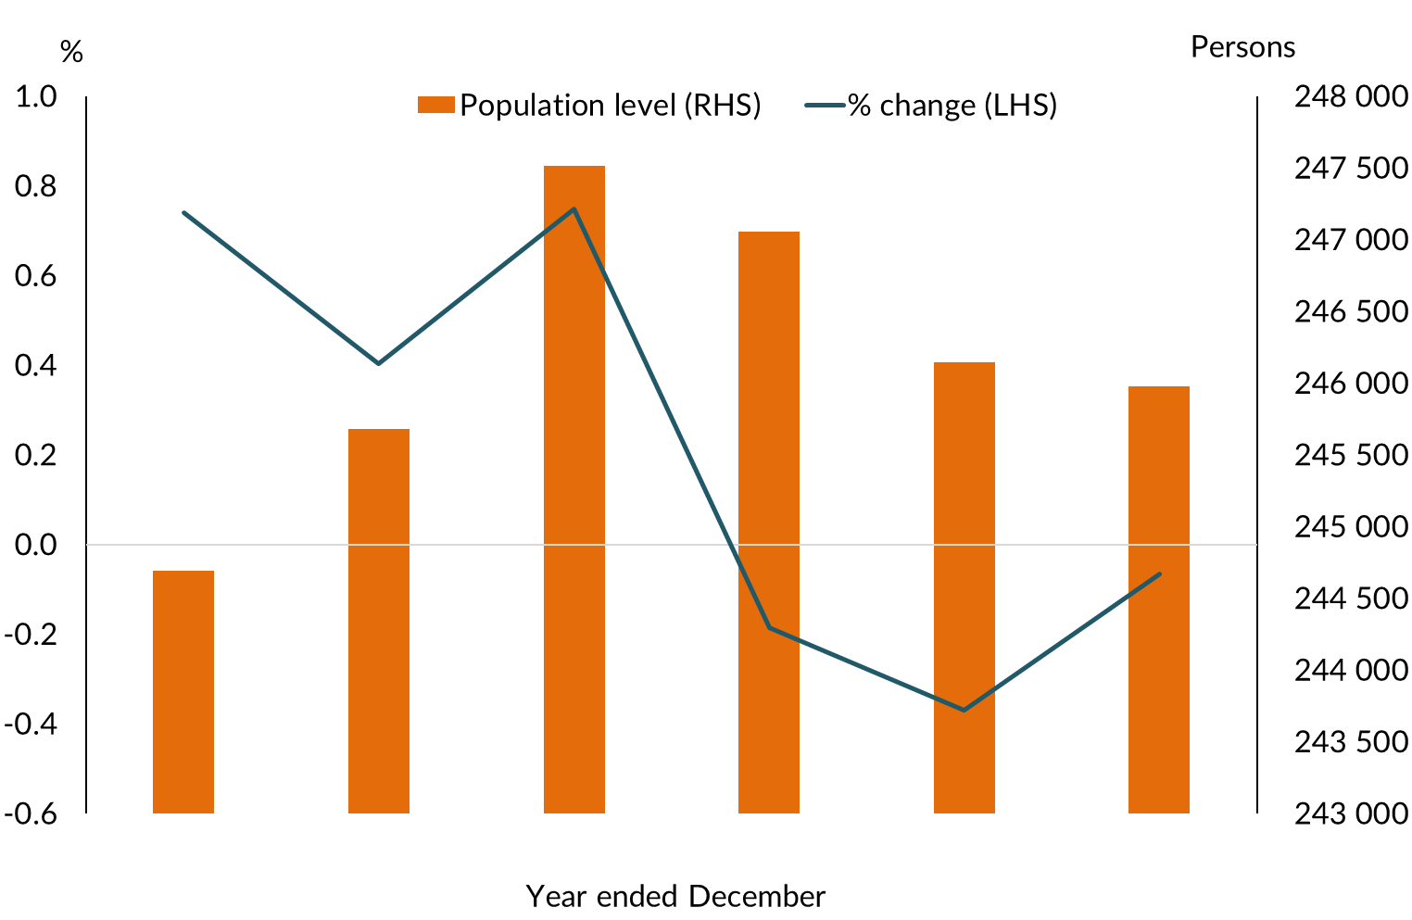

*Source: ABS Cat. No. 3101.0*

**Chart 8: NT Age Distribution 2019**

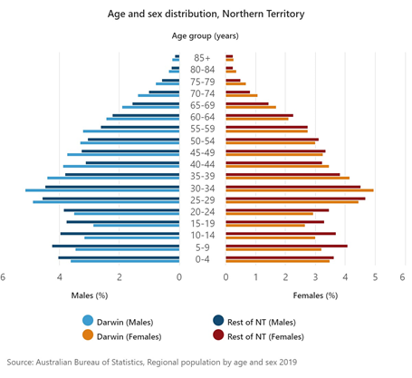

*Source: ABS Cat. No. 3101.0*

**Chart 9: NT Regional Population, June 2019**

59.9% of the Northern Territory population is in Greater Darwin
16% of the Northern Territory population is in Alice Springs
2.5% of the Northern Territory population is in Barkly
7.2% of the Northern Territory population is in Daly-Tiwi-West Arnhem
5.9% of the Northern Territory population is in East Arnhem
8.5% of the Northern Territory population is in Katherine

*Source: ABS Cat. No. 3218.0*

In the December quarter 2020, the civilian population (15+ years) of the NT was 188,963 persons, about 76% of the total population. Nationally, the civilian population was 81% of the population.

Around 59.9% of the NT population is located in the Greater Darwin area (Darwin City, Darwin suburbs, Litchfield and Palmerston) with Central Australia (Alice Springs region) accounting for a further 16.0% and the Katherine region accounting for 8.5% of the total population (Chart 9).

# Labour market

The NT labour market is characterised by a relatively skilled labour force with a high level of labour participation. There are however, regional differences in the labour market characteristics.

In December 2020, the NT unemployment rate decreased to 5.4% (seasonally adjusted) and has increased by 0.2 percentage points over the year (Chart 10), and has the second lowest unemployment rate of all Australian jurisdictions. Nationally, the unemployment rate was 6.6% (seasonally adjusted).

Employment levels have increased to 129,212 persons employed across the NT at December 2020. This represents a 3.6% decrease when compared to December 2019. The year on year change in resident employment declined by 0.3% (Chart 11), while national employment levels decreased by 0.7% over the same period.

Regional statistics show the unemployment rate decreased in all NT regions, except for Greater Darwin in the September quarter 2020. Daly-Tiwi-West Arnhem reported the highest unemployment rate of 9.1% in the quarter, while Alice Springs reported the lowest unemployment of 4.5%.

**Chart 10: NT Participation and Unemployment Rate**

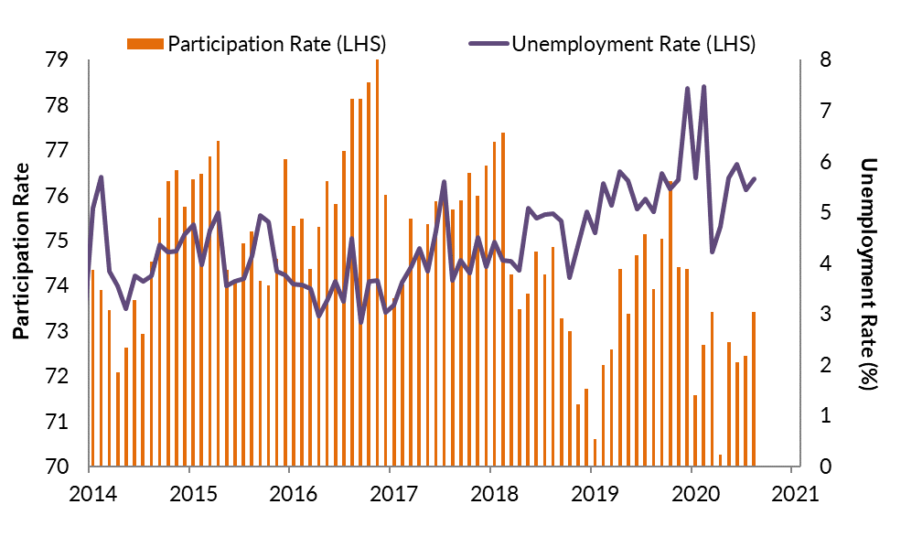

*Source: ABS Cat. No. 6202.0*

**Chart 11: NT Total Employed and Growth Rate**

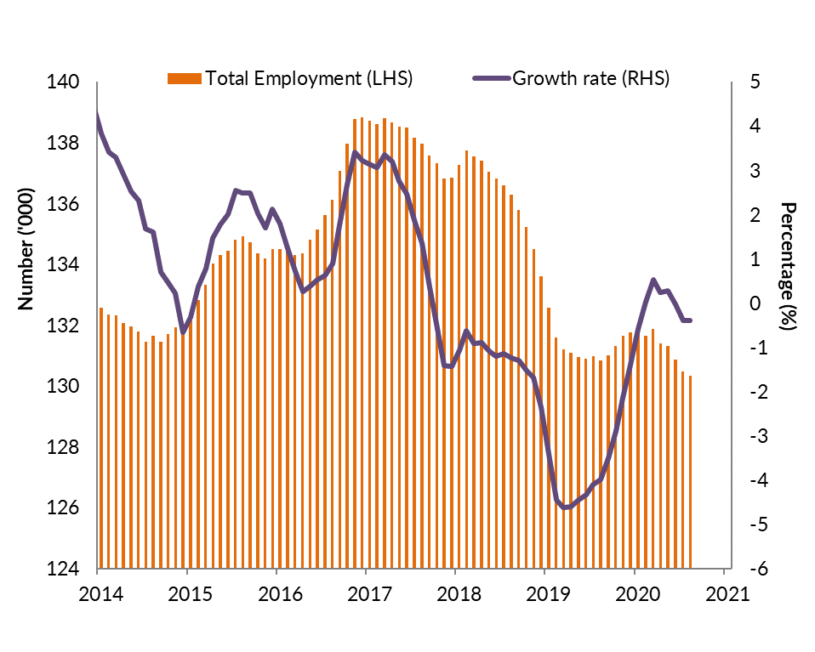

*Source: ABS Cat. No. 6202.0*

As at December 2020, of the civilian population (15+ years) of 188,963, 73.0% (137 744) are in the labour force, of which 129 212 were employed.

The NT underemployment rate was the second lowest of all jurisdictions at 6.4% of total employed persons in December 2020, compared to 8.5% nationally. This signifies that there are more employed people in the NT working their desired number of hours.

The NT underemployment rate has been falling since peaking in April 2020 when social distancing measures were in place.

The NT underutilisation rate (unemployment rate+ underemployment rate) was 11.8% of the total employed persons in December 2020. Similar, to the underemployment rate, this rate has trended down since peaking at 17.7% in May 2020.

The NT participation rate has been trending down over the four months but remains highest of all jurisdictions at 72.4% (Chart 10). This represents a 2.7 percentage point decrease in annual terms. The national participation rate was 66.1% in the same period.

Non-resident labour (including fly-in-fly-out workers) is an important component of the NT labour market statistics. Although difficult to measure, Census 2016 estimated it to be about 8700 workers in June 2016. Similarly, members of the Australian Defence Force are also not included in the labour force statistics, but Australian Defence Force data estimated it to be about 4393 permanent defence force personnel as at June 2020 (Department of Treasury and Finance).

Employment levels in the NT are forecast to fall by 1.6% in 2020-21 before recovering to 1.4% growth in 2021-22 (Deloitte Access Economics Business Outlook, December 2020).

**Chart 12: NT Total Employment by Industry, February 2021**

In the year to November 2019, employment by industry in the Northern Territory is as follows:
Public administration and safety is 15700
Health care and social assistance is 15200
Construction is 8000
Education and training is 9400
Retail trade is 8800
Accommodation and food services is 6400
Professional, scientific and technical services is 5600
Other services is 5300
Transport, postal and warehousing is 4600
Administrative and support services is 4100
Mining is 1700
Arts and recreation services is 3100
Manufacturing is 2800
Electricity, gas, water, and waste services is 1400
Wholesale trade is 2100
Rental, hiring and real estate services is 1800
Financial and insurance services is 1100
Agriculture, forestry and fishing is 1700
Information, media and telecommunications is 1100

*Source: ABS Cat. No. 6291.0.55.003*

**Chart 13: Labour underutilisation rate**

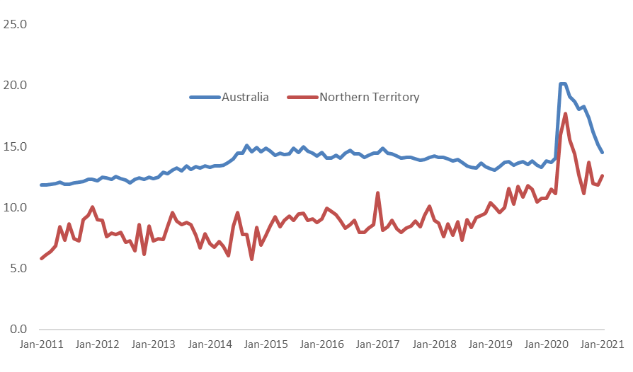

*Source: ABS Cat. No. 6202.0*

As at December 2020 the number of youth employed (aged 15-24 years) in the NT decreased to 14 100, which represents a 3.9% year on year decline. At the national level, youth employment increased to 1, 902,859 persons, representing a 5.4% year on year decrease. NT employment by industry sector data (annual moving average at Feb 2021) shows that Public administration and safety is the largest employer employing about 15.7% of the total employed, ahead of Health care and social assistance (15.2%).

Other large industry employers include Education and training (9.4%), Retail trade (8.8%) and Construction (8.0%). The Mining industry on the other hand employs around 1.7% of the NT workforce (Chart 12).

Year to date to February 2021, there were 347 apprentice and trainee commencements in the Territory, a decrease of 18.0% compared to the same period in the previous year. Over the same period, there were 115 apprentice and trainee completions, an increase of 22.3% compared to the same time last year.

# Prices

The consumer price index (CPI) increased by 0.6% in the December quarter 2020 (Chart 14).

Over the year to December 2020, the Darwin CPI returned to the same levels as December 2019 of 111.5. Over the year, all categories recorded increases except Housing (down by 7.1%) Transport (down by 6.0%), and Communication (down by 2.6%).

Alcohol & tobacco reported the largest annual increase over the year (up by 8.4%). Darwin’s annual CPI to December 2020 was flat, compared to a 0.9% increase nationally.

**Chart 14: Inflation Aggregates, Annual data Dec 2020**

*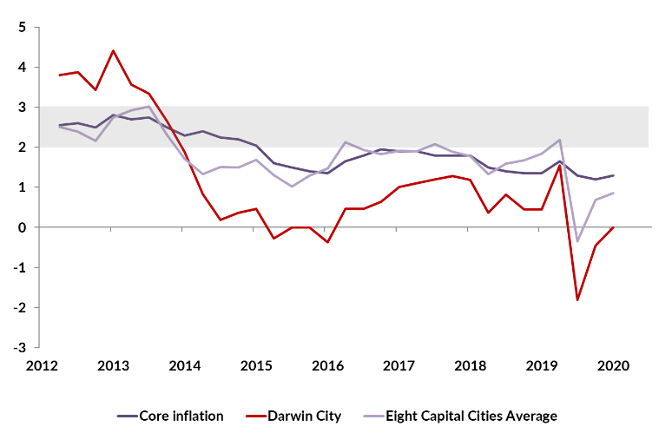 Source: ABS Cat. No. 6401.0*

**Chart 15: Darwin CPI Components, December Qtr. 2020**

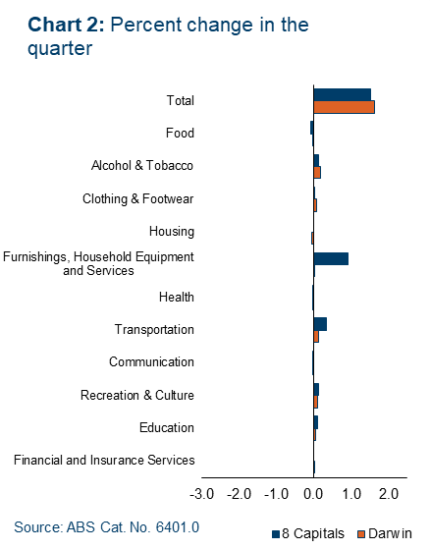

*Source: ABS Cat. No. 6401.0*

The Reserve Bank of Australia’s (RBA) measure of the national annual underlying inflation (core inflation) increased by 1.3% (Average of Weighted Median and Trimmed Mean) in the December Quarter 2020, lower than the RBA’s target inflation range of 2-3%.

# Residential property prices

The NT property market ended the year with increases in sales volumes, median prices and rents, and decreases in vacancy rates. This is the most positive year in over half a decade.

The December Quarter 2020 Real Estate Institute of the NT’s (REINT) data on median prices for a 3 bedroom house ranged from $200,000 in Tennant Creek to $655,000 in Inner Darwin (Chart 16). Median 2 bedroom residential unit prices ranged from $190,000 in Katherine to $380,000 in Darwin North East.

REINT reported the median rent price for a 3 bedroom house ranged from $440 in Katherine to $680 in Inner Darwin. Median 2 bedroom residential unit rents ranged from $322 in Palmerston to $445 in Inner Darwin (Chart 17).

| **Location** | **Median House price** | **Median Unit/ Townhouse price** |
| --- | --- | --- |
| Darwin Overall | $500 000 | $320 000 |
| Inner Darwin | $655 000 | $333 500 |
| Palmerston | $465 000 | $245 000 |
| Katherine | $310 000 | $190 000 |
| Tennant Creek | $200 000 | n.a |
| Alice Springs | $476 250 | $358 500 |

The property price index (PPI - established house price and attached house price) produced by ABS for Australian capital cities, show that for the September Quarter 2020, Darwin PPI increased by 0.8%, while nationally the PPI increased by 0.8%.

**Chart 16:** **House and Unit Purchase Price, December Qtr.**

House prices in Darwin have gradually decreased between December 2017 and December 2020, from around $500000 to about $450000. House prices have moderated over the last 12 months.
Unit prices in Darwin have gradually decreased between December 2017 and December 2020, from around $480000 to about $300000.
Palmerston house prices gradually decreased between December 2016 and December 2019, from around $480000 to about $420000. 
Palmerston unit prices have gradually decreased between December 2016 and December 2019, from around $385000 to about $220000.

*Source: REINT*

**Chart 17: House and Unit Weekly Rental Price, December Qtr**

House prices in Darwin have gradually increased between December 2017 and December 2020, from around $585000 to about $700000. House prices have moderated over the last 12 months.
Unit prices in Darwin have gradually decreased between December 2017 and December 2020, from around $445000 to about $425000.
Palmerston house prices have been relatively stable between December 2017 and December 2020, at around $440000.
Palmerston unit prices have been relatively stable between December 2017 and December 2020, at around $325000.

*Source: REINT*

# Income

The average weekly earnings and wage price index measures are different but related concepts. Average weekly earnings captures the current average value of wages and salaries paid to employees. Wage price index measures changes in wages and salaries paid to employees for a unit of labour where the quality and quantity of labour are not considered. The Wage Price Index is designed to measure inflationary pressures on wages and salaries.

Average weekly earnings have generally increased over time, however the rate of growth has fluctuated.

In annual terms the average weekly full time adult earnings (AWFTE) in the NT decreased by 0.2% in the 11-month period to November 2020 to $1776, compared to the national weekly earnings of $1767 (Chart 18). The NT has the fourth highest AWFTE among Australian jurisdictions, behind ACT ($1919), WA ($1908), and NSW ($1814).

Over the year, the AWFTE for males in the NT increased by 0.4% to $1914 and for females it increased by 1.1% to $ 1625. A substantial difference between male and female wage levels exists - both in the NT and at the national level.

In annual terms to December 2020, the WPI increased by 1.6% in the NT. Nationally, the growth in the WPI was 1.4% in the same period (Chart 19).

**Chart 18: Average Weekly Earnings**

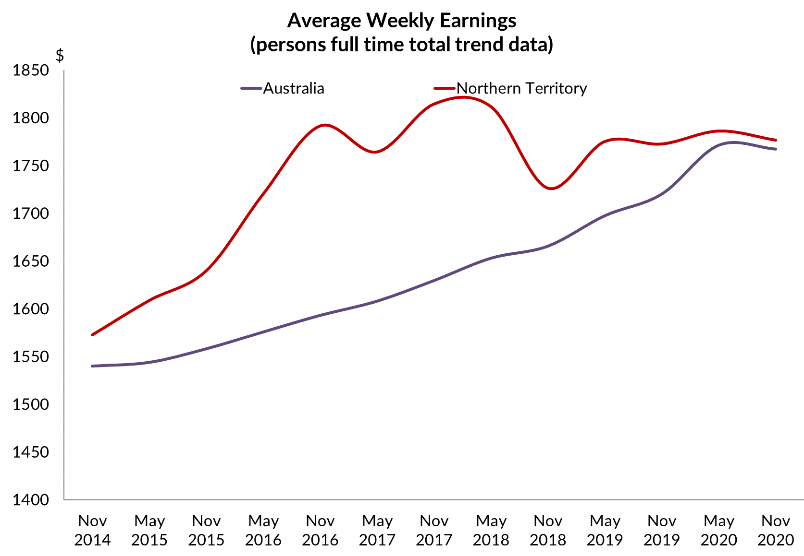

*Source: ABS Cat. No. 6302*

**Chart 19: Wage Price Index, all sectors**

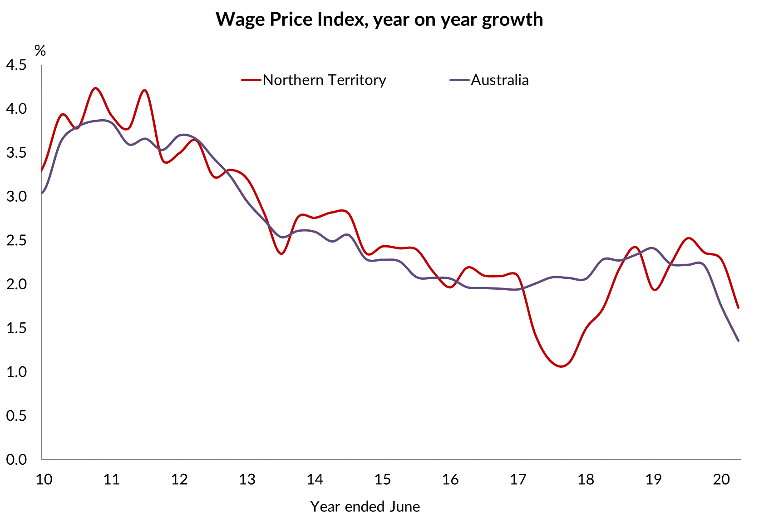

*Source: ABS Cat. No. 6345.0*

# Business confidence

The Department of Industry, Tourism and Trade (DITT) conducts its own quarterly business confidence survey with a significantly higher sample size than the Sensis® Business Index (SBI), and includes results by region and industry.

In the December 2020 DITT quarterly survey, business confidence was +67%, with confidence by region ranging from +100% in Barkly-Tennant Creek to +43% in Alice Springs. Business confidence is at a record high, after touching a record low in the June quarter 2020 (Chart 20).

Overall 37% of businesses report business performance is better this year compared to the previous year. Over the past six months, the proportion of businesses reporting better business conditions has been trending up, while the proportion of businesses reporting worse business conditions has been trending downwards (Chart 21).

In the December quarter 2020, key reasons for businesses feeling confident include strong customer relations, strong market position, and business opportunities. Key reasons why businesses were worried included a decrease in business/sales, a weak local economy, and increasing business costs.

*Note: The SBI does not adequately assess the business confidence levels in the Territory due to a small and unrepresentative sample size (approximately 20 survey responses for over 14 000 businesses in the December quarter 2020). In 2019, SBI incorporated changes to its survey methodology, largely reflecting the transition to online surveys from telephone-based interviews, and publication design. Sensis noted that the methodology change would result in a quicker turnaround time.*

**Chart 20: NT Business Confidence**

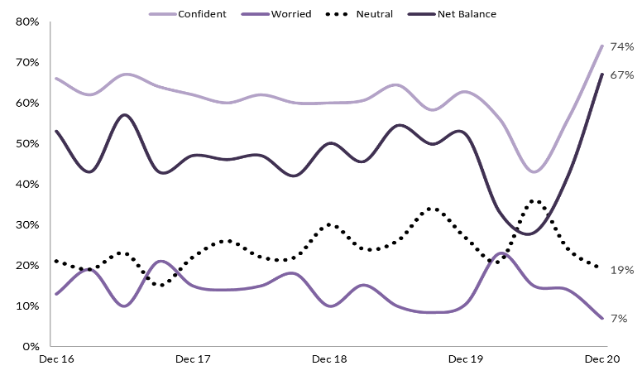

*Source: DITT Business Confidence Survey*

**Chart 21: NT Business Performance**

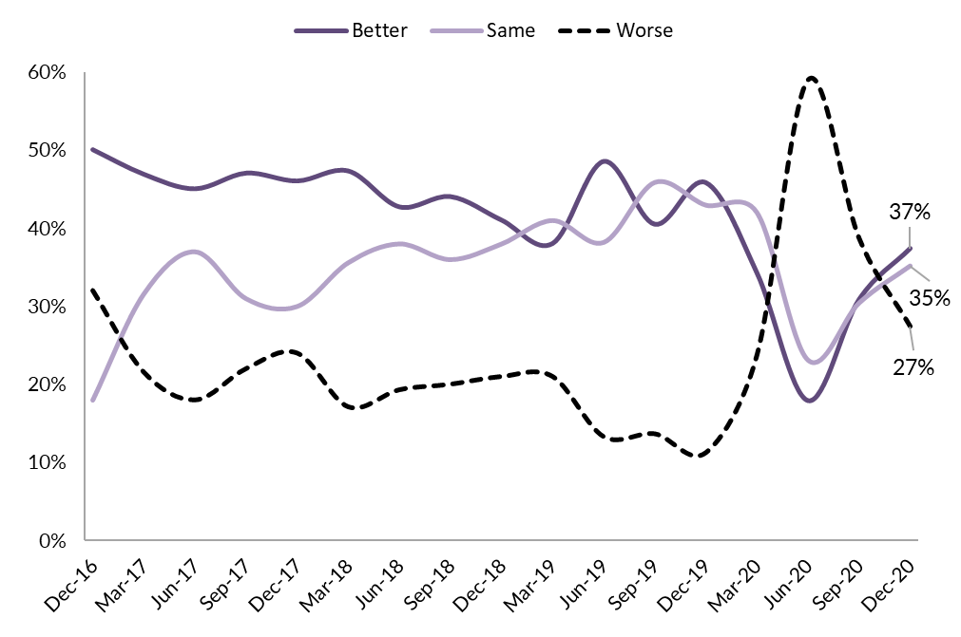

*Source: DITT Business Confidence Survey*

# Count of NT businesses

The Northern Territory (NT) had 15 072 actively trading businesses at June 2020, comprising 0.62% of total actively trading businesses in Australia. In June 2019 there were 14 769 businesses operating (Chart 22).

The highest number of operating businesses was in New South Wales followed by Victoria, Queensland, Western Australia, South Australia, Tasmania, the Australian Capital Territory and the NT.

In 2019-20, the entry rate for businesses in the NT was 14.9%, slightly higher than the national average of 14.5%. In 2019-20, the exit rate for NT was 12.4%, lower than the entry rate and resulting in an increase in the number of overall businesses. Nationally, the exit rate was 12.5%.

In June 2016, the NT had 14 289 operating businesses and of these 87.3% were still operating in June 2017, 77.3% survived to June 2018, 70.3% were still operating in June 2019 and 64.6% survived to June 2020. Similarly, at the national level, 65.1% of the businesses operating in June 2016 survived to June 2020.

Australian Bureau of Statistics (ABS) defines business size by level of employment as follows:

* Small business: 0-19 employees
* Medium business: 20-199 employees
* Large business: 200+ employees.

The majority of actively trading businesses in the NT are small. In June 2020, 95.9% were small businesses, 3.7% were medium businesses and 0.3% were large businesses. Nationally, 97.5% of the businesses were small.

**Chart 22: Number and Growth of NT Businesses**

The number of actively trading businesses in the Northern Territory increased in 
2019-20 to 15072 , 2018-19 equals to 14776, 2017-18 equalsto 14479, and 2016-17 equals to 14442

*Source: ABS Cat. No. 8165.0*

**Chart 23: NT Business size, June 2020**

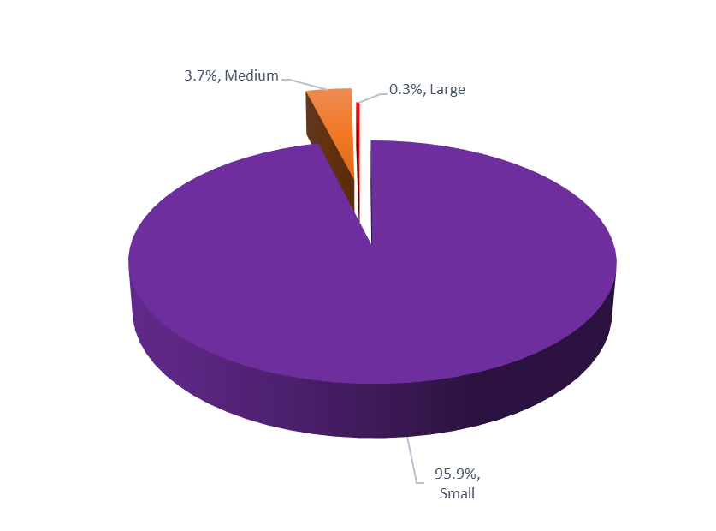

*Source: ABS Cat. No. 8165.0*

Of the small businesses in the NT, 63.2% were non-employing businesses, 23.3% had 1-4 employees and 13.5% had between 5-19 employees

In June 2020, the ‘Construction” industry had the highest number of businesses operating in the NT with 18.8% of total businesses.

This was followed by ‘Rental, Hiring and Real Estate Services’ (12.6%); ‘Professional, Scientific and Technical Services’ (9.6%); ‘Transport, Postal and Warehousing’ (8.8%); ‘Retail Trade’ (6.2%) and ‘Finance and Insurance Services’ (6.1%). (Chart 24).

The majority of businesses in the NT are in the ‘services sector’ (all industries except ‘Agriculture, Forestry and Fishing’; ‘Mining’; ‘Manufacturing’; ‘Electricity, water, gas and waste services’; and ‘Construction’).

In June 2020, the ‘services sector’ had 71.5% of all NT businesses.

At the national level, ‘Construction’ industry had the highest number of businesses (16.4%) followed by ‘Professional, Scientific and Technical Services’ (12.5%), ‘Rental, Hiring and Real Estate Services’ (10.9%), and ‘Financial & Insurance Services (9.0%).

The majority of the businesses in the Territory are located in the Greater Darwin region (Darwin City, Darwin Suburbs, Litchfield and Palmerston).

In June 2020, 74.1% of all businesses in the NT were located in the Greater Darwin region. The Alice Springs region had the second highest number of businesses (14.0%), the Katherine region had 6.4%, Daly-Tiwi-West Arnhem had 2.4%, East Arnhem had 1.7%, and the Barkly region had 1.3%. Business locations of about 1.0% of the businesses were ‘currently unknown’.

**Chart 24: NT Business by Industry, June 2020**

In 2019-20, proportion of businesses by industry to total businesses in the Northern Territory is as follows:
Construction is 18.8 per cent
Rental, hiring and real estate services is 12.6 per cent
Professional, scientific and technical services is 9.6 per cent
Transport, postal and warehousing is 8.8 per cent
Retail trade is 6.2 per cent
Financial and insurance services is 6.1 per cent
Agriculture, forestry and fishing is 6 per cent
Other services is 5.9 per cent
Health care and social assistance is 5.7 per cent
Accommodation and food services is 5.1 per cent
Administrative and support services is 5 per cent
Manufacturing is 3.1 per cent
Wholesale trade is 2.1 per cent
Education and training is 1.3 per cent
Arts and recreation services is 1.4 per cent
Education and Training is 1.2 per cent
Information, media and telecommunications is 0.7 per cent
Mining is 0.6 per cent
Public administration and safety is 0.4 per cent 
Electricity, gas, water, and waste services is 0.3 per cent


*Source: ABS Cat. No. 8165.0*

**Chart 25: Business Location, June 2020**

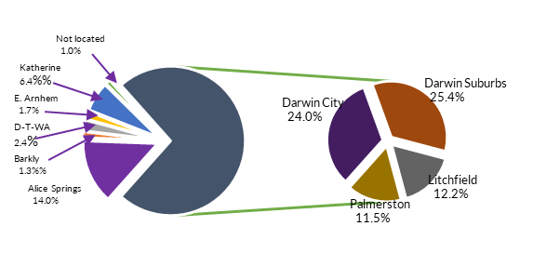

*Source: ABS Cat. No. 8165.0*

At June 2020, the NT had 25.2% of businesses operating in the ‘zero to <$50k’ turnover range. About 12.8% of the businesses were operating in the ‘$50k to <$100k’ range, 17.6% in the ‘$100k to <$200k’ range, 18.5% were in the ‘$200k to <$500k’ range, 17.0% in the ‘$500k to <$2m’ range, 5.4% in the ‘$2m to <$5m range, 1.8% in the $5m to <$10m range, and 1.7% in the $10m+ range.

# Key industry sectors

The structure of the NT economy is different to the national economy with greater contributions to production in the NT from Construction, Mining, Public administration and safety, Education and training, and Health care and social assistance industries.

These five sectors together make up 58.0% of the total of industry sector contributions to the NT’s GSP in 2019-20 with the combined value of their contribution to the NT economy being about $15.1 billion.

| **Industry** **sector** | **Value Added 2019-20** | **Proportion of NT GSP** |
| --- | --- | --- |
| Mining | $7.5 billion | 28.8% |
| Public Administration and Safety | $3.0 billion | 11.7% |
| Heath Care & Social Assistance | $1.9 billion | 7.5% |
| Construction | $1.4 billion | 5.6% |
| Education and training | $1.1 billion | 4.5% |

**Chart 26: Sector Contribution to Output, NT and Australia 2019-20**

In 2019-20, gross state product contribution by industry is as follows:
Construction is 5.6 per cent in the Northern Territory and 7.0 per cent nationally
Mining is 28.8 per cent in the Northern Territory and 10.4 per cent nationally
Public administration and safety is 11.7 per cent in the Northern Territory and 8.6 per cent nationally
Health care and social assistance is 7.5 per cent in the Northern Territory and 7.4 per cent nationally
Transport, postal and warehousing is 2.9 per cent in the Northern Territory and 4.8 per cent nationally
Rental, hiring and real estate services is 1.4 per cent in the Northern Territory and 2.0 per cent nationally
Education and training is 4.5 per cent in the Northern Territory and 7.0 per cent nationally
Professional, scientific and technical services is 3.7 per cent in the Northern Territory and 5.5 per cent nationally
Manufacturing is 3.8 per cent in the Northern Territory and 5.6 per cent nationally
Retail trade is 2.6 per cent in the Northern Territory and 4.3 per cent nationally
Administrative and support services is 1.7 per cent in the Northern Territory and 2.4 per cent nationally
Financial and insurance services is 2.4 per cent in the Northern Territory and 3.6 per cent nationally
Electricity, gas, water, and waste services is 1.8 per cent in the Northern Territory and 2.8 per cent nationally
Agriculture, forestry and fishing is 2.5 per cent in the Northern Territory and 4.0 per cent nationally
Accommodation and food services is 2.2 per cent in the Northern Territory and 3.6 per cent nationally
Wholesale trade is 1.6 per cent in the Northern Territory and 2.0 per cent nationally
Other services is 1.6 per cent in the Northern Territory and 2.2 per cent nationally
Arts and recreation services is 1.1 per cent in the Northern Territory and 1.7 per cent nationally
Information, media and telecommunications is 0.4 per cent in the Northern Territory and 0.8 per cent nationally


*Source: ABS; Cat. No. 5220.0*

# Mining and energy sector

Mining and energy sector contributed $7. 5 billion (gross value-added) or 28.8% to NT GVA in 2019-20 (Chart 29).

The main minerals produced and processed in the NT are bauxite, gold, manganese and zinc/lead concentrate. Key energy commodities are oil, natural gas, uranium, and the production of LNG.

Although the sector is the largest contributor to NT GSP it employs around 2.0% of the resident employment, as it is capital intensive and a portion of its FIFO workers are residents of other jurisdictions.

The value of Mining and energy increased strongly in 2019-20 as LNG production commenced at INPEX’s LNG plant.

**Chart 29: Mining, GVA, Inflation Adjusted**

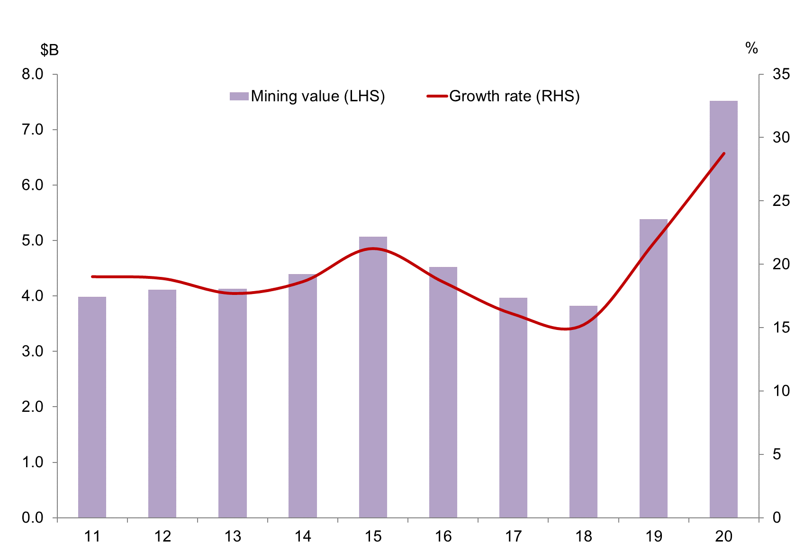

*Source: ABS Cat. No. 5220.0*

# Construction sector

In 2019-20, the Construction sector contributed $1.4 billion to NT GSP, with an industry share of total output of 5.6%. The construction industry accounts for 8.0% of the NT’s resident employment.

The value of the Construction sector is now below historical levels largely due to the completion of major construction projects such as INPEX LNG gas project.

In 2020, construction work done decreased by 0.9% to $2.1 billion. Engineering work done decreased by 6.9% to $1.2 billion, residential construction increased by 2.9% to $335 million and non‑residential construction increased by 14.2% to $497 million (Chart 27).

Over the next few years, growth is forecast to remain subdued with the completion of the construction phase of some resource projects.

**Chart 27: NT Construction Activity December 2020**

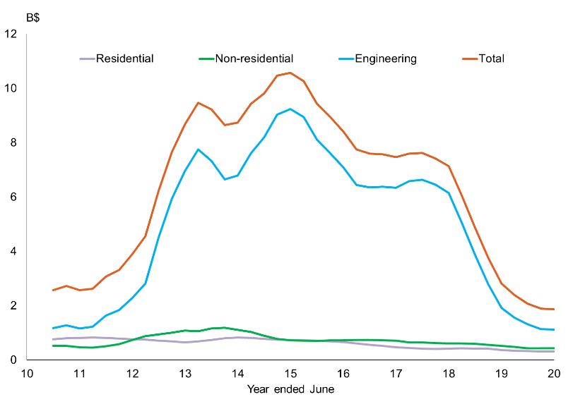

*Source: ABS Cat. No. 8755.0*

**Chart 28: Construction, GVA, Inflation Adjusted**

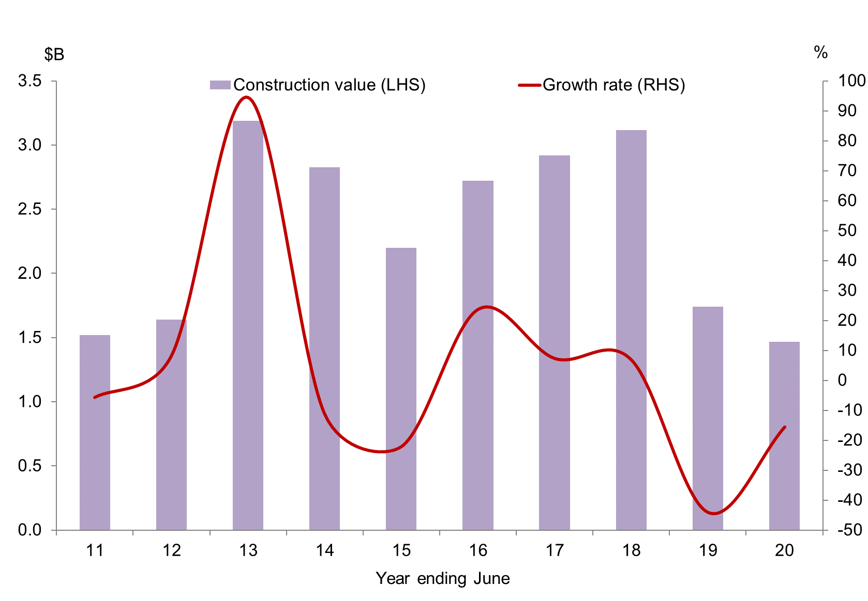

*Source: ABS Cat. No. 5220.0*

# Manufacturing sector

In 2019-20, the Manufacturing sector accounted for 3.8% of the NT’s GSP (Chart 30).

Manufacturing in the NT consists mainly of small scale production of various products for export and domestic consumption.

This sector employs around 3600 people, 2.8% of the NT’s total resident employment in the year to February 2021.

**Chart 30: Manufacturing, GVA, Inflation Adjusted**

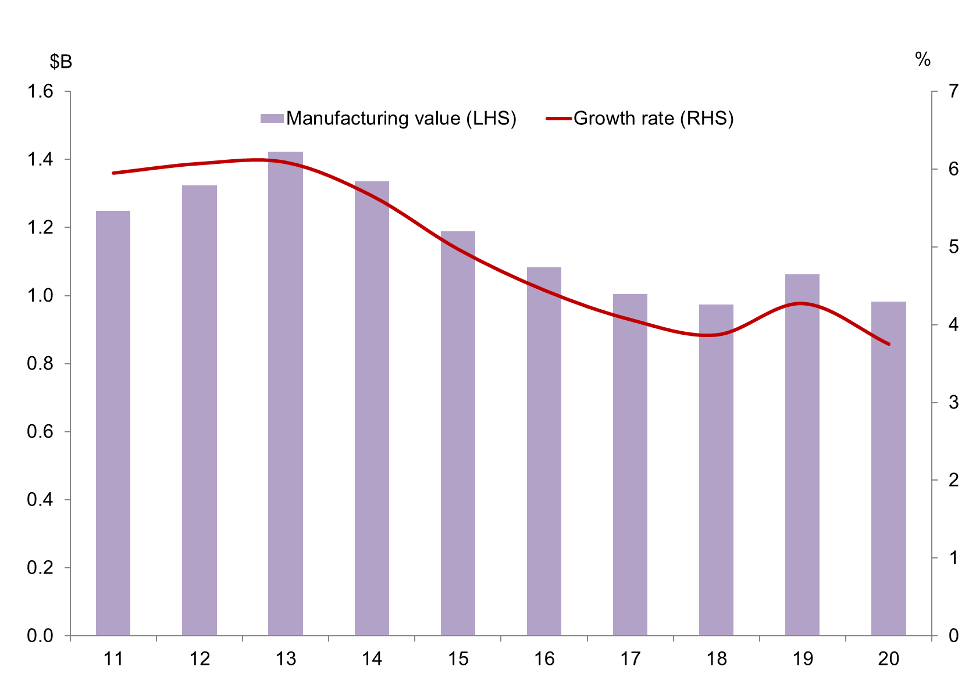

*Source: ABS Cat. No. 5220.0*

# Retail sector

The Retail trade sector value (gross value added) decreased by 0.9% in 2019-20 to $690 million. The sector contributes around 2.6% to NT GSP and 9.0% to total NT resident employment in the year to November 2020 (Chart 31).

Nationally, retail turnover in 2019-20 contributed about 4.1% of the national GDP and the sector fell by 0.5% in the same period.

The retail turnover (sales) in the NT in the year to January 2021 was $3.4 billion, a year on year increase of 11.0%.

Food retailing is the largest single component contributing 5.4 percentage points to total NT growth in the year, followed by Other retailing (11.9 percentage points), and Electrical and electronic goods retailing (1.7 percentage points).

**Chart 31: Retail trade, GVA, inflation adjusted**

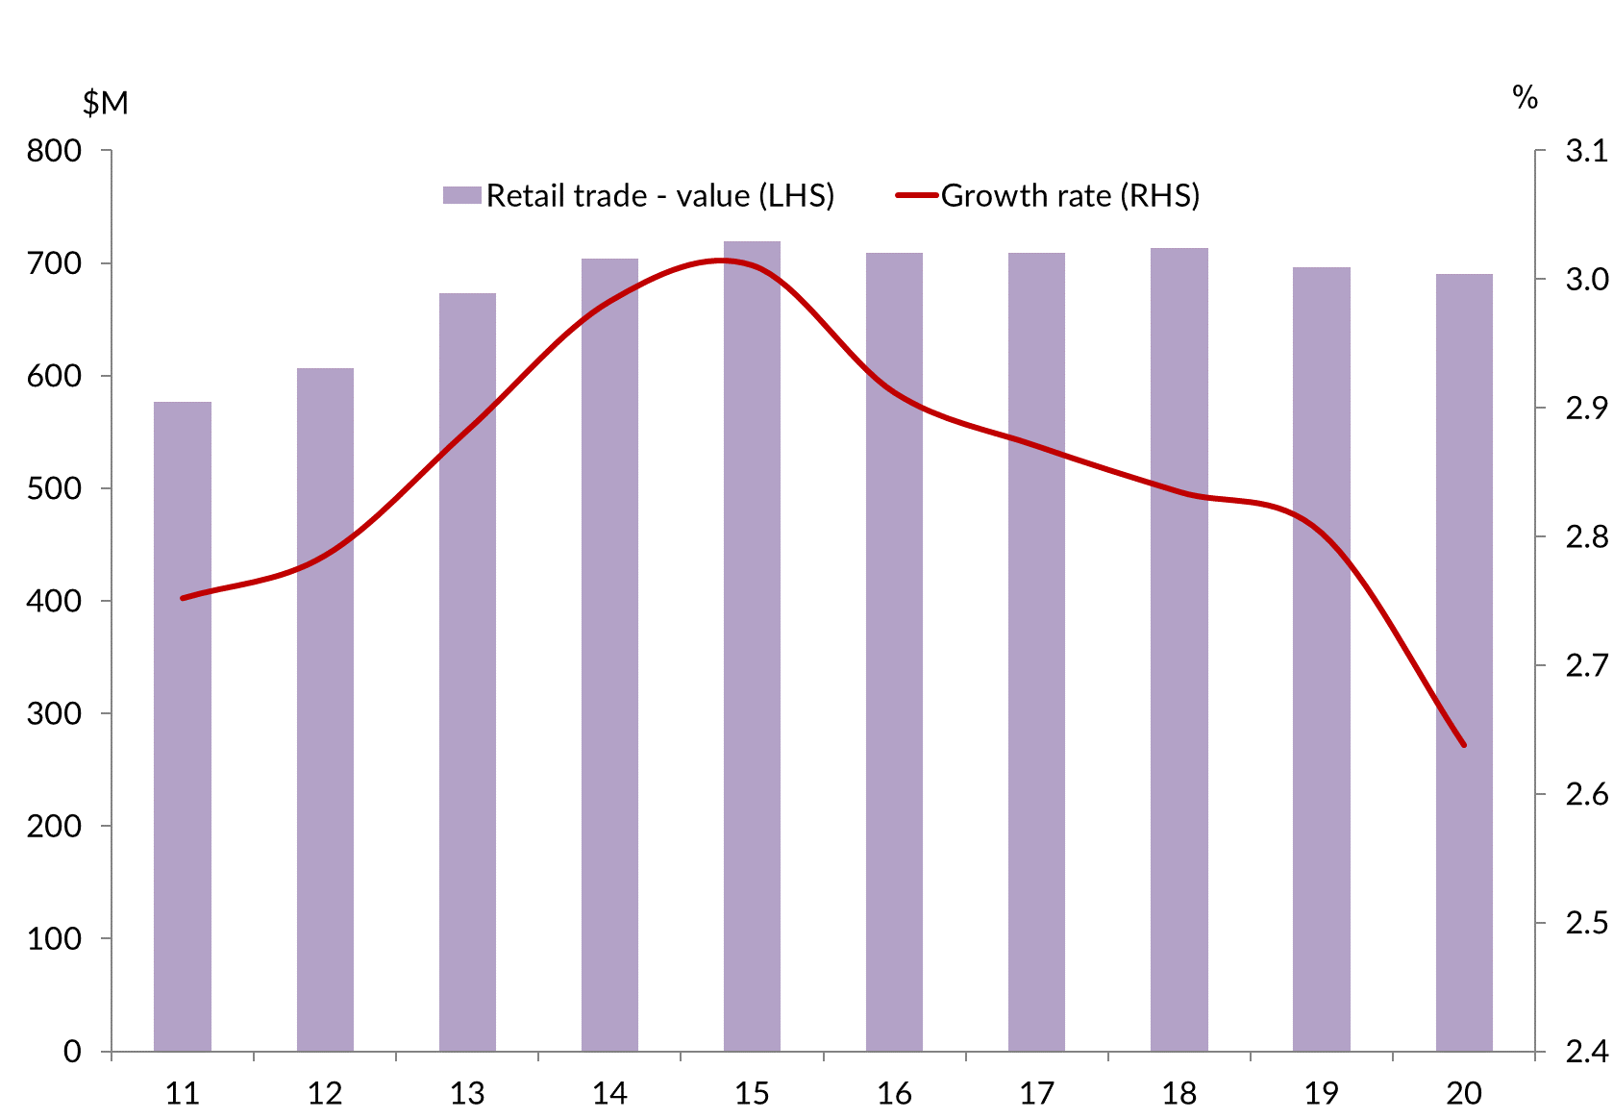

*Source: ABS Cat. No. 5220.0*

The growth in NT retail turnover is expected to be subdued in the short term, largely reflecting softening population growth in the NT.

The Wholesale trade sector contributed $422 million or about 1.6% of the NT GSP.

# Agriculture, forestry and fishing

Key agricultural commodities include livestock, horticulture produce and fisheries.

The key livestock commodities of the NT include cattle, buffaloes and crocodiles. In the horticultural sector, the main commodities include fruit (mangos, melons, and bananas), Asian vegetables, and plant nursery products. The fishing sector includes commercial, recreational and traditional indigenous fishing. The commercial fishing sector includes wild catch fish (such as barramundi, snapper, and shark), crustaceans (mainly prawns and mud crabs) and aquaculture (pearls). Forestry includes sandalwood and African Mahogany production.

Agriculture, fishing and forestry contributed $649 million (inflation adjusted), about 2.5% to the value of NT GSP in 2019-20 (Chart 32).

Cattle production is the largest component of agriculture, forestry and fishing. The key markets for NT cattle are interstate markets (for further growing or slaughter) and live exports overseas (mainly Indonesia). In the short term, the value of this industry is expected to increase, driven by growth in the value of live cattle exports under the free trade agreement signed in March 2019 between Australia and Indonesia. This will be partly offset by competition from Indian buffalo meat and disruptions in the cattle supply chain from severe Queensland floods.

Horticultural production is expected to improve with favourable outlooks for barramundi and prawn production, and recovering production of bananas and melons. The horticultural products are mainly destined for interstate markets.

Fisheries production in the NT has strong potential in the coming years with the expansion of aquaculture production, e.g. Seafarms’ $1.45 billion Sea Dragon Project.

**Chart 32: Agriculture, Forestry and Fishing: NT GVA, Inflation Adjusted**

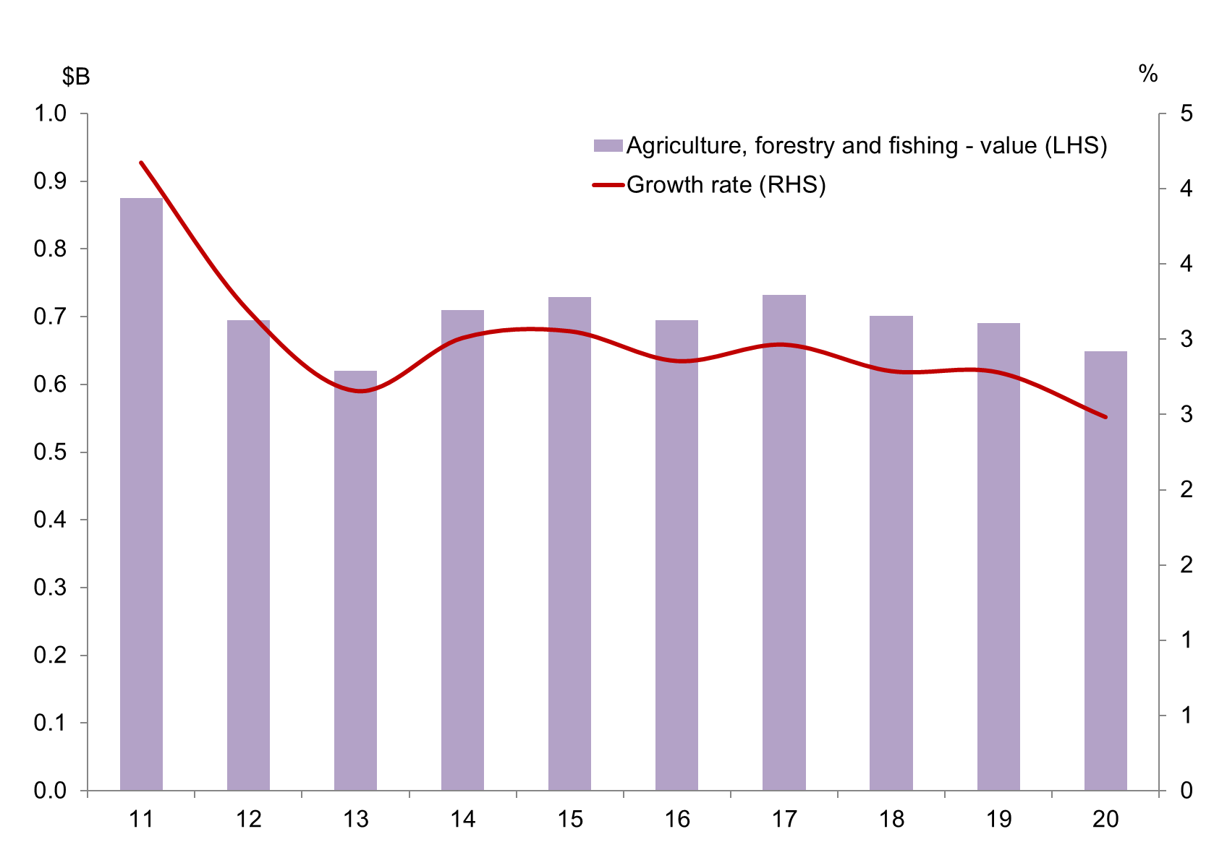

*Source: ABS Cat. No. 5220.0*

# Tourism

The Tourism sector is distributed across a number of Australian and New Zealand Standard Industrial Classification (ANZSIC) industry sectors. The largest industry sectors that directly contribute to tourism gross value added (GVA) in the NT include Accommodation and food services; Transport, postal and warehousing, and Recreation and culture.

In the year to September 2020, visitor expenditure in the NT was $1.2 billion (Tourism NT).

Over the same period, 1.19 million people visited the NT, down 39% on the previous year’s visitor numbers.

Tourism employs around 11.8% of the NT employment.

**Chart 33: Share of Tourism in Gross Value Added, 2018-19**

In 2018-19, tourism share of gross value added in the Northern Territory is second highest in the nation behind Tasmania. Western Australia had the lowest share of gross value added and gross state product in 2018-19.

*Source: Tourism Research Australia, 2018-19*

# Goods-producing and service-producing sectors

In categorising goods and services, dwelling growth is excluded.

The GVA of goods-producing sectors (Agriculture, forestry and fishing, Mining, Manufacturing, Electricity, gas and water, Construction) was $11.09 billion in 2019‑20, about 48.3% of all industries.

Service producing sectors’ output (“things you cannot drop on your foot”) was valued at $11.9 billion, contributing 51.7% of all industries NT GSP (ownership of dwellings is excluded from the service-producing sectors).

Business services (those industries that provide non-distribution services to other companies) have grown strongly since 2011 and contributed $2.5 billion (9.7%) of NT GSP in 2019-20. Since 2012, business services have grown, on average, by 1.6%. There are however, variations in growth in individual business service sectors (Chart 34).

**Chart 34: Business Services Output**

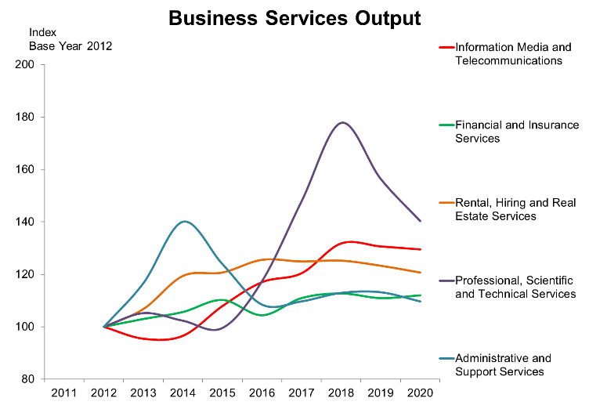

*Source: ABS Cat. No. 5220.0*

# Regional labour markets, population and income

| **Region1** | **Labour force Sept Qtr 2020** | **Unemployment Sept Qtr 2020** | **Unemployment rate (%) Sept Qtr 2020** | **Population 2019-20** | **Median weekly household income 2016 ($)1** |
| --- | --- | --- | --- | --- | --- |
| Greater Darwin | 83,346 | 4,966 | 6.6 | 147,231 | 2,1832 |
| Darwin city | 18,491 | 831 | 4.8 | 27,542 | 2,320 |
| Darwin suburbs | 31,908 | 2,072 | 7.3 | 55,508 | 2,075 |
| Litchfield | 14,643 | 548 | 4.0 | 25,164 | 2,219 |
| Palmerston | 18,304 | 1515 | 10.1 | 39,017 | 2,199 |
| Alice Springs | 17,748 | 776 | 4.5 | 39,391 | 1,715 |
| Barkly | 2,943 | 196 | 6.7 | 6,142 | 1,366 |
| Daly-Tiwi-West Arnhem | 7,567 | 608 | 9.1 | 17,909 | 1,134 |
| East Arnhem | 6,225 | 409 | 6.4 | 14,565 | 1,944 |
| Katherine | 10,812 | 544 | 7.2 | 20,905 | 1,485 |

*Source: ABS Cat. No. 3218.0, Commonwealth Department of Employment (Small Area Labour Market* *December Quarter 2020), and Census 2016 on Population and Housing*

1. Statistical Area Level 3 (SA3)

# Enquiries

Economic Analysis and Advice, Department of Industry, Tourism and Trade

Email: Economicinnovation.ITT@nt.gov.au

# Disclaimer

The Northern Territory of Australia gives no warranty of assurance, and makes no representation as to the accuracy of any information or advice contained in this publication, or that it is suitable for your intended use. You should not rely upon information in this publication for the purpose of making any serious business or investment decisions without obtaining independent, professional advice in relation to your particular situation.