Mineral Titles Act
NOTICE OF GRANT OF A MINERAL TITLE
Title Type and Number: | Extractive Mineral Exploration Licence 32564
Granted: | 15 March 2021, for a period of 2 Years
Area: | 4 Blocks, 10.50 km²
Locality: | MANBULLOO
Name of Holder/s: | 100% WARRIJA CONSTRUCTION AND CIVIL PTY. LTD. [ACN. 616 177 845]
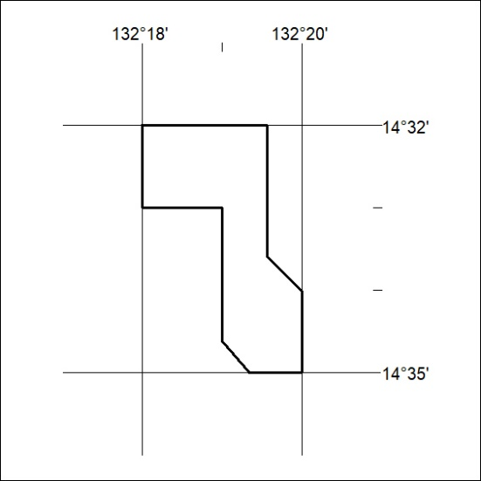
Area granted is indicated above. The titleholder is not permitted to exercise occupational rights on any land that is subject to a development title, or an application for a development title. Any land the subject of a Reserved Land gazettal under the Mineral Titles Act and all land vested in the Commonwealth of Australia is also excluded by description but not excised from the grant area.

48/21

