Mineral Titles Act 2010
NOTICE OF LAND CEASING TO BE A MINERAL TITLE AREA
Title Type and Number: | Exploration Licence 31941
Area Ceased on: | 22 February 2021
Area: | 17 Blocks, 56.69 km²
Locality: | MARUMBA
Name of Applicant(s)/Holder(s): | 100% SCRIVEN EXPLORATION PTY LTD [ACN. 006 264 615]
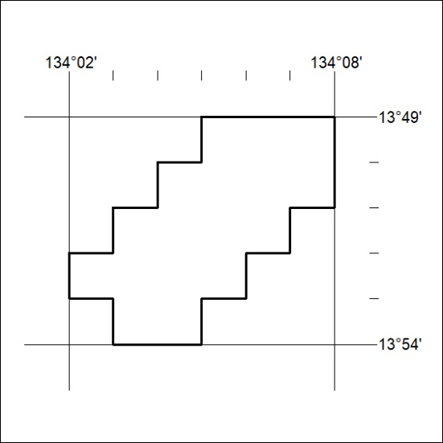

37/21

