Mineral Titles Act 2010
NOTICE OF LAND CEASING TO BE A MINERAL TITLE AREA
Title Type and Number: | Exploration Licence 29787
Area Ceased on: | 17 February 2021
Area: | 34 Blocks, 107.56 km²
Locality: | MT WEDGE
Name of Applicant(s)/Holder(s): | 100% PIPER PRESTON PTY LTD [ACN. 142 962 409]
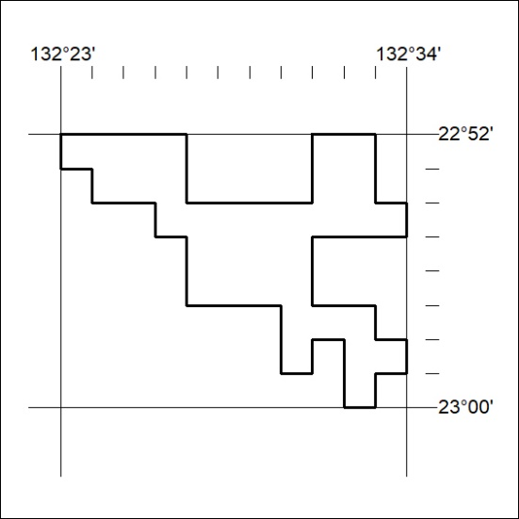

36/21

Mineral Titles Act 2010
NOTICE OF LAND CEASING TO BE A MINERAL TITLE AREA
Title Type and Number: | Exploration Licence 29903
Area Ceased on: | 17 February 2021
Area: | 15 Blocks, 47.48 km²
Locality: | MT WEDGE
Name of Applicant(s)/Holder(s): | 100% PIPER PRESTON PTY LTD [ACN. 142 962 409]
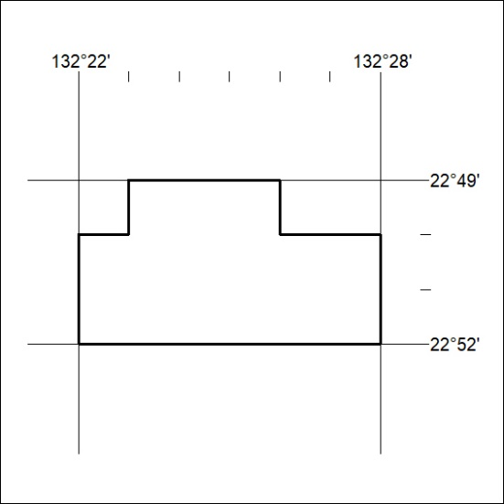

37/21

