Mineral Titles Act
NOTICE OF GRANT OF A MINERAL TITLE
Title Type and Number: | Extractive Mineral Permit 31266
Granted: | 04 January 2021, for a period of 5 Years
Area: | 10.00 Hectares
Locality: | NOONAMAH
Name of Holder/s: | 100% ALDEBARAN CONTRACTING PTY LTD [ACN. 128 020 299]
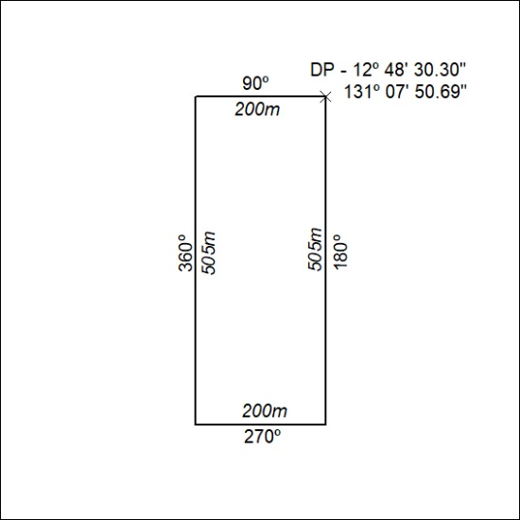

06/21

Mineral Titles Act
NOTICE OF GRANT OF A MINERAL TITLE
Title Type and Number: | Extractive Mineral Permit 31267
Granted: | 04 January 2021, for a period of 5 Years
Area: | 38.00 Hectares
Locality: | NOONAMAH
Name of Holder/s: | 100% ALDEBARAN CONTRACTING PTY LTD [ACN. 128 020 299]
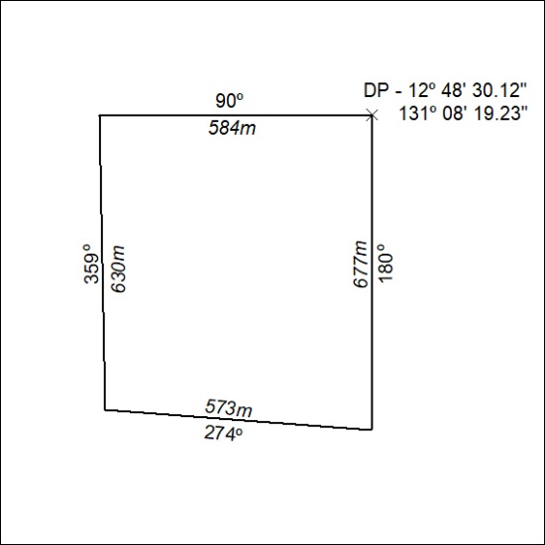

07/21

Mineral Titles Act
NOTICE OF GRANT OF A MINERAL TITLE
Title Type and Number: | Extractive Mineral Permit 31611
Granted: | 04 January 2021, for a period of 5 Years
Area: | 82.00 Hectares
Locality: | NOONAMAH
Name of Holder/s: | 100% ALDEBARAN CONTRACTING PTY LTD [ACN. 128 020 299]
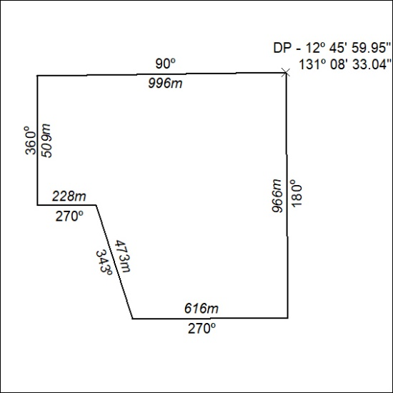

08/21

Mineral Titles Act
NOTICE OF GRANT OF A MINERAL TITLE
Title Type and Number: | Extractive Mineral Permit 31612
Granted: | 04 January 2021, for a period of 5 Years
Area: | 68.00 Hectares
Locality: | NOONAMAH
Name of Holder/s: | 100% ALDEBARAN CONTRACTING PTY LTD [ACN. 128 020 299]
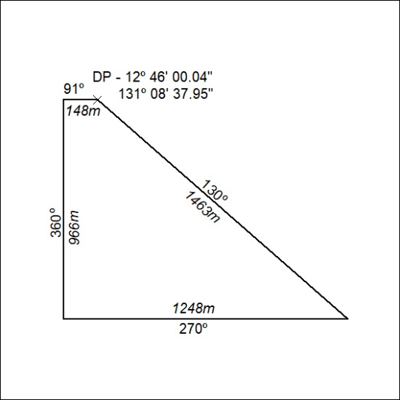

09/21

Mineral Titles Act
NOTICE OF GRANT OF A MINERAL TITLE
Title Type and Number: | Extractive Mineral Permit 31613
Granted: | 04 January 2021, for a period of 5 Years
Area: | 93.00 Hectares
Locality: | NOONAMAH
Name of Holder/s: | 100% ALDEBARAN CONTRACTING PTY LTD [ACN. 128 020 299]
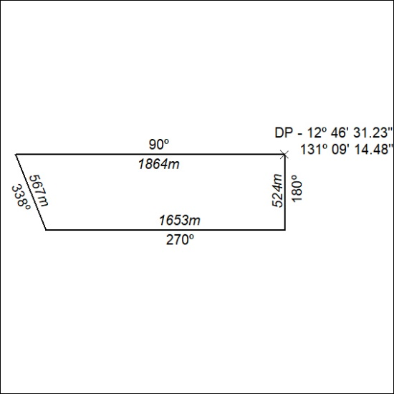

10/21

