Mineral Titles Act 2010
NOTICE OF LAND CEASING TO BE A MINERAL TITLE APPLICATION AREA
Title Type and Number: | Exploration Licence 31638
Area Ceased on: | 04 January 2021
Area: | 250 Blocks, 805.51 km²
Locality: | CHALUBA
Name of Applicant(s)/Holder(s): | 100% CERBERUS RESOURCES PTY LTD [ACN. 615 192 535]
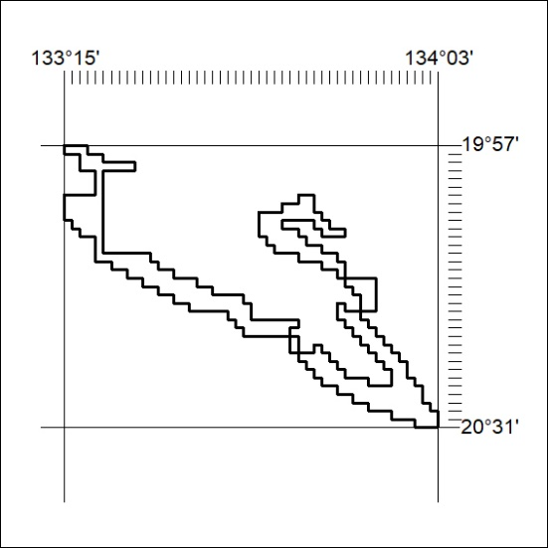

01/21

Mineral Titles Act 2010
NOTICE OF LAND CEASING TO BE A MINERAL TITLE APPLICATION AREA
Title Type and Number: | Exploration Licence 31639
Area Ceased on: | 04 January 2021
Area: | 250 Blocks, 807.79 km²
Locality: | BILLIATT
Name of Applicant(s)/Holder(s): | 100% CERBERUS RESOURCES PTY LTD [ACN. 615 192 535]
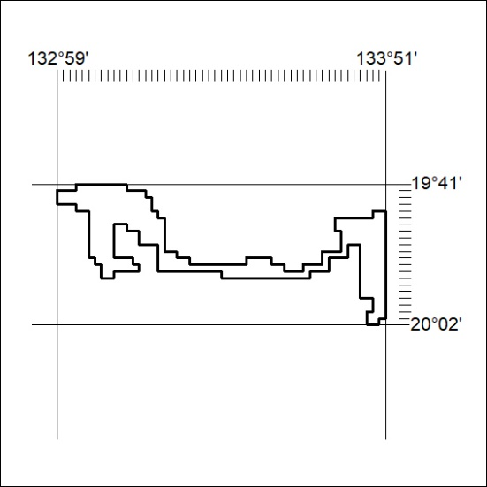

02/21

Mineral Titles Act 2010
NOTICE OF LAND CEASING TO BE A MINERAL TITLE AREA
Title Type and Number: | Mineral Lease (Central) 647
Area ceased on: | 31 December 2020
Area: | 7.00 Hectare
Locality: | OORADIDGEE
Name of Applicants(s)Holder(s): | 100% TODD RIVER METALS PTY LTD [ACN. 600 314 038]
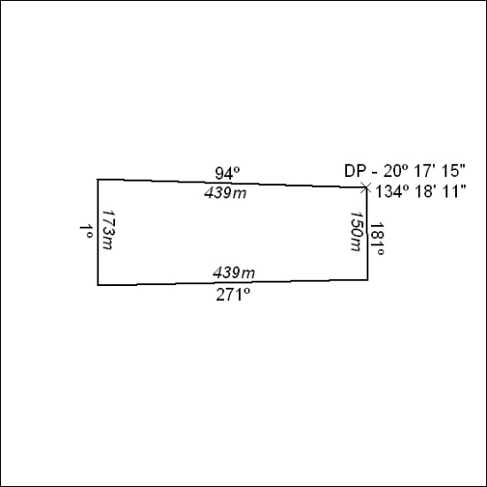

03/21

Mineral Titles Act
NOTICE OF GRANT OF A MINERAL TITLE
Title Type and Number: | Extractive Mineral Exploration Licence 32502
Granted: | 29 December 2020, for a period of 2 Years
Area: | 4 Blocks, 13.36 km²
Locality: | McKINLAY RIVER
Name of Holder/s: | 100% ACACIA ENTERPRISES (NT) PTY LTD [ACN. 158 649 864]
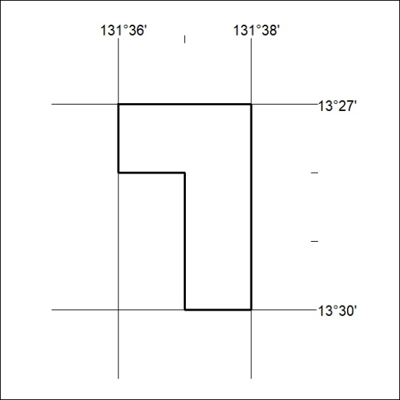
Area granted is indicated above. The titleholder is not permitted to exercise occupational rights on any land that is subject to a development title, or an application for a development title. Any land the subject of a Reserved Land gazettal under the Mineral Titles Act and all land vested in the Commonwealth of Australia is also excluded by description but not excised from the grant area.

04/21

Mineral Titles Act
NOTICE OF GRANT OF A MINERAL TITLE
Title Type and Number: | Extractive Mineral Exploration Licence 32503
Granted: | 29 December 2020, for a period of 2 Years
Area: | 4 Blocks, 13.36 km²
Locality: | McKINLAY RIVER
Name of Holder/s: | 100% ACACIA ENTERPRISES (NT) PTY LTD [ACN. 158 649 864]
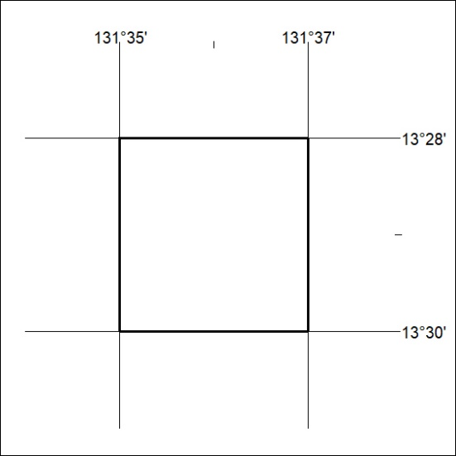
Area granted is indicated above. The titleholder is not permitted to exercise occupational rights on any land that is subject to a development title, or an application for a development title. Any land the subject of a Reserved Land gazettal under the Mineral Titles Act and all land vested in the Commonwealth of Australia is also excluded by description but not excised from the grant area.

05/21

