Mineral Titles Act 2010
NOTICE OF LAND CEASING TO BE A MINERAL TITLE APPLICATION AREA
Title Type and Number: | Extractive Mineral Exploration Licence 32377
Area Ceased on: | 21 December 2020
Area: | 4 Blocks, 13.35 km²
Locality: | PINE CREEK
Name of Applicant(s)/Holder(s): | 100% BRIDGE CREEK SAND MINING PTY LTD [ACN. 639 190 873]
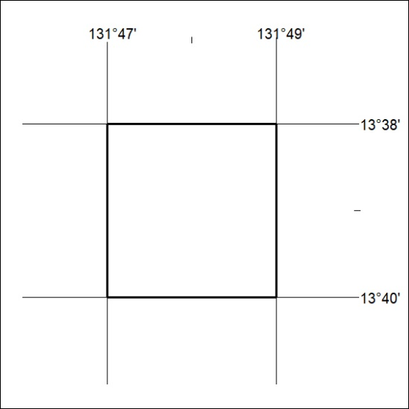

492/20

Mineral Titles Act 2010
NOTICE OF LAND CEASING TO BE A MINERAL TITLE APPLICATION AREA
Title Type and Number: | Extractive Mineral Exploration Licence 32378
Area Ceased on: | 21 December 2020
Area: | 4 Blocks, 13.35 km²
Locality: | PINE CREEK
Name of Applicant(s)/Holder(s): | 100% BRIDGE CREEK SAND MINING PTY LTD [ACN. 639 190 873]
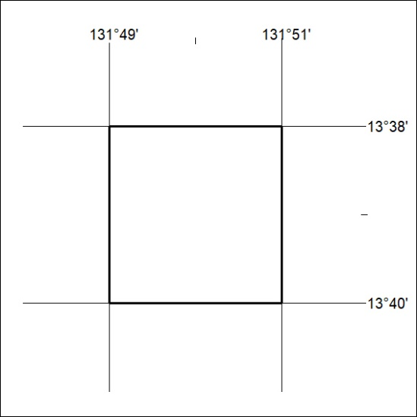

493/20
Mineral Titles Act 2010
NOTICE OF LAND CEASING TO BE A MINERAL TITLE APPLICATION AREA
Title Type and Number: | Extractive Mineral Exploration Licence 32379
Area Ceased on: | 21 December 2020
Area: | 4 Blocks, 13.35 km²
Locality: | PINE CREEK
Name of Applicant(s)/Holder(s): | 100% BRIDGE CREEK SAND MINING PTY LTD [ACN. 639 190 873]
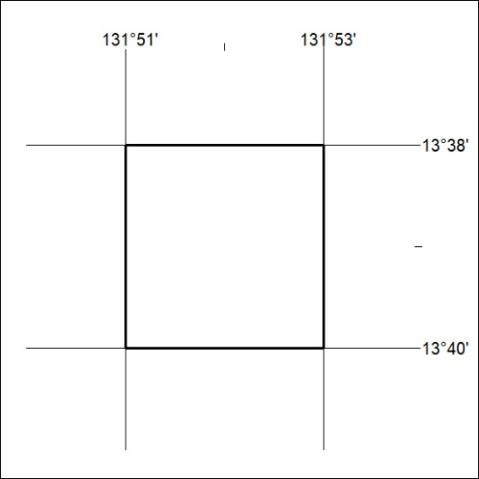

494/20

Mineral Titles Act 2010
NOTICE OF LAND CEASING TO BE A MINERAL TITLE APPLICATION AREA
Title Type and Number: | Extractive Mineral Exploration Licence 32380
Area Ceased on: | 21 December 2020
Area: | 4 Blocks, 13.35 km²
Locality: | PINE CREEK
Name of Applicant(s)/Holder(s): | 100% BRIDGE CREEK SAND MINING PTY LTD [ACN. 639 190 873]
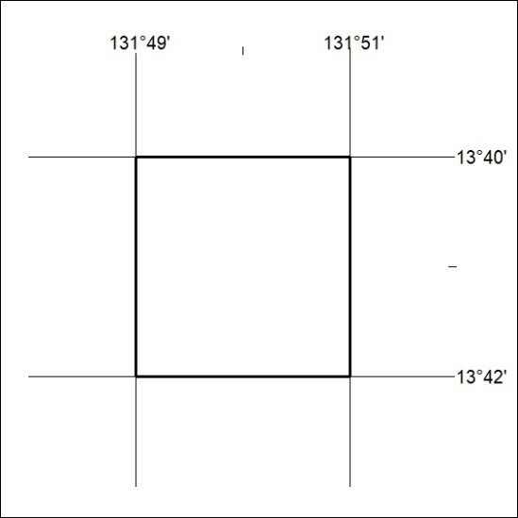

495/20
Mineral Titles Act 2010
NOTICE OF LAND CEASING TO BE A MINERAL TITLE APPLICATION AREA
Title Type and Number: | Extractive Mineral Exploration Licence 32381
Area Ceased on: | 21 December 2020
Area: | 4 Blocks, 13.35 km²
Locality: | PINE CREEK
Name of Applicant(s)/Holder(s): | 100% BRIDGE CREEK SAND MINING PTY LTD [ACN. 639 190 873]
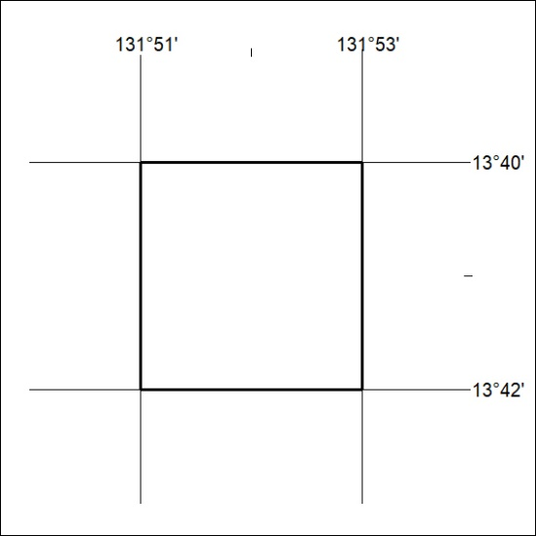

496/20

Mineral Titles Act
NOTICE OF GRANT OF A MINERAL TITLE
Title Type and Number: | Extractive Mineral Exploration Licence 32490
Granted: | 21 December 2020, for a period of 2 Years
Area: | 2 Blocks, 1.16 km²
Locality: | MARY RIVER
Name of Holder/s: | 50% ANICTOMATIS Ross, 50% OSTOJIC GROUP PTY LTD* [ACN. 009 629 805]
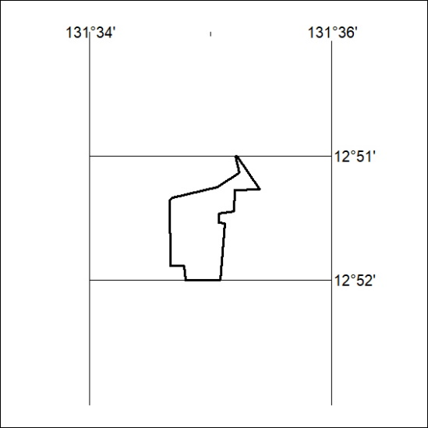
Area granted is indicated above. The titleholder is not permitted to exercise occupational rights on any land that is subject to a development title, or an application for a development title. Any land the subject of a Reserved Land gazettal under the Mineral Titles Act and all land vested in the Commonwealth of Australia is also excluded by description but not excised from the grant area.

497/20

Mineral Titles Act 2010
NOTICE OF LAND CEASING TO BE A MINERAL TITLE AREA
Title Type and Number: | Extractive Mineral Permit 30861
Area ceased on: | 22 December 2020
Area: | 26.00 Hectare
Locality: | NOONAMAH
Name of Applicants(s)Holder(s): | 100% OSTOJIC GROUP PTY LTD* [ACN. 009 629 805]
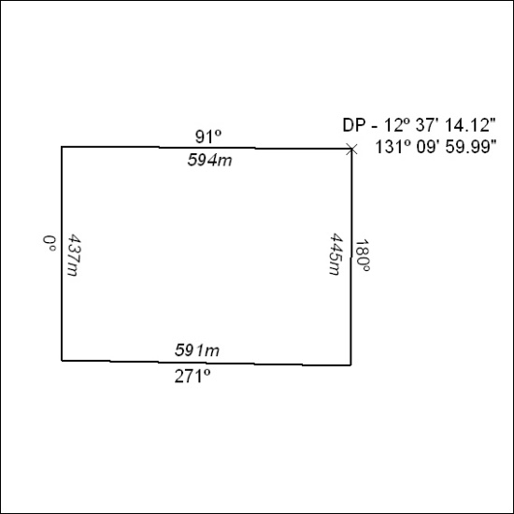

498/20

