Mineral Titles Act
NOTICE OF GRANT OF A MINERAL TITLE
Title Type and Number: | Exploration Licence 32281
Granted: | 23 September 2020, for a period of 6 Years
Area: | 16 Blocks, 27.82 km²
Locality: | GOSSE RIVER
Name of Holder/s: | 100% KNOX RESOURCES LIMITED [ACN. 623 480 286]
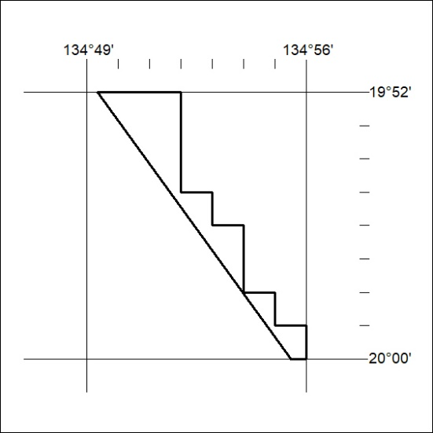
Area granted is indicated above. The titleholder is not permitted to exercise occupational rights on any land that is subject to a development title, or an application for a development title. Any land the subject of a Reserved Land gazettal under the Mineral Titles Act and all land vested in the Commonwealth of Australia is also excluded by description but not excised from the grant area.
320/20

Mineral Titles Act
NOTICE OF GRANT OF A MINERAL TITLE
Title Type and Number: | Exploration Licence 32282
Granted: | 23 September 2020, for a period of 6 Years
Area: | 250 Blocks, 808.69 km²
Locality: | GOSSE RIVER
Name of Holder/s: | 100% KNOX RESOURCES LIMITED [ACN. 623 480 286]
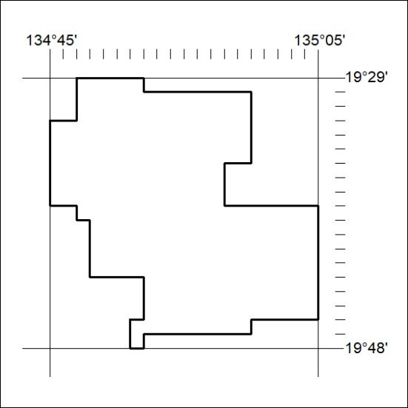
Area granted is indicated above. The titleholder is not permitted to exercise occupational rights on any land that is subject to a development title, or an application for a development title. Any land the subject of a Reserved Land gazettal under the Mineral Titles Act and all land vested in the Commonwealth of Australia is also excluded by description but not excised from the grant area.
321/20

Mineral Titles Act
NOTICE OF GRANT OF A MINERAL TITLE
Title Type and Number: | Exploration Licence 32283
Granted: | 23 September 2020, for a period of 6 Years
Area: | 128 Blocks, 402.26 km²
Locality: | FAVENC
Name of Holder/s: | 100% KNOX RESOURCES LIMITED [ACN. 623 480 286]
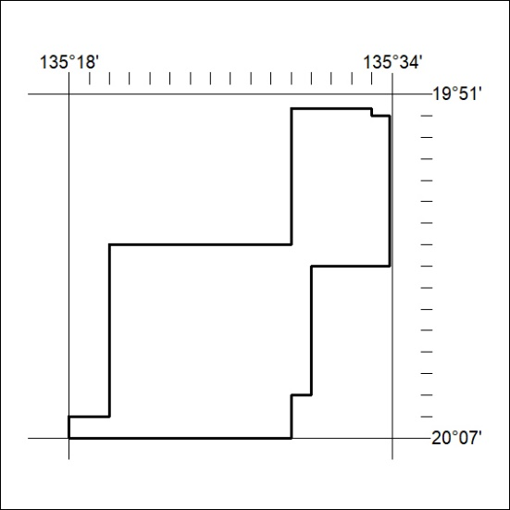
Area granted is indicated above. The titleholder is not permitted to exercise occupational rights on any land that is subject to a development title, or an application for a development title. Any land the subject of a Reserved Land gazettal under the Mineral Titles Act and all land vested in the Commonwealth of Australia is also excluded by description but not excised from the grant area.
322/20

Mineral Titles Act
NOTICE OF GRANT OF A MINERAL TITLE
Title Type and Number: | Exploration Licence 32285
Granted: | 23 September 2020, for a period of 6 Years
Area: | 225 Blocks, 728.48 km²
Locality: | LULU
Name of Holder/s: | 100% KNOX RESOURCES LIMITED [ACN. 623 480 286]
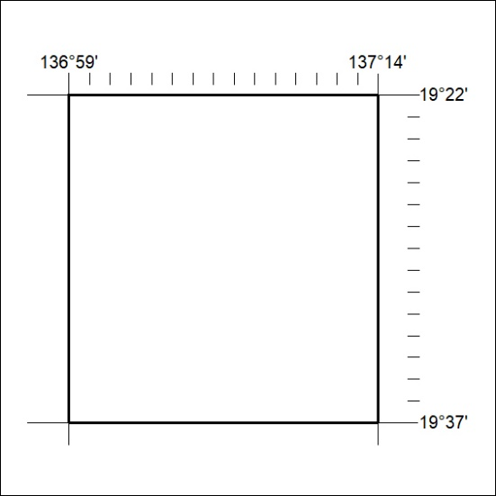
Area granted is indicated above. The titleholder is not permitted to exercise occupational rights on any land that is subject to a development title, or an application for a development title. Any land the subject of a Reserved Land gazettal under the Mineral Titles Act and all land vested in the Commonwealth of Australia is also excluded by description but not excised from the grant area.
323/20

Mineral Titles Act
NOTICE OF GRANT OF A MINERAL TITLE
Title Type and Number: | Exploration Licence 32286
Granted: | 23 September 2020, for a period of 6 Years
Area: | 208 Blocks, 673.55 km²
Locality: | LULU
Name of Holder/s: | 100% KNOX RESOURCES LIMITED [ACN. 623 480 286]
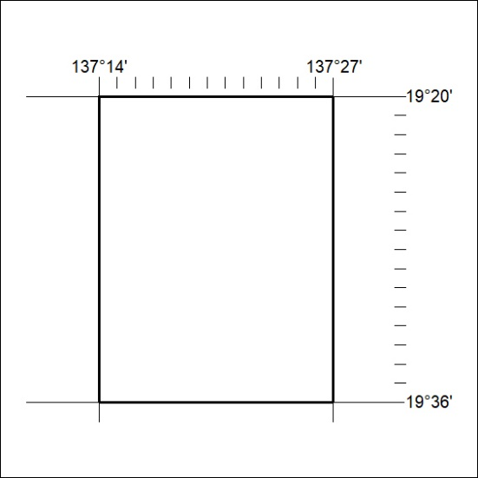
Area granted is indicated above. The titleholder is not permitted to exercise occupational rights on any land that is subject to a development title, or an application for a development title. Any land the subject of a Reserved Land gazettal under the Mineral Titles Act and all land vested in the Commonwealth of Australia is also excluded by description but not excised from the grant area.
324/20

Mineral Titles Act
NOTICE OF GRANT OF A MINERAL TITLE
Title Type and Number: | Exploration Licence 32295
Granted: | 23 September 2020, for a period of 6 Years
Area: | 140 Blocks, 426.99 km²
Locality: | DALMORE
Name of Holder/s: | 100% KNOX RESOURCES LIMITED [ACN. 623 480 286]
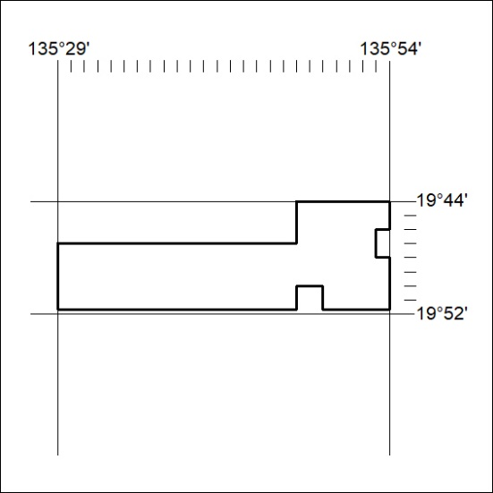
Area granted is indicated above. The titleholder is not permitted to exercise occupational rights on any land that is subject to a development title, or an application for a development title. Any land the subject of a Reserved Land gazettal under the Mineral Titles Act and all land vested in the Commonwealth of Australia is also excluded by description but not excised from the grant area.
325/20

Mineral Titles Act
NOTICE OF GRANT OF A MINERAL TITLE
Title Type and Number: | Exploration Licence 32296
Granted: | 23 September 2020, for a period of 6 Years
Area: | 35 Blocks, 113.18 km²
Locality: | FAVENC
Name of Holder/s: | 100% KNOX RESOURCES LIMITED [ACN. 623 480 286]
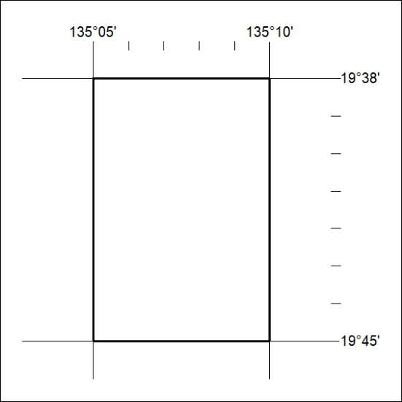
Area granted is indicated above. The titleholder is not permitted to exercise occupational rights on any land that is subject to a development title, or an application for a development title. Any land the subject of a Reserved Land gazettal under the Mineral Titles Act and all land vested in the Commonwealth of Australia is also excluded by description but not excised from the grant area.
326/20

