Mineral Titles Act 2010
NOTICE OF LAND CEASING TO BE A MINERAL TITLE AREA
Title Type and Number: | Extractive Mineral Lease (Northern) 9
Area ceased on: | 02 August 2020
Area: | 16.00 Hectare
Locality: | KOOLPINYAH
Name of Applicants(s)Holder(s): | 100% ELITE INTERIORS NT PTY LTD [ACN. 153 658 514]
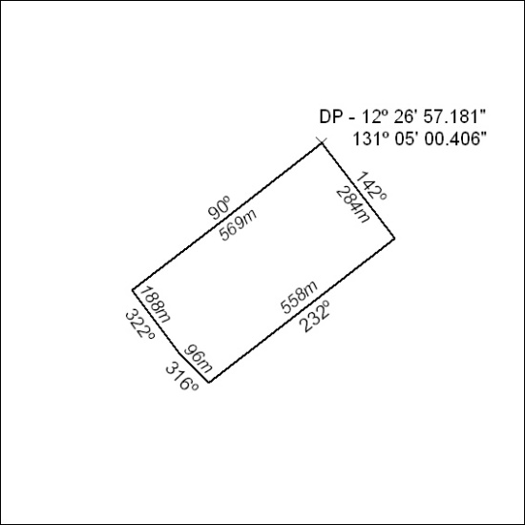

252/20

Mineral Titles Act
NOTICE OF GRANT OF A MINERAL TITLE
Title Type and Number: | Exploration Licence 32175
Granted: | 03 August 2020, for a period of 6 Years
Area: | 143 Blocks, 470.19 km²
Locality: | GLYDE
Name of Holder/s: | 100% TECK AUSTRALIA PTY LTD [ACN. 091 271 911]
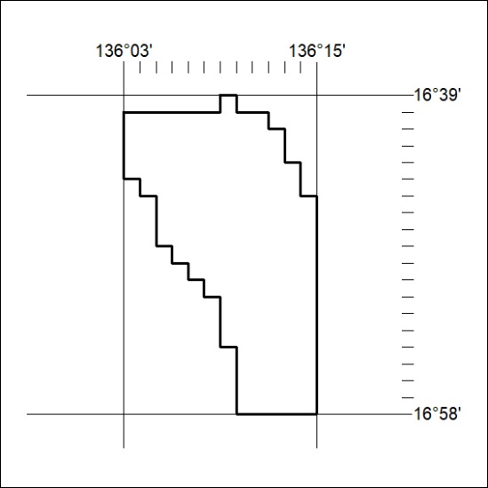
Area granted is indicated above. The titleholder is not permitted to exercise occupational rights on any land that is subject to a development title, or an application for a development title. Any land the subject of a Reserved Land gazettal under the Mineral Titles Act and all land vested in the Commonwealth of Australia is also excluded by description but not excised from the grant area.

253/20

Mineral Titles Act
NOTICE OF GRANT OF A MINERAL TITLE
Title Type and Number: | Exploration Licence 32347
Granted: | 03 August 2020, for a period of 6 Years
Area: | 57 Blocks, 165.09 km²
Locality: | BORROLOOLA
Name of Holder/s: | 100% TECK AUSTRALIA PTY LTD [ACN. 091 271 911]
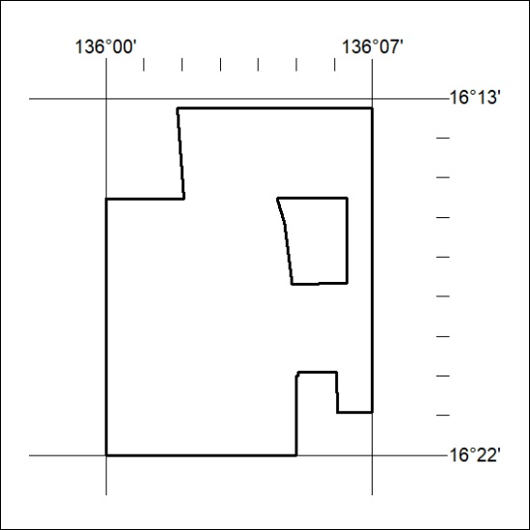
Area granted is indicated above. The titleholder is not permitted to exercise occupational rights on any land that is subject to a development title, or an application for a development title. Any land the subject of a Reserved Land gazettal under the Mineral Titles Act and all land vested in the Commonwealth of Australia is also excluded by description but not excised from the grant area.

254/20

