Northern Territory  
Business Confidence survey

December Quarter 2019

# Northern Territory Business Confidence Survey

**December Quarter 2019**

## Summary

* The Territory-wide business confidence level was +52% in the December quarter 2019. This represents a 2 percentage point increase from the September quarter 2019 and a 2 percentage point increase on the same quarter in 2018.
* Between 1 October and 30 December 2019, 262 businesses were surveyed across Territory regions and industry sectors.
* Business confidence by region ranged from +89% in East Arnhem to +11% in the Daly-Tiwi-West Arnhem region.
* 46% of businesses surveyed expected to perform better this year compared to the previous year, representing a 6 percentage point increase from the September quarter 2019.

## Introduction

Northern Territory Business Confidence is a quarterly publication which highlights confidence levels of Territory-wide businesses.

The survey covers urban and regional areas of the Territory and captures different industry sectors and business sizes (small, medium and large).

Monitoring business confidence levels is important as it is a key barometer and a leading indicator of business conditions and the overall health of the economy. Business confidence drives business growth and investment, supports employment opportunities and attracts people to the region.

## Number of businesses surveyed by regions

**(ABS statistical area 3 – sa3 levels)**

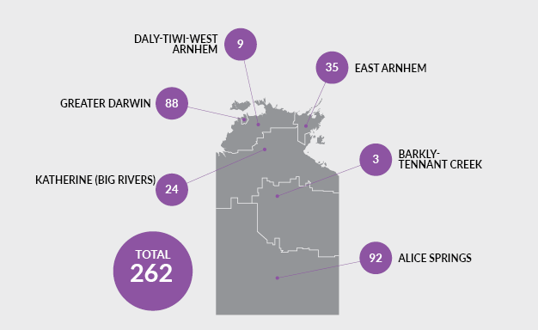

| Region | Total no of businesses | Businesses surveyed | Proportional of total |
| --- | --- | --- | --- |
| Greater Darwin | 10 652 | 88 | 0.8% |
| Daly-Tiwi-West Arnhem | 360 | 9 | 2.5% |
| East Arnhem | 220 | 35 | 15.9% |
| Katherine (Big Rivers) | 927 | 24 | 2.6% |
| Barkly-Tennant Creek | 214 | 3 | 1.4% |
| Alice Springs | 2076 | 92 | 4.4% |
| Unclassified | n.a | 11 | n.a. |
| **TOTAL** | **14 449** | **262** | **1.8%** |

Source: ABS Cat. No. 81650.0

## Business confidence

Q. How confident are you about your business prospects for the next 12 months?

### Territory wide

In the December quarter 2019, the Territory-wide business confidence index was +52%. The response rate for this question was 95.4%.

### Overall business confidence index

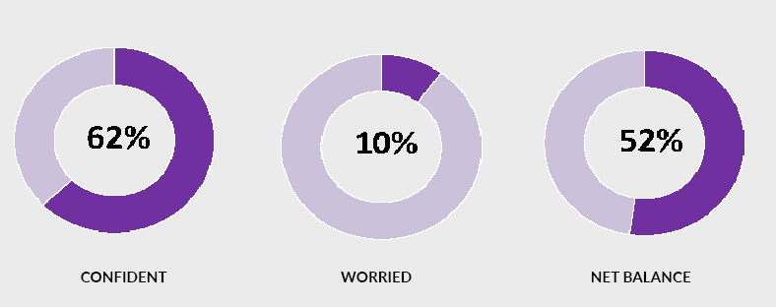

Note: 27% of the responses remained neutral (neither confident nor worried)

### Confidence in the regions

Business confidence varied among Territory regions, ranging from +89% in East Arnhem to +11% in the Daly-Tiwi-West Arnhem region.

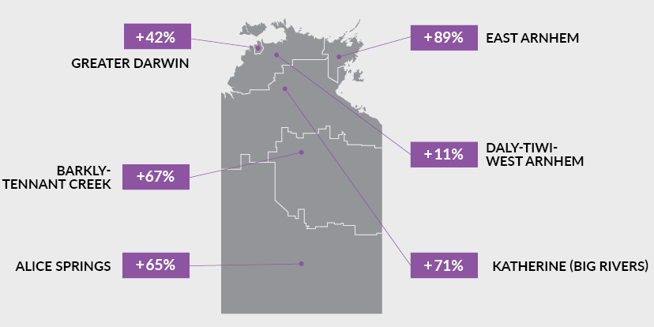

## Confidence trends

### Territory wide

|  | Dec Qtr  2018 | Mar Qtr  2019 | Jun Qtr  2019 | Sep Qtr  2019 | Dec Qtr  2019 |
| --- | --- | --- | --- | --- | --- |
| Confident | 60% | 61% | 64% | 58% | 62% |
| Worried | 10% | 15% | 10% | 8% | 10% |
| Net balance | 50% | 46% | 54% | 50% | 52% |

In the December quarter 2019, business confidence increased 2 percentage points to +52% from the previous quarter. This also represents a 2 percentage point increase from the December quarter 2018.

The above table and the chart below show that the level of overall business confidence in the Territory has been stable and relatively buoyant over the past year.

### Trends in nt business confidence

See above table for detailed figures.

### Business confidence by region

In the December quarter 2019, business confidence improved in Katherine (Big Rivers) and Barkly-Tennant Creek, and declined in Greater Darwin, Daly-Tiwi-West Arnhem, East Arnhem, and Alice Springs, compared to the previous quarter.

| Region | Dec Qtr  2018 | Mar Qtr  2019 | Jun Qtr  2019 | Sep Qtr  2019 | Dec Qtr  2019 |
| --- | --- | --- | --- | --- | --- |
| Greater Darwin |  |  |  |  |  |
| Confident | 53% | 57% | 59% | 53% | 53% |
| Worried | 12% | 16% | 11% | 7% | 11% |
| Net balance | 41% | 41% | 48% | 46% | 42% |
| Daly-Tiwi-West Arnhem |  |  |  |  |  |
| Confident | 33% | 42% | 48% | 71% | 22% |
| Worried | 19% | 37% | 4% | 6% | 11% |
| Net balance | 14% | 5% | 44% | 65% | 11% |
| East Arnhem |  |  |  |  |  |
| Confident | 91% | 66% | 82% | 100% | 89% |
| Worried | 5% | 12% | 0% | 0% | 0% |
| Net balance | 86% | 54% | 82% | 100% | 89% |
| Katherine (Big Rivers) |  |  |  |  |  |
| Confident | 88% | 88% | 88% | 77% | 75% |
| Worried | 0% | 2% | 9% | 8% | 4% |
| Net balance | 88% | 86% | 79% | 69% | 71% |
| Barkly-Tennant Creek |  |  |  |  |  |
| Confident | 75% | 78% | 78% | 71% | 67% |
| Worried | 0% | 22% | 11% | 14% | 0% |
| Net balance | 75% | 56% | 67% | 57% | 67% |
| Alice Springs |  |  |  |  |  |
| Confident | 82% | 65% | 81% | 80% | 78% |
| Worried | 4% | 14% | 8% | 10% | 13% |
| Net balance | 78% | 51% | 73% | 70% | 65% |

### Business confidence by industry

The Territory-wide business confidence was +52% but remained varied among the industries for the December quarter 2019. The chart below displays the top 10 most surveyed industries.

| Sector | Confident | Worried | Net balance | | |
| --- | --- | --- | --- | --- | --- |
|  |  |  | **Dec Qtr 2019** | Sep Qtr 2019 | June Qtr 2019 |
| Agriculture, Forestry and Fishing | 71% | 14% | **57%** | 43% | 77% |
| Construction | 58% | 12% | **46%** | 44% | 36% |
| Retail Trade | 67% | 10% | **57%** | 46% | 42% |
| Accommodation and Food Services | 64% | 9% | **55%** | 69% | 57% |
| Transport, Postal and Warehousing | 67% | 11% | **56%** | 59% | 55% |
| Professional Services | 71% | 6% | **65%** | 63% | 93% |
| Education and Training | 50% | 13% | **37%** | 91% | 55% |
| Health Care and Social  Assistance | 86% | 9% | **77%** | 71% | 81% |
| Arts and Recreation Services | 77% | 9% | **68%** | 57% | 58% |
| Other Services | 68% | 8% | **60%** | 63% | 44% |

Note: Caution is advised when using this data as the sample size in some sectors may be relatively small.

### Industry expectations

This graph shows the confidence levels by industry, listed from most confident (health care and social assistance)  to least confident (education and training). See table above for detailed figures.

## Key business insights

### Confident

Of the Territory businesses confident about their business prospects for the next 12 months, key reasons cited are: 'strong customer relations'; 'strong market position'; 'been in business a long time' and 'business opportunity'. The graph below shows the relative importance of the key reasons for confidence.

The chart outlines the key reasons why surveyed businesses were confident, over the past two quarters. Further detail provided in text above.

### Worried

Of those Territory businesses worried about their business prospects for the next 12 months, the main reasons cited for being worried are: 'lack of suitably skilled workers'; 'decrease in business/sales'; and 'weak local economy'. The graph below shows the relative importance of the key reasons for being worried for the last two quarters.

The chart outlines the key reasons why surveyed businesses were worried, over the past two quarters. Further detail provided in text above.

## Business performance

Q. How is your business performing this year compared to last year?

46% of Territory businesses noted that their business performance is better this year compared to last year, while 43% of the businesses stated that business performance is the same as last year, and 11% of businesses stated their business performance is worse than last year.

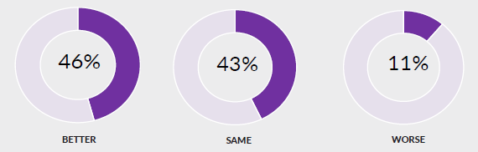

### Trend in Business performance

Compared to the same quarter in previous years, fewer businesses report that their performance was getting worse. The majority of businesses reported that their performance was the same or better compared to the previous year.

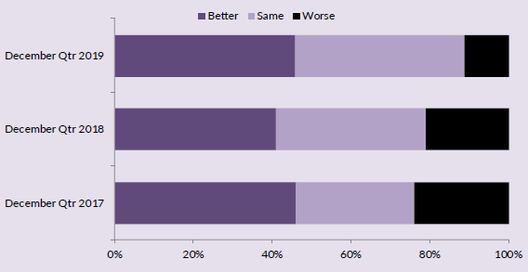

### Business performance this year compared to last year by region

The table and graphs below highlight that business performance levels varied among businesses in the regions. Compared to the previous quarter, the Greater Darwin region show improved business performance, whereas expectations for business performance has declined in all other regions.

| Statistical area level 3 (sa3) regions | Business performance | | |
| --- | --- | --- | --- |
|  | **Better** | **Same** | **Worse** |
| Greater Darwin | 42% | 47% | 11% |
| Katherine (Big Rivers) | 25% | 54% | 21% |
| East Arnhem | 51% | 43% | 6% |
| Daly-Tiwi-West Arnhem | 11% | 89% | 0% |
| Barkly-Tennant Creek | 0% | 100% | 0% |
| Alice Springs | 58% | 30% | 12% |
| Territory-wide | **46%** | **43%** | **11%** |

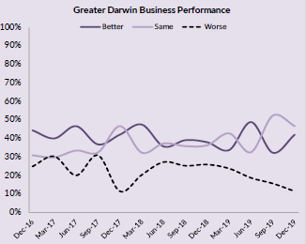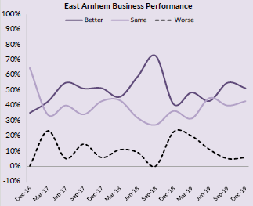

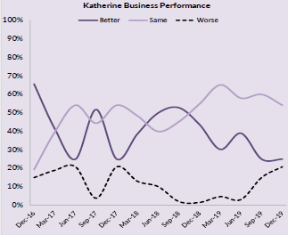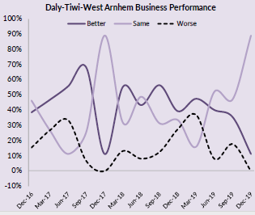

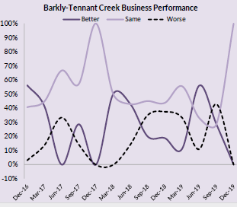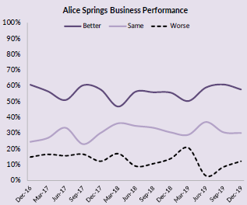

## Survey methodology

A face-to-face survey of businesses operating in the Territory is conducted by the Department of Trade, Business and Innovation (DTBI) on a quarterly basis. Business confidence is estimated using the business confidence index.

There are approximately 14,000 operating businesses in the Territory. Therefore, for the sample survey to achieve a 95% confidence level with a margin of error of 5%, 375 survey responses are required.

Business confidence index is calculated as the difference between the proportion of businesses that are ‘confident about their business prospects for the next 12 months' minus the proportion of businesses that are ‘worried about their business prospects for the next 12 months’ (net balance approach).

The higher the net balance the greater the level of business confidence. For example, if 60% of businesses are confident and 40% of businesses are worried, the net balance is +20%. Survey responses are also analysed by region and industry sector of businesses.

The business confidence results are presented for overall Northern Territory, Greater Darwin (Darwin City, Darwin suburbs, Palmerston and Litchfield) and for individual regions.

The overall Territory-wide confidence index is weighted to account for the number of businesses in each of the regions. The weights are based on the proportion of total Territory businesses in each region. The weighted result provides a more balanced reflection of overall business confidence.

**business.nt.gov.au**

