Mineral Titles Act 2010
NOTICE OF LAND CEASING TO BE A MINERAL TITLE AREA
Title Type and Number: | Exploration Licence 31534
Area Ceased on: | 01 November 2019
Area: | 54 Blocks, 171.54 km²
Locality: | ARAPUNGA
Name of Applicant(s)/Holder(s): | 100% CENTEX RESOURCES PTY LTD* [ACN. 125 826 717]
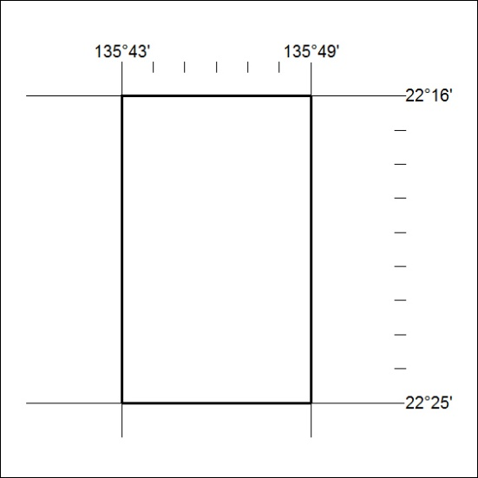

467/19

Mineral Titles Act 2010
NOTICE OF LAND CEASING TO BE A MINERAL TITLE AREA
Title Type and Number: | Exploration Licence 31535
Area Ceased on: | 01 November 2019
Area: | 34 Blocks, 108.10 km²
Locality: | OORATIPPRA
Name of Applicant(s)/Holder(s): | 100% CENTEX RESOURCES PTY LTD* [ACN. 125 826 717]
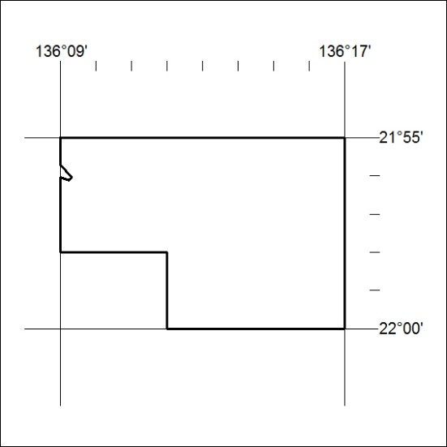

468/19
Mineral Titles Act 2010
NOTICE OF LAND CEASING TO BE A MINERAL TITLE APPLICATION AREA
Title Type and Number: | Exploration Licence 32203
Area Ceased on: | 01 November 2019
Area: | 2 Blocks, 6.70 km²
Locality: | BYNOE
Name of Applicant(s)/Holder(s): | 100% LITHIUM PLUS PTY LTD [ACN. 626 593 799]
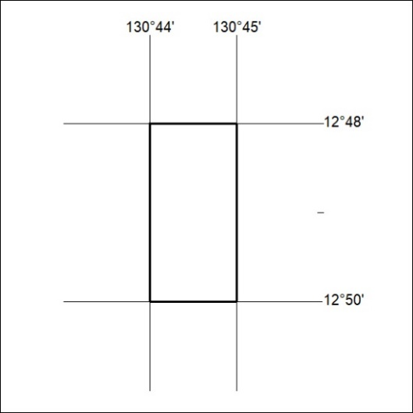

469/19

Mineral Titles Act 2010
NOTICE OF LAND CEASING TO BE A MINERAL TITLE APPLICATION AREA
Title Type and Number: | Exploration Licence 32242
Area Ceased on: | 01 November 2019
Area: | 12 Blocks, 25.73 km²
Locality: | TENNANT CREEK
Name of Applicant(s)/Holder(s): | 100% ICA MINING SERVICES PTY LTD [ACN. 629 874 246]
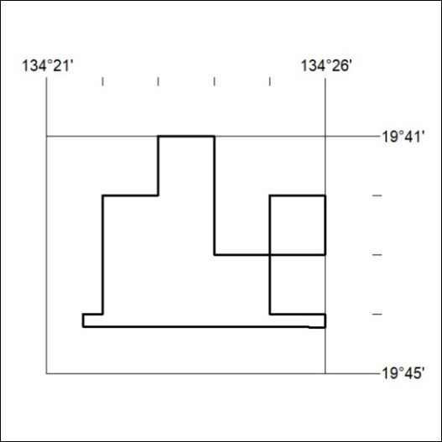

470/19

Mineral Titles Act
NOTICE OF GRANT OF A MINERAL TITLE
Title Type and Number: | Extractive Mineral Permit 32033
Granted: | 31 October 2019, for a period of 5 Years
Area: | 12.00 Hectares
Locality: | NOONAMAH
Name of Holder/s: | 100% KIGILIA PTY LTD [ACN. 113 822 343]
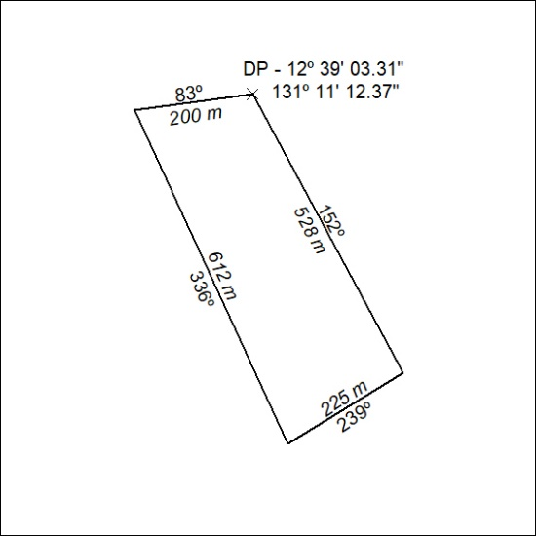

471/19

Mineral Titles Act
NOTICE OF GRANT OF A MINERAL TITLE
Title Type and Number: | Extractive Mineral Permit 32034
Granted: | 31 October 2019, for a period of 5 Years
Area: | 10.00 Hectares
Locality: | NOONAMAH
Name of Holder/s: | 100% KIGILIA PTY LTD [ACN. 113 822 343]
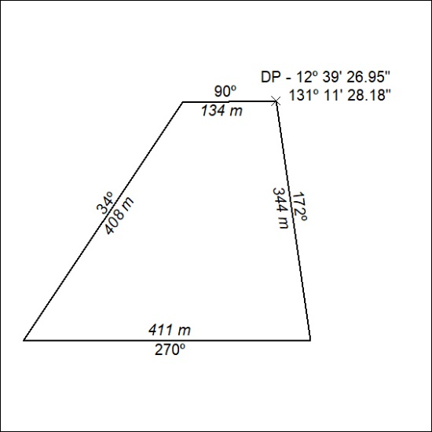

472/19

