Mineral Titles Act 2010
NOTICE OF LAND CEASING TO BE A MINERAL TITLE AREA
Title Type and Number: | Exploration Licence 29747
Area Ceased on: | 18 October 2019
Area: | 52 Blocks, 164.15 km²
Locality: | LEISLER
Name of Applicant(s)/Holder(s): | 100% CASTILE RESOURCES PTY LTD [ACN. 124 314 085]
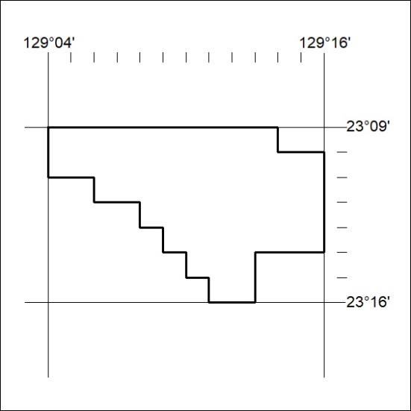

439/19

Mineral Titles Act 2010
NOTICE OF LAND CEASING TO BE A MINERAL TITLE AREA
Title Type and Number: | Exploration Licence 30729
Area Ceased on: | 18 October 2019
Area: | 135 Blocks, 426.73 km²
Locality: | CAREY
Name of Applicant(s)/Holder(s): | 100% PRODIGY GOLD NL* [ACN. 009 127 020]
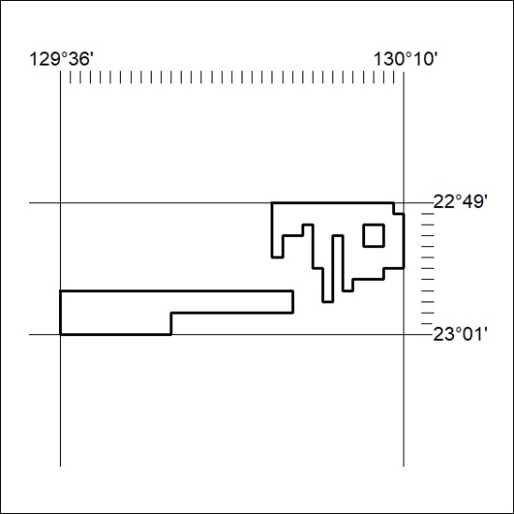

440/19
Mineral Titles Act 2010
NOTICE OF LAND CEASING TO BE A MINERAL TITLE AREA
Title Type and Number: | Exploration Licence 30739
Area Ceased on: | 18 October 2019
Area: | 168 Blocks, 501.52 km²
Locality: | GURNER
Name of Applicant(s)/Holder(s): | 100% PRODIGY GOLD NL* [ACN. 009 127 020]
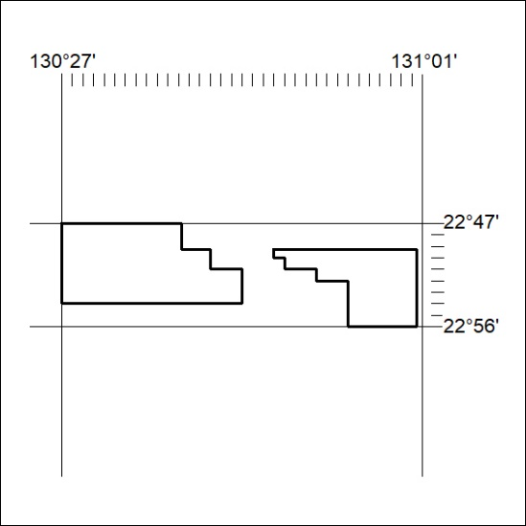

441/19

