The Plant Industries Branch of the NT Department of Primary Industry and Resources (NT DPIR) partnered with the Australian Centre for International Agricultural Research (ACIAR) and various corporate partners to complete three mango fruit fly disinfestation trials in 2017 and 2018.The methodology used in each trial segmented areas of the supply chain that may affect the quality of mango fruit treated with disinfestation. Key findings are summarised below.

Maturity matters
The harvest maturity of mango fruit can affect the quality of fruit treated with disinfestation. For some cultivars, decline in fruit quality after treatment is exaggerated in overly mature fruit. However, we also found the opposite could also occur in other cultivars. Identifying harvest maturity of a fruit lot can allow for adjustment of treatment conditions to manage quality. Fruit lots with inconsistent harvest maturity are therefore difficult to treat.

Pre-treatment quality
Many quality issues present in mango fruit before disinfestation treatment are exacerbated after treatment. Lenticels, scratches and lesions to the skin particularly effected.

Fungal and bacterial blemish
The incidence of fungal and bacterial conditions is reduced in response to disinfestation treatments. In particular, we found reductions in skin and stem end rots, and Resin Canal Discolouration (RCD) in fruit treated with gamma irradiation, hot water treatment and vapour heat treatment.

Figure 1. Incidence of Resin Canal Discolouration (RCD) in fruit treated with heat disinfestation.

Pre-ripening for irradiation
Fruit that is not ripened before gamma irradiation treatment retains green skin colour. Fruit with lower harvest maturities require a longer ripening period than those with higher harvest maturities.

Conditioning for hot water
Acclimatising mango fruit to higher temperatures, with storage at 30 °C for 12 hours or more, reduces internal and external quality decline as a result of hot water treatment.

Cultivar specific treatment
Mango cultivars respond differently to fruit fly disinfestation treatments. It is important to identify the specific treatment conditions required to maintain quality of each mango cultivar. For some cultivars, only certain treatments are suitable.
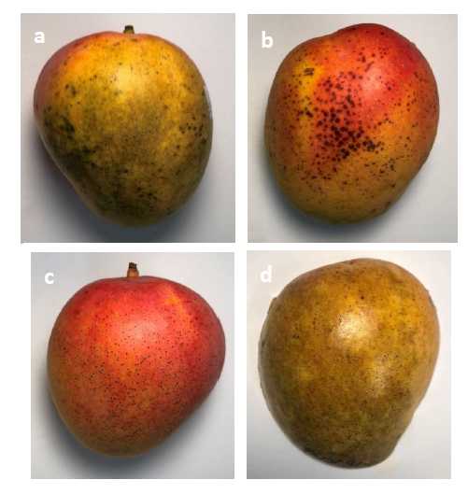
Figure 2. Fruit treated with gamma irradiation with green skin, under skin browning and severe lenticels a. green skin, b. severe lenticels, c. mild lenticels, d. under skin browning.

Figure 3. Incidence of Resin Canal Discolouration (RCD) in fruit treated with heat disinfestation.
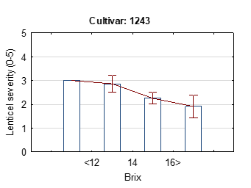
Figure 4. Lenticel severity and brix* of ripe NMBP 1243
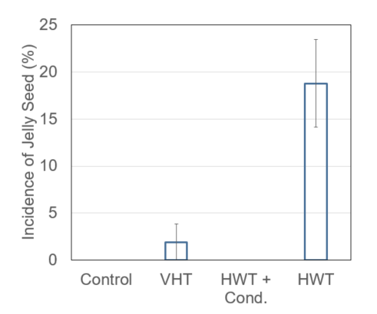
Figure 5. Incidence (%) of Jelly Seed in fruit treated with heat disinfestation

For more information:
Dr Cameron McConchie
Research Leader, Plant Industries Branch, NT DPIR
P: +61 8 8999 2310; E: Cameron.McConchie@nt.gov.au

