Mineral Titles Act 2010
NOTICE OF LAND CEASING TO BE A MINERAL TITLE AREA
Title Type and Number: | Exploration Licence 29599
Area Ceased on: | 09 May 2019
Area: | 5 Blocks, 15.84 km²
Locality: | JERVOIS RANGE
Name of Applicant(s)/Holder(s): | 100% MOLYHIL MINING PTY LTD [ACN. 112 922 497]
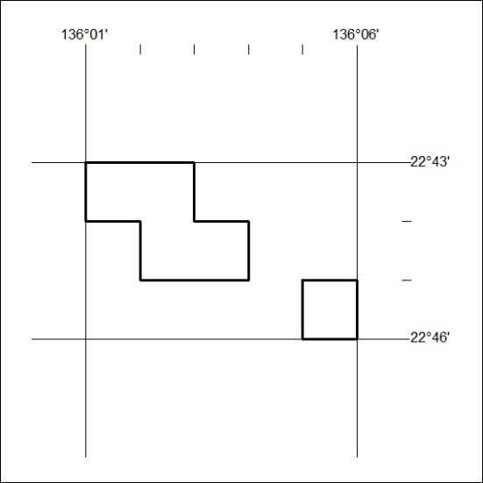

174/19

