Mineral Titles Act 2010
NOTICE OF LAND CEASING TO BE A MINERAL TITLE AREA
Title Type and Number: | Extractive Mineral Lease 24368
Area ceased on: | 24 April 2019
Area: | 25.00 Hectare
Locality: | NOONAMAH
Name of Applicants(s)Holder(s): | 100% OSTOJIC GROUP PTY LTD* [ACN. 009 629 805]
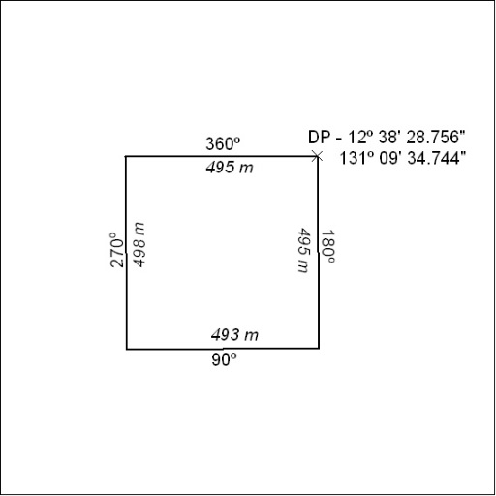
(Area now amalgamated into Extractive Mineral Lease 32110 under s102)

132/19

Mineral Titles Act 2010
NOTICE OF LAND CEASING TO BE A MINERAL TITLE AREA
Title Type and Number: | Extractive Mineral Lease 30675
Area ceased on: | 24 April 2016
Area: | 4.00 Hectare
Locality: | NOONAMAH
Name of Applicants(s)Holder(s): | 100% OSTOJIC GROUP PTY LTD* [ACN. 009 629 805]
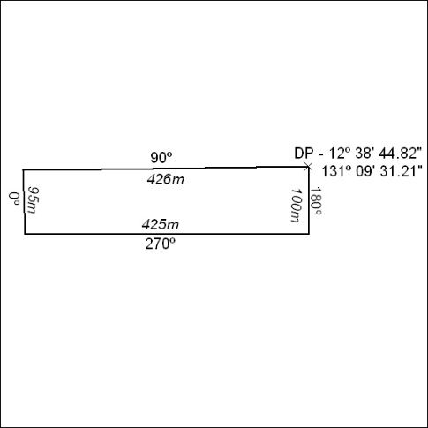
(Area now amalgamated into Extractive Mineral Lease 32110 under s102)

133/19

