Mineral Titles Act
NOTICE OF LAND CEASING TO BE A MINERAL TITLE AREA
Title Type and Number: | Exploration Licence 26530
Area Ceased on: | 15 March 2019
Area: | 125 Blocks, 390.21 km²
Locality: | BLOODS RANGE
Name of Applicant(s)/Holder(s): | 100% GEMPART (NT) PTY LTD* [ACN. 081 859 896]
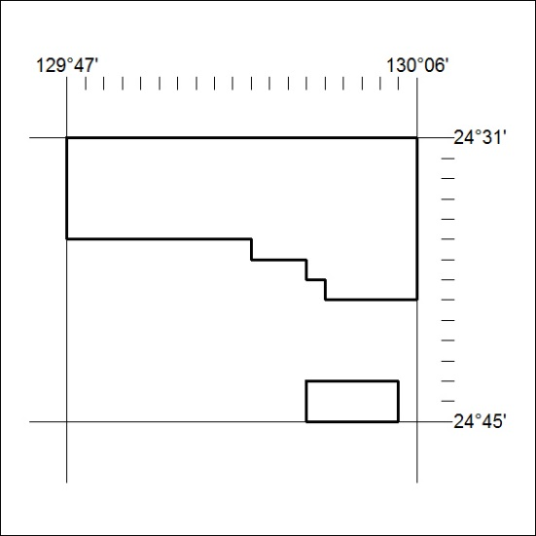

88/19

Mineral Titles Act
NOTICE OF LAND CEASING TO BE A MINERAL TITLE AREA
Title Type and Number: | Exploration Licence 26819
Area Ceased on: | 15 March 2019
Area: | 50 Blocks, 155.19 km²
Locality: | POTTOYU
Name of Applicant(s)/Holder(s): | 100% GEMPART (NT) PTY LTD* [ACN. 081 859 896]
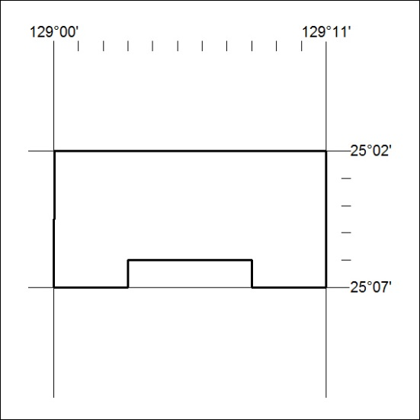

89/19

Mineral Titles Act
NOTICE OF LAND CEASING TO BE A MINERAL TITLE AREA
Title Type and Number: | Exploration Licence 27560
Area Ceased on: | 03 March 2019
Area: | 2 Blocks, .10 km²
Locality: | NOONAMAH
Name of Applicant(s)/Holder(s): | 100% NORTHERN TERRITORIES RESOURCES PTY LTD* [ACN. 124 647 829]
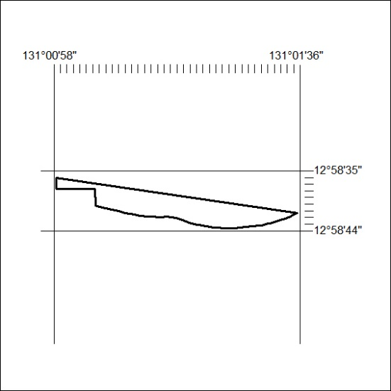

90/19

Mineral Titles Act
NOTICE OF LAND CEASING TO BE A MINERAL TITLE AREA
Title Type and Number: | Exploration Licence 27581
Area Ceased on: | 15 March 2019
Area: | 87 Blocks, 255.62 km²
Locality: | HULL
Name of Applicant(s)/Holder(s): | 100% GEMPART (NT) PTY LTD* [ACN. 081 859 896]
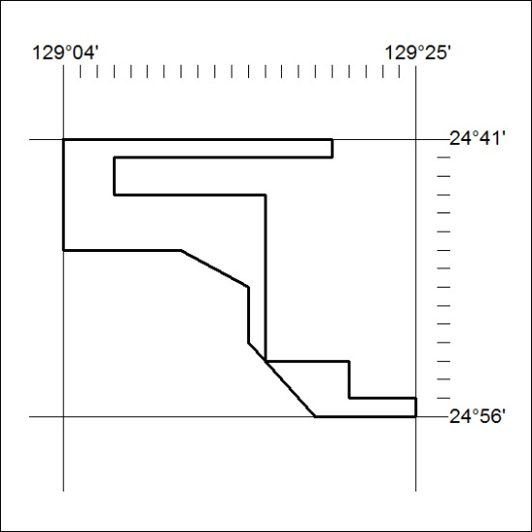

91/19

Mineral Titles Act
NOTICE OF LAND CEASING TO BE A MINERAL TITLE AREA
Title Type and Number: | Exploration Licence 31531
Area Ceased on: | 15 March 2019
Area: | 125 Blocks, 389.58 km²
Locality: | BLOODS RANGE
Name of Applicant(s)/Holder(s): | 100% GEMPART (NT) PTY LTD* [ACN. 081 859 896]
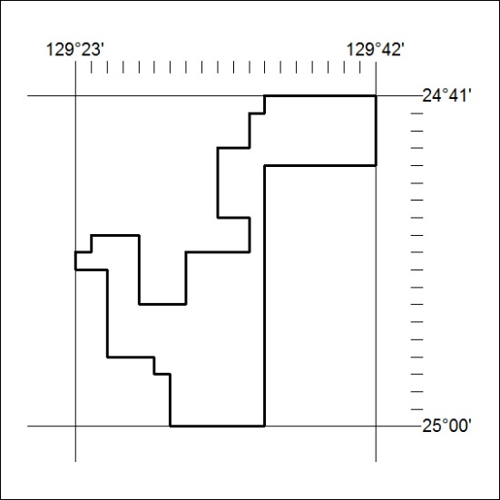

92/19

Mineral Titles Act
NOTICE OF GRANT OF A MINERAL TITLE
Title Type and Number: | Exploration Licence 31926
Granted: | 13 March 2019, for a period of 6 Years
Area: | 35 Blocks, 109.92 km²
Locality: | LIMBLA
Name of Holder/s: | 100% MAY DOWNS RESOURCES PTY LTD [ACN. 624 302 530]
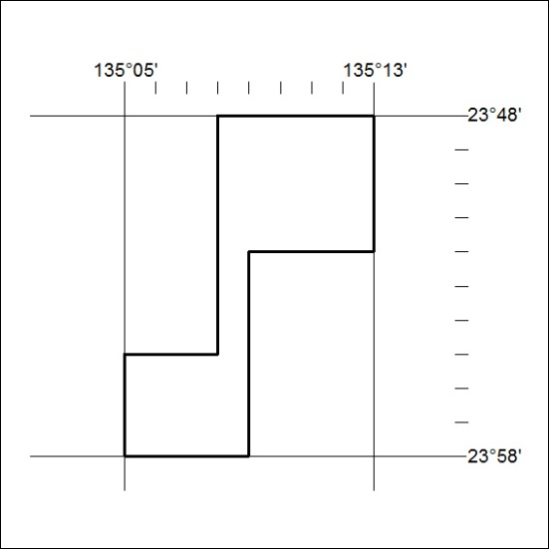
Area granted is indicated above. The titleholder is not permitted to exercise occupational rights on any land that is subject to a development title, or an application for a development title. Any land the subject of a Reserved Land gazettal under the Mineral Titles Act and all land vested in the Commonwealth of Australia is also excluded by description but not excised from the grant area.

93/19

Mineral Titles Act
NOTICE OF GRANT OF A MINERAL TITLE
Title Type and Number: | Extractive Mineral Permit 31827
Granted: | 13 March 2019, for a period of 5 Years
Area: | 23.80 Hectares
Locality: | KATHERINE
Name of Holder/s: | 100% DOWNES Terrance William
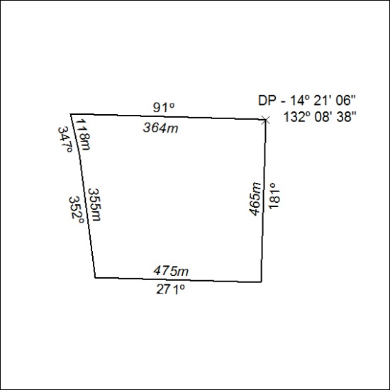

94/19

