NT DPIR has produced this special issue of the Pastoral Feed Outlook in response to the poor wet season being experienced in some districts and industry concerns about the feed supply for the year ahead.

The purpose of this outlook is to summarise information relevant to the pastoral industry such as current feed supplies, seasonal conditions, the development of drought conditions in central Australia and fire risk.

You can see the entire document and all districts by continuing to scroll through this file. If you are interested in selected sections, you can click on the links below.

Summary of current situation & trends - all districts

Northern Territory Seasonal Outlook – as at January 2019

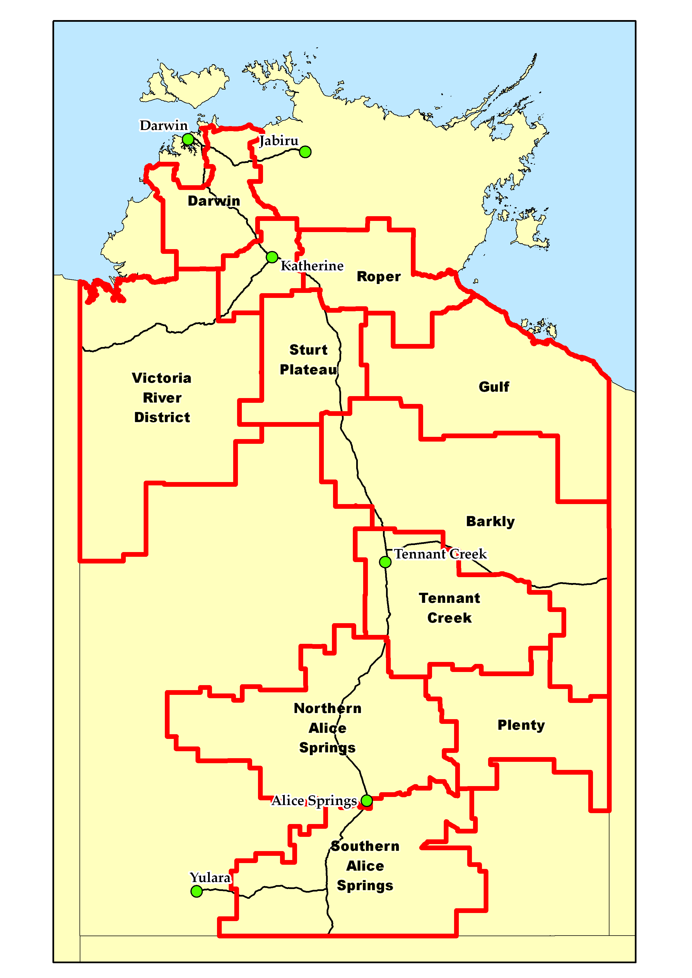

Individual District Summaries:

Darwin District

Katherine District

Victoria River District

Sturt Plateau District

Roper District

Gulf District

Barkly District

Tennant Creek District

Northern Alice Springs District

Plenty District

Southern Alice Springs District

# Summary of current situation and trends – all districts – January 2019

The 2018/19 season commenced with patchy rain across much of the Northern Territory but seasonal conditions have deteriorated in several districts in the past two months. The predicted late onset to the northern wet season has materialised. **Parts of the Barkly district have experienced low to extremely low pasture growth (some in the lowest 10% of years on record) during the past 24 months and a large area currently has low levels of standing dry matter (<500kg/ha)**. The BOM forecast suggests there is a low chance of exceeding average rainfall in the coming months. The chance of exceeding median pasture growth between now and the end of the wet season is average to below average in most districts.

|  |  |  |  |  |  |  |
| --- | --- | --- | --- | --- | --- | --- |
| KEY | Green = low risk | | Orange = watch | | Red = high risk | |
| KEY | | **↑** = increasing trend | | **↓** = decreasing trend | | **↔** = steady | |

|  |  |  |  |  |  |  |  |  |  |  |  |  |
| --- | --- | --- | --- | --- | --- | --- | --- | --- | --- | --- | --- | --- |
|  | **Northern Territory Pastoral Districts** | | | | | | | | | | |  |
| **Indicator** | **Darwin** | **Katherine** | **VRD** | **Sturt Plateau** | **Roper** | **Gulf** | **Barkly** | **Tennant Creek** | **Northern Alice Springs** | **Plenty** | **Southern Alice Springs** | **Comments** |
| 2018/2019 total pasture growth | **↔** | **↔** | **↔** | **↔** | **↔** | **↔** | **↓** | **↓** | **↓** | **↓** | **↔** | Arrows indicate trend compared to the long-term median (for this time of year). |
| Current estimated standing biomass | **↑** | **↑** | **↔** | **↔** | **↑** | **↔** | **↓** | **↔** | **↔** | **↔** | **↔** | Arrows indicate trend since previous quarter. |
| Current fire risk | **↓** | **↓** | **↓** | **↓** | **↓** | **↔** | **↔** | **↔** | **↓** | **↓** | **↔** | Arrows indicate the trend since previous quarter. |
| Current seasonal outlook | **↔** | **↔** | **↔** | **↔** | **↔** | **↔** | **↔** | **↔** | **↔** | **↔** | **↓** | Arrows indicate the trend since previous quarter and taking into account the forecasted model predictions. |

For further information about this Outlook, please contact Chris Materne on 08 8951 8135 or Dionne Walsh on 08 8999 2178

# Northern Territory Seasonal Outlook as at January 2019*

Sourced from the Australian Bureau of Meteorology

*This seasonal outlook was correct at the time of publication. For the most up-to-date seasonal outlook, please go to the “[climate outlook](http://www.bom.gov.au/climate/outlooks/)” section of the BOM website.

The outlook for February to April 2019 indicates that:

* **Average** to **Drier** than average conditions are generally expected across most of the NT
* **Drier** than average conditions are more than likely across the western half of the NT
* **Warmer** than averagedays and nights are likely for almost all of Australia. For daytime temperatures, the chances of being warmer than median are very high, greater than 80% for most of the country

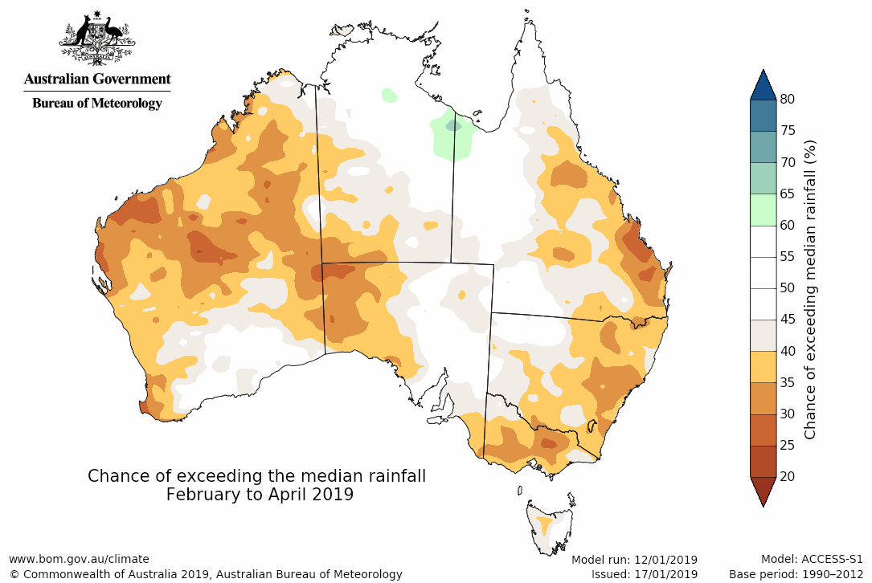

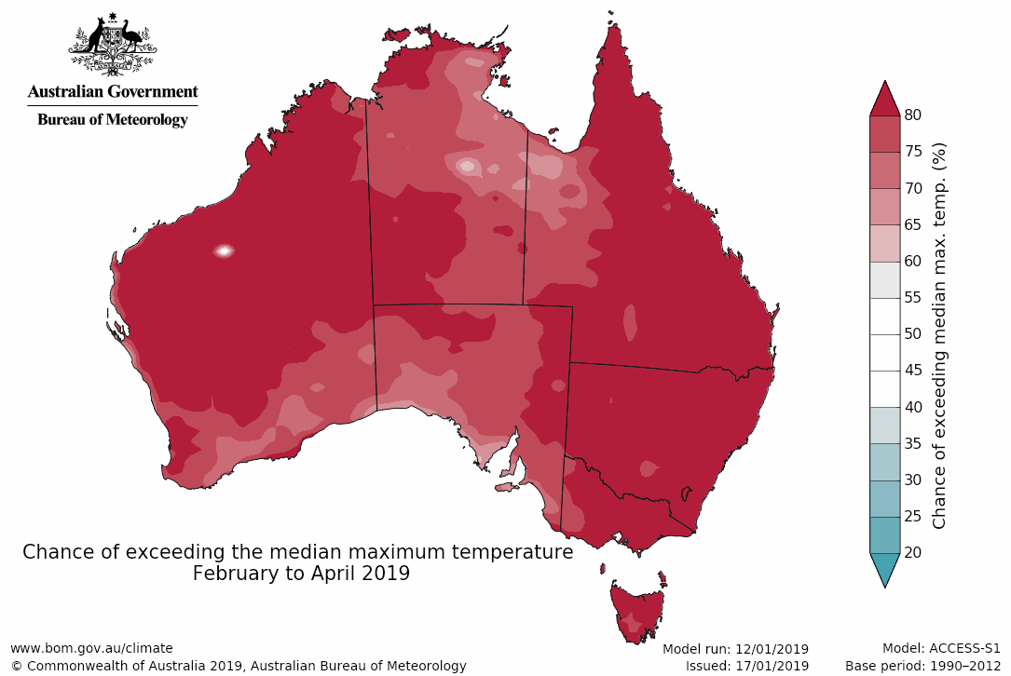

Chance of exceeding the median maximum temperature

February to April 2019

Chance of exceeding the median rainfall

February to April 2019

|  |  |
| --- | --- |
| **Seasonal Indicator** | **Comments** (sourced from the Australian Bureau of Meteorology) |
| **El Niño Southern Oscillation (ENSO)**  [Bureau of Meteorology ENSO Wrap-Up](http://www.bom.gov.au/climate/enso/)  Current outlook:  **Neutral**  ENSO status: **Watch** | **El Niño–Southern Oscillation neutral and the immediate risk of El Niño has passed**  Tropical Pacific sea surface and sub-surface temperatures remain warmer than average, but since late 2018 they have cooled. Atmospheric indicators such as cloudiness, trade winds and the SOI all continue to generally remain within the ENSO-neutral range. While most climate models indicate ENSO-neutral conditions for the immediate future, the current ocean warmth and likelihood of ongoing warmer than average conditions mean the risk of El Niño remains.    To see larger versions of these images, go to the SOI and Outlooks tabs at [Bureau of Meteorology ENSO Wrap-Up](http://www.bom.gov.au/climate/enso/) |

|  |  |
| --- | --- |
| **Indian Ocean Dipole (IOD)**  [Bureau of Meteorology ENSO Wrap-Up](http://www.bom.gov.au/climate/enso/)  Current outlook:  **Neutral** | **The Indian Ocean Dipole (IOD) is currently neutral**  Due to the movement of the monsoon trough in the Indian Ocean, the IOD typically has little influence on Australian climate from December to April. All six international climate models surveyed by the Bureau indicate that the IOD will remain neutral through autumn 2019.    To see larger versions of these images, go to [IOD Time Series](http://www.bom.gov.au/climate/enso/indices.shtml?bookmark=iod) and the Indian Ocean tab at [Bureau of Meteorology ENSO Wrap-Up](http://www.bom.gov.au/climate/enso/) |

# Darwin District

* 2017/18 pasture growth was similar to the long-term median.
* Inconsistent rainfall has resulted in a patchy start to the 2018/19 season. The district as a whole is experiencing average pasture growth to date. There are small pockets experiencing below average and above average growth.
* 9% of the district has been burnt since 1 July 2018.

**2018/19 Pasture Growth So Far**

**837 kg/ha**

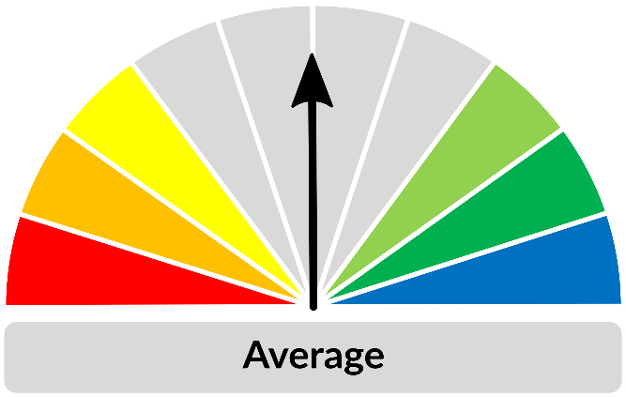

As at 1 January 2019

In a typical wet season, pasture growth in the Darwin region tends to be limited by available soil nitrogen rather than soil moisture. Therefore, a poor wet season may not generally affect the total quantity of pasture grown on upland country.

| **As at 1 January 2019** | | | | |
| --- | --- | --- | --- | --- |
| **(% of district)** | **<1,000kg/ha** | **1,000 - 2,000kg/ha** | **2,000 - 3,000kg/ha** | **>3,000kg/ha** |
| 2018/19  Pasture Growth | 93% | 7% | 0% | 0% |
| Total Standing Dry Matter | 34% | 48% | 16% | 2% |

|  |  |
| --- | --- |
| **Median Pasture Growth (kg/ha)**  **(Running Total)** | **Current Estimated**  **Total Standing Dry Matter** |
|  |  |

|  |  |
| --- | --- |
| **Growth Relative to Long Term**  **(October 2018 – January 2019)** | **Chance of Exceeding Median Pasture Growth**  **(January 2019 – March 2019)** |
|  | |

# Katherine District

* 2017/18 pasture growth was similar to the long-term median for the district as a whole, but some locations did experience much better growth than others.
* The district as a whole is experiencing average pasture growth to date, however there are some areas in the southern half achieving above average growth.
* 22% of the district has been burnt since 1 July 2018.

**2018/19 Pasture Growth So Far**

**576 kg/ha**



As at 1 January 2019

| **As at 1 January 2019** | | | | |
| --- | --- | --- | --- | --- |
| **(% of district)** | **<1,000kg/ha** | **1,000 - 2,000kg/ha** | **2,000 - 3,000kg/ha** | **>3,000kg/ha** |
| 2018/19  Pasture Growth | 100% | 0% | 0% | 0% |
| Total Standing Dry Matter | 31% | 58% | 10% | 1% |

|  |  |
| --- | --- |
| **Median Pasture Growth (kg/ha)**  **(Running Total)** | **Current Estimated**  **Total Standing Dry Matter** |
|  |  |

|  |  |
| --- | --- |
| **Growth Relative to Long Term**  **(October 2018 – January 2019)** | **Chance of Exceeding Median Pasture Growth**  **(January 2019 – March 2019)** |
|  | |

# Victoria River District

* 2017/18 pasture growth was similar to the long-term median but a lot lower than 2016/17.
* Overall, the district is tracking average to below average growth in the 2018/19 season to date.
* There has been above average growth in small areas in the NE corner of the district.
* 14% of the district has been burnt since 1 July 2018.

**2018/19 Pasture Growth So Far**

**191 kg/ha**

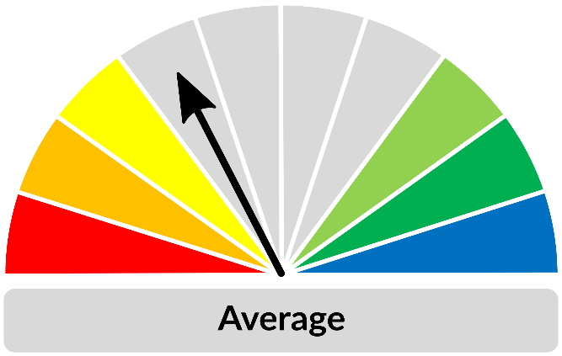

As at 1 January 2019

|  |  |  |  |  |
| --- | --- | --- | --- | --- |
| **As at 1 January 2019** | | | | |
| **(% of district)** | **<1,000kg/ha** | **1,000 - 2,000kg/ha** | **2,000 - 3,000kg/ha** | **>3,000kg/ha** |
| 2018/19  Pasture Growth | 100% | 0% | 0% | 0% |
| Total Standing Dry Matter | 36% | 34% | 18% | 12% |

|  |  |
| --- | --- |
| **Median Pasture Growth (kg/ha)**  **(Running Total)** | **Current Estimated**  **Total Standing Dry Matter** |
|  |  |

|  |  |
| --- | --- |
| **Growth Relative to Long Term**  **(October 2018 – January 2019)** | **Chance of Exceeding Median Pasture Growth**  **(January 2019 – March 2019)** |
|  | |

# Sturt Plateau District

* 2017/18 pasture growth was slightly better than the long-term median and similar to 2016/17.
* The majority of the district is experiencing average growth in the 2018/19 season to date.
* Some areas in the NW part of the district are experiencing above average growth for this time of the year.
* 11% of the district has been burnt since 1 July 2018.

**2018/19 Pasture Growth So Far**

**329 kg/ha**

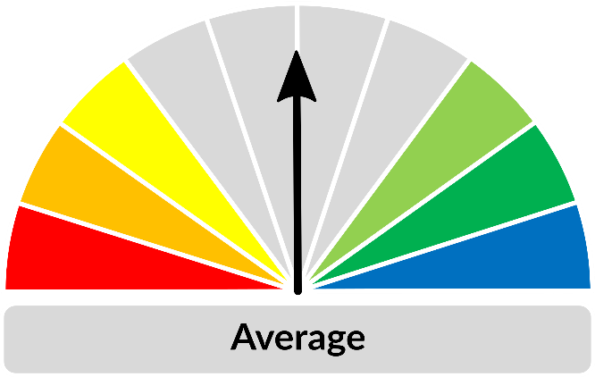

As at 1 January 2019

|  |  |  |  |  |
| --- | --- | --- | --- | --- |
| **As at 1 January 2019** | | | | |
| **(% of district)** | **<1,000kg/ha** | **1,000 - 2,000kg/ha** | **2,000 - 3,000kg/ha** | **>3,000kg/ha** |
| 2018/19  Pasture Growth | 100% | 0% | 0% | 0% |
| Total Standing Dry Matter | 38% | 56% | 3% | 3% |

|  |  |
| --- | --- |
| **Median Pasture Growth (kg/ha)**  **(Running Total)** | **Current Estimated**  **Total Standing Dry Matter** |
|  |  |

|  |  |  |
| --- | --- | --- |
| **Growth Relative to Long Term**  **(October 2018 – January 2019)** | | **Chance of Exceeding Median Pasture Growth**  **(January 2019 – March 2019)** |
|  | | |

# Roper District

* 2017/18 pasture growth was similar to the long-term median but lower than 2016/17.
* Most of the district is experiencing average to above average growth for the 2018/19 season to date.
* 24% of the district has been burnt since 1 July 2018.

**2018/19 Pasture Growth So Far**

**359 kg/ha**

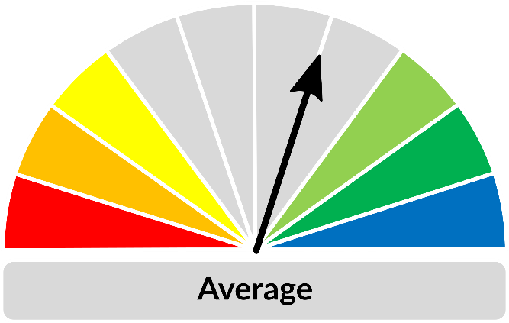

As at 1 January 2019

|  |  |  |  |  |
| --- | --- | --- | --- | --- |
| **As at 1 January 2019** | | | | |
| **(% of district)** | **<1,000kg/ha** | **1,000 - 2,000kg/ha** | **2,000 - 3,000kg/ha** | **>3,000kg/ha** |
| 2018/19  Pasture Growth | 100% | 0% | 0% | 0% |
| Total Standing Dry Matter | 28% | 56% | 10% | 6% |

|  |  |
| --- | --- |
| **Median Pasture Growth (kg/ha)**  **(Running Total)** | **Current Estimated**  **Total Standing Dry Matter** |
|  |  |

|  |  |
| --- | --- |
| **Growth Relative to Long Term**  **(October 2018 – January 2019)** | **Chance of Exceeding Median Pasture Growth**  **(January 2019 – March 2019)** |
|  | |

# Gulf District

* 2017/18 pasture growth was similar to the long-term median but lower than 2016/17.
* The district as a whole is experiencing average to below average growth as shown on the tracker to the right, but there are large contrasts between different areas of the district.
* The western side of the district has mostly experienced average to above average growth to date.
* The eastern side of the district is experiencing growth in the lowest 30% of years on record, with some areas experiencing extremely low growth (lowest 10% of years on record).
* 19% of the district has been burnt since 1 July 2018.

**2018/19 Pasture Growth So Far**

**157 kg/ha**

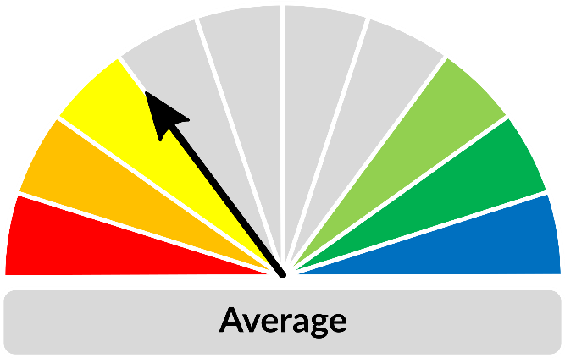

As at 1 January 2019

|  |  |  |  |  |
| --- | --- | --- | --- | --- |
| **As at 1 January 2019** | | | | |
| **(% of district)** | **<1,000kg/ha** | **1,000 - 2,000kg/ha** | **2,000 - 3,000kg/ha** | **>3,000kg/ha** |
| 2018/19  Pasture Growth | 100% | 0% | 0% | 0% |
| Total Standing Dry Matter | 39% | 36% | 17% | 8% |

|  |  |
| --- | --- |
| **Median Pasture Growth (kg/ha)**  **(Running Total)** | **Current Estimated**  **Total Standing Dry Matter** |
|  |  |

|  |  |
| --- | --- |
| **Growth Relative to Long Term**  **(October 2018 – January 2019)** | **Chance of Exceeding Median Pasture Growth**  **(January 2019 – March 2019)** |
|  | |

# Barkly District

* 2017/18 district-wide pasture growth was similar to the long-term median, but there was considerable variation depending on location.
* The SE corner of the district experienced very poor growth last year. There has only been average growth there to date, so very low standing dry matter levels persist (<200 kg/ha).
* The NE portion of the district is currently experiencing growth in the lowest 30% of years on record, with some areas experiencing extremely low growth (lowest 10% of years on record).
* Without a significant improvement in rainfall and growth, large areas of the Barkly district will be at risk of feed shortages in 2019.
* 3% of the district has been burnt since 1 July 2018.**2018/19 Pasture Growth So Far**



**27 kg/ha**

As at 1 January 2019

|  |  |  |  |  |
| --- | --- | --- | --- | --- |
| **As at 1 January 2019** | | | | |
| **(% of district)** | **<250kg/ha** | **250 - 500kg/ha** | **500 - 1,000kg/ha** | **>1,000kg/ha** |
| 2018/19  Pasture Growth | 100% | 0% | 0% | 0% |
| Total Standing Dry Matter | 24% | 34% | 16% | 26% |

|  |  |
| --- | --- |
| **Median Pasture Growth (kg/ha)**  **(Running Total)** | **Current Estimated**  **Total Standing Dry Matter** |
|  |  |

|  |  |
| --- | --- |
| **Growth Relative to Long Term**  **(October 2018 – January 2019)** | **Chance of Exceeding Median Pasture Growth**  **(January 2019 – March 2019)** |
|  | |

# Tennant Creek District

* 2017/18 pasture growth was similar to the long-term median but much lower than 2016/17.
* Patchy spring rain across much of the district resulted in an average start to the 2018/19 season overall, but there is some variation.
* A small area in the central part of the district is experiencing above average growth, whilst some southern and eastern parts are experiencing below-average growth for this time of year.
* 2% of the district has been burnt since 1 July 2018.

**2018/19 Pasture Growth So Far**

**37 kg/ha**

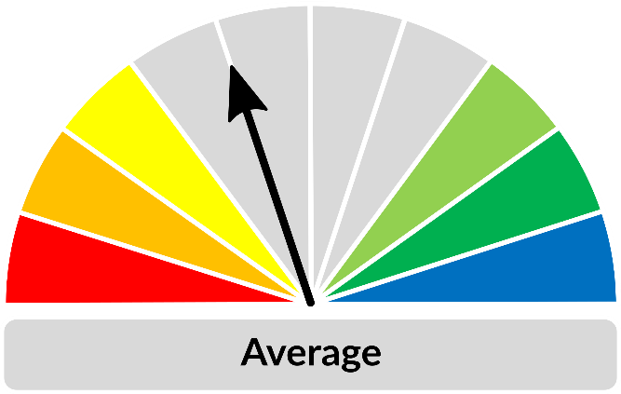

As at 1 January 2019

| **As at 1 January 2019** | | | | |
| --- | --- | --- | --- | --- |
| **(% of district)** | **<250kg/ha** | **250 - 500kg/ha** | **500 - 1,000kg/ha** | **>1,000kg/ha** |
| 2018/19  Pasture Growth | 100% | 0% | 0% | 0% |
| Total Standing Dry Matter | 8% | 9% | 22% | 61% |

| **Median Pasture Growth (kg/ha)**  **(Running Total)** | **Current Estimated**  **Total Standing Dry Matter** |
| --- | --- |
|  |  |

| **Growth Relative to Long Term**  **(October 2018 – January 2019)** | **Chance of Exceeding Median Pasture Growth**  **(January 2019 – March 2019)** |
| --- | --- |
|  | |

# Northern Alice Springs District

* 2017/18 pasture growth was slightly lower than the long-term median and very much lower than 2016/17.
* Patchy spring rain across much of the district resulted in some pasture growth but conditions have deteriorated in the past two months.
* The central and NE portions of the district are experiencing growth in the lowest 30% of years on record, with some areas experiencing extremely low growth (lowest 10% of years on record).
* 3% of the district has been burnt since 1 July 2018.
* Most of the district had a high fire risk as at 1 January 2019.

**2018/19 Pasture Growth So Far**

**81 kg/ha**



As at 1 January 2019

|  |  |  |  |  |
| --- | --- | --- | --- | --- |
| **As at 1 January 2019** | | | | |
| **(% of district)** | **<250kg/ha** | **250 - 500kg/ha** | **500 - 1,000kg/ha** | **>1,000kg/ha** |
| 2018/19  Pasture Growth | 100% | 0% | 0% | 0% |
| Total Standing Dry Matter | 4% | 13% | 46% | 37% |

| **Median Pasture Growth (kg/ha)**  **(Running Total)** | **Current Estimated**  **Total Standing Dry Matter** |
| --- | --- |
|  |  |

| **Growth Relative to Long Term**  **(October 2018 – January 2019)** | **Chance of Exceeding Median Pasture Growth**  **(January 2019 – March 2019)** |
| --- | --- |
|  | |

# Plenty District

* 2017/18 pasture growth was similar to the long-term median across the district, however some central areas experienced below average pasture growth (in the lowest 30% of years).
* Rainfall and pasture growth conditions have deteriorated in the past two months.
* The NW corner of the district is experiencing growth in the lowest 30% of years on record, with some areas experiencing extremely low growth (lowest 10% of years on record).
* Less than 1% of the district has been burnt since 1 July 2018.

**2018/19 Pasture Growth So Far**



**30 kg/ha**

As at 1 January 2019

|  |  |  |  |  |
| --- | --- | --- | --- | --- |
| **As at 1 January 2019** | | | | |
| **(% of district)** | **<250kg/ha** | **250 - 500kg/ha** | **500 - 1,000kg/ha** | **>1,000kg/ha** |
| 2018/19  Pasture Growth | 100% | 0% | 0% | 0% |
| Total Standing Dry Matter | 7% | 33% | 36% | 24% |

| **Median Pasture Growth (kg/ha)**  **(Running Total)** | **Current Estimated**  **Total Standing Dry Matter** |
| --- | --- |
|  |  |

| **Growth Relative to Long Term**  **(October 2018 – January 2019)** | **Chance of Exceeding Median Pasture Growth**  **(January 2019 – March 2019)** |
| --- | --- |
|  | |

# Southern Alice Springs District

* 2017/18 pasture growth was similar to the long-term median but much lower than 2016/17.
* The eastern half of the district is experiencing average growth for this time of year whilst large areas of the western half of the district have experienced above average growth.
* Less than 1% of the district has been burnt since 1 July 2018.
* Most of the district had a high fire risk as at 1 January 2019.

**2018/19 Pasture Growth So Far**

**86 kg/ha**



As at 1 January 2019

|  |  |  |  |  |
| --- | --- | --- | --- | --- |
| **As at 1 January 2019** | | | | |
| **(% of district)** | **<250kg/ha** | **250 - 500kg/ha** | **500 - 1,000kg/ha** | **>1,000kg/ha** |
| 2018/19  Pasture Growth | 100% | 0% | 0% | 0% |
| Total Standing Dry Matter | 7% | 18% | 37% | 38% |

| **Median Pasture Growth (kg/ha)**  **(Running Total)** | **Current Estimated**  **Total Standing Dry Matter** |
| --- | --- |
|  |  |

| **Growth Relative to Long Term**  **(October 2018 – January 2019)** | **Chance of Exceeding Median Pasture Growth**  **(January 2019 – March 2019)** |
| --- | --- |
|  | |

# Pasture information

The pasture and fire risk information in this document is derived from AussieGRASS. AussieGRASS is a model that simulates pasture growth and standing biomass using climate data, vegetation mapping, fire history and regional estimates of grazing pressure. The model can be used to track simulated pasture growth and total standing pasture biomass at the landscape scale.

Note that the model does not use stocking rate data for individual properties. Where stock numbers are significantly higher or lower than typical for a district, model estimates of total standing dry matter may be erroneous.

**Disclaimer**

While all care has been taken to ensure that information contained in this document is true and correct at the time of production, changes in circumstances after the time of distribution may affect the accuracy of its information. The Northern Territory of Australia gives no warranty or assurance, and makes no representation as to the accuracy of any information or advice contained herein, or that it is suitable for your intended use.

You should not rely solely upon information in this document for the purpose of making business or investment decisions in relation to your particular situation.

The Northern Territory of Australia disclaims any liability or responsibility or duty of care towards any person for loss of damage caused by any use of or reliance on this information.