Mineral Titles Act
NOTICE OF LAND CEASING TO BE A MINERAL TITLE AREA
Title Type and Number: | Exploration Licence 30424
Area Ceased on: | 11 December 2018
Area: | 20 Blocks, 41.57 km²
Locality: | BYNOE
Name of Applicant(s)/Holder(s): | 100% TRACKER GEOSERVICES PTY LTD [ACN. 093 390 197]
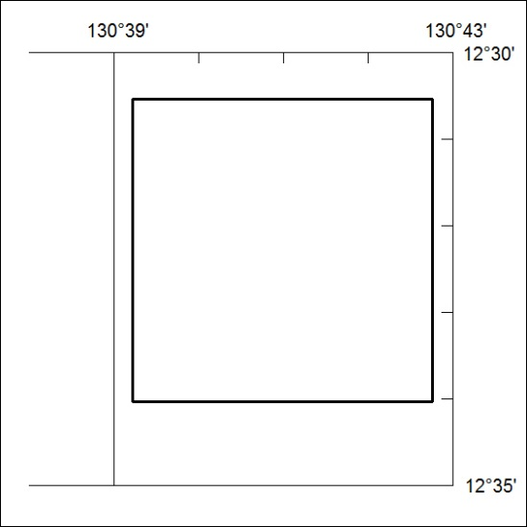

577/18

Mineral Titles Act
NOTICE OF LAND CEASING TO BE A MINERAL TITLE AREA
Title Type and Number: | Exploration Licence 31080
Area Ceased on: | 11 December 2018
Area: | 6 Blocks, 19.28 km²
Locality: | GRANITES
Name of Applicant(s)/Holder(s): | 100% MIDAS ENVIRONMENTAL TECHNOLOGY PTY LTD [ACN. 167 496 479]
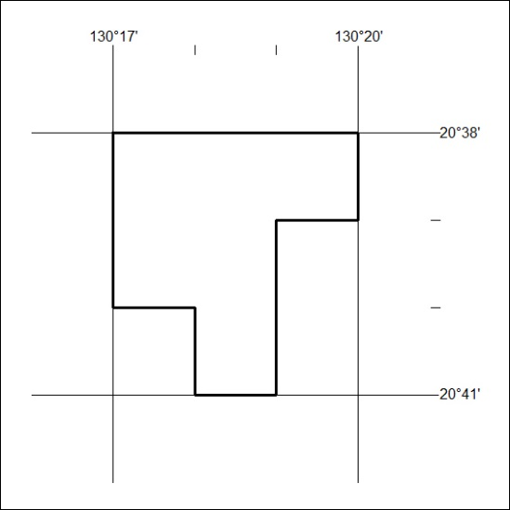

578/18

Mineral Titles Act
NOTICE OF LAND CEASING TO BE A MINERAL TITLE AREA
Title Type and Number: | Exploration Licence 31829
Area Ceased on: | 04 December 2018
Area: | 250 Blocks, 790.89 km²
Locality: | DELNY
Name of Applicant(s)/Holder(s): | 100% SYNERGY PROSPECTING PTY LTD [ACN. 622 779 980]
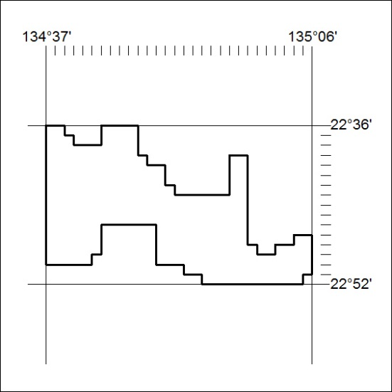

579/18

Mineral Titles Act
NOTICE OF LAND CEASING TO BE A MINERAL TITLE AREA
Title Type and Number: | Exploration Licence 31830
Area Ceased on: | 04 December 2018
Area: | 250 Blocks, 789.48 km²
Locality: | DNEIPER
Name of Applicant(s)/Holder(s): | 100% SYNERGY PROSPECTING PTY LTD [ACN. 622 779 980]
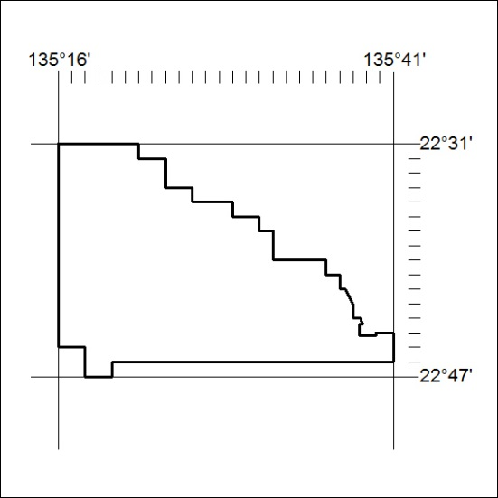

580/18

