Mineral Titles Act
NOTICE OF LAND CEASING TO BE A MINERAL TITLE AREA
Title Type and Number: | Exploration Licence 30007
Area Ceased on: | 07 December 2018
Area: | 7 Blocks, 22.22 km²
Locality: | MACDONALD DOWNS
Name of Applicant(s)/Holder(s): | 100% XAVIER RESOURCES PTY LTD [ACN. 623 262 304]
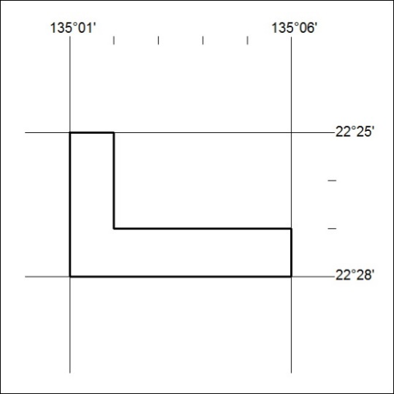

563/18

Mineral Titles Act
NOTICE OF LAND CEASING TO BE A MINERAL TITLE AREA
Title Type and Number: | Exploration Licence 28838
Area Ceased on: | 07 December 2018
Area: | 4 Blocks, 12.70 km²
Locality: | MACDONALD DOWNS
Name of Applicant(s)/Holder(s): | 100% XAVIER RESOURCES PTY LTD [ACN. 623 262 304]
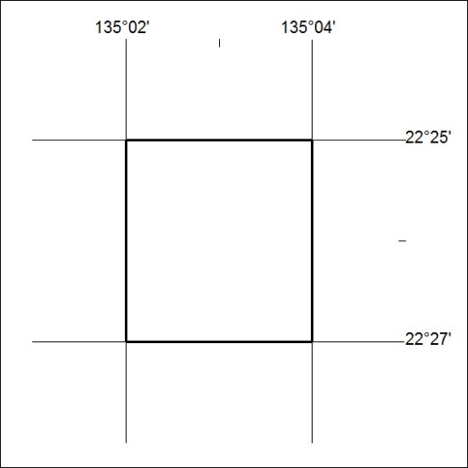

564/18

Mineral Titles Act
NOTICE OF GRANT OF A MINERAL TITLE
Title Type and Number: | Extractive Mineral Exploration Licence 31920
Granted: | 05 December 2018, for a period of 2 Years
Area: | 4 Blocks, 8.56 km²
Locality: | MARY RIVER
Name of Holder/s: | 100% MT ROMANCE (NT) PTY LTD [ACN. 623 930 594]
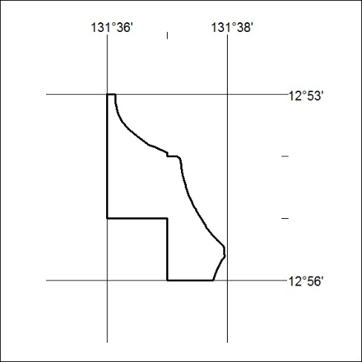
Area granted is indicated above. The titleholder is not permitted to exercise occupational rights on any land that is subject to a development title, or an application for a development title. Any land the subject of a Reserved Land gazettal under the Mineral Titles Act and all land vested in the Commonwealth of Australia is also excluded by description but not excised from the grant area.

565/18

Mineral Titles Act
NOTICE OF GRANT OF A MINERAL TITLE
Title Type and Number: | Extractive Mineral Exploration Licence 31921
Granted: | 05 December 2018, for a period of 2 Years
Area: | 4 Blocks, 13.39 km²
Locality: | MARY RIVER
Name of Holder/s: | 100% MT ROMANCE (NT) PTY LTD [ACN. 623 930 594]
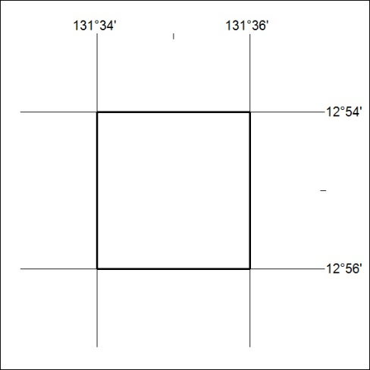
Area granted is indicated above. The titleholder is not permitted to exercise occupational rights on any land that is subject to a development title, or an application for a development title. Any land the subject of a Reserved Land gazettal under the Mineral Titles Act and all land vested in the Commonwealth of Australia is also excluded by description but not excised from the grant area.

566/18

Mineral Titles Act
NOTICE OF GRANT OF A MINERAL TITLE
Title Type and Number: | Extractive Mineral Exploration Licence 31922
Granted: | 05 December 2018, for a period of 2 Years
Area: | 4 Blocks, 12.44 km²
Locality: | MARY RIVER
Name of Holder/s: | 100% MT ROMANCE (NT) PTY LTD [ACN. 623 930 594]
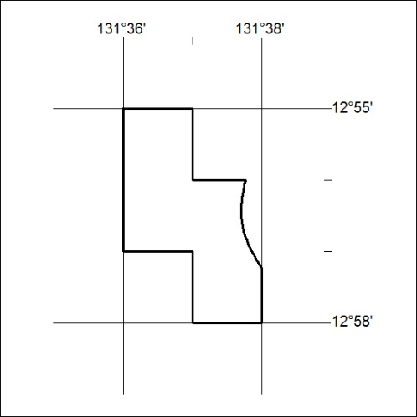
Area granted is indicated above. The titleholder is not permitted to exercise occupational rights on any land that is subject to a development title, or an application for a development title. Any land the subject of a Reserved Land gazettal under the Mineral Titles Act and all land vested in the Commonwealth of Australia is also excluded by description but not excised from the grant area.

567/18

Mineral Titles Act
NOTICE OF GRANT OF A MINERAL TITLE
Title Type and Number: | Extractive Mineral Exploration Licence 31923
Granted: | 05 December 2018, for a period of 2 Years
Area: | 4 Blocks, 13.39 km²
Locality: | MARY RIVER
Name of Holder/s: | 100% MT ROMANCE (NT) PTY LTD [ACN. 623 930 594]
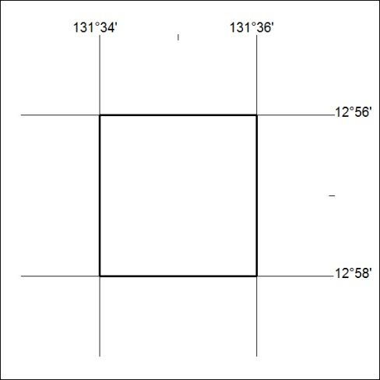
Area granted is indicated above. The titleholder is not permitted to exercise occupational rights on any land that is subject to a development title, or an application for a development title. Any land the subject of a Reserved Land gazettal under the Mineral Titles Act and all land vested in the Commonwealth of Australia is also excluded by description but not excised from the grant area.

568/18

