Mineral Titles Act
NOTICE OF GRANT OF A MINERAL TITLE
Title Type and Number: | Exploration Licence 31824
Granted: | 12 November 2018, for a period of 6 Years
Area: | 112 Blocks, 333.64 km²
Locality: | GREGORYS DEPOT
Name of Holder/s: | 100% SCRIVEN EXPLORATION PTY LTD [ACN. 006 264 615]
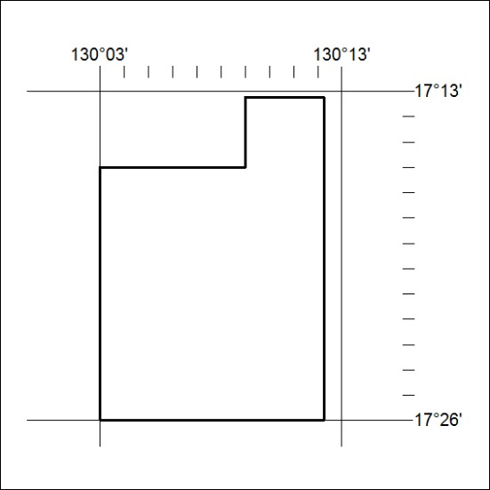
Area granted is indicated above. The titleholder is not permitted to exercise occupational rights on any land that is subject to a development title, or an application for a development title. Any land the subject of a Reserved Land gazettal under the Mineral Titles Act and all land vested in the Commonwealth of Australia is also excluded by description but not excised from the grant area.
515/18

Mineral Titles Act
NOTICE OF GRANT OF A MINERAL TITLE
Title Type and Number: | Exploration Licence 31851
Granted: | 13 November 2018, for a period of 6 Years
Area: | 42 Blocks, 133.06 km²
Locality: | TARLTON
Name of Holder/s: | 100% BOWGAN MINERALS LTD [ACN. 137 527 336]
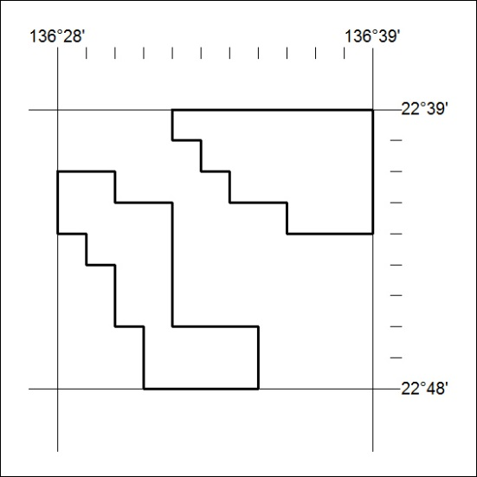
Area granted is indicated above. The titleholder is not permitted to exercise occupational rights on any land that is subject to a development title, or an application for a development title. Any land the subject of a Reserved Land gazettal under the Mineral Titles Act and all land vested in the Commonwealth of Australia is also excluded by description but not excised from the grant area.
516/18

Mineral Titles Act
NOTICE OF GRANT OF A MINERAL TITLE
Title Type and Number: | Exploration Licence 31897
Granted: | 12 November 2018, for a period of 6 Years
Area: | 46 Blocks, 153.35 km²
Locality: | MAINORU
Name of Holder/s: | 100% SCRIVEN EXPLORATION PTY LTD [ACN. 006 264 615]
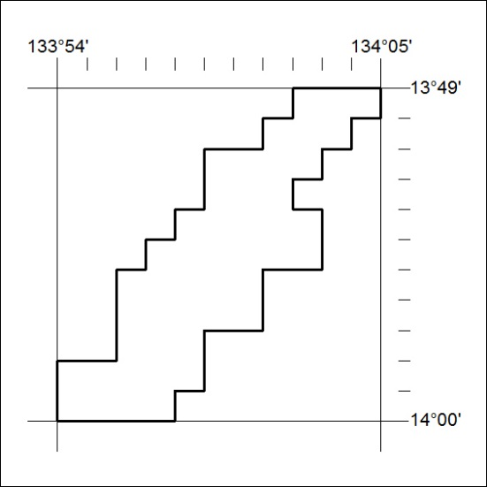
Area granted is indicated above. The titleholder is not permitted to exercise occupational rights on any land that is subject to a development title, or an application for a development title. Any land the subject of a Reserved Land gazettal under the Mineral Titles Act and all land vested in the Commonwealth of Australia is also excluded by description but not excised from the grant area.
517/18

