Mineral Titles Act
NOTICE OF LAND CEASING TO BE A MINERAL TITLE AREA
Title Type and Number: | Exploration Licence 31694
Area Ceased on: | 24 September 2018
Area: | 25 Blocks, 82.19 km²
Locality: | GLYDE
Name of Applicant(s)/Holder(s): | 100% CERBERUS RESOURCES PTY LTD [ACN. 615 192 535]
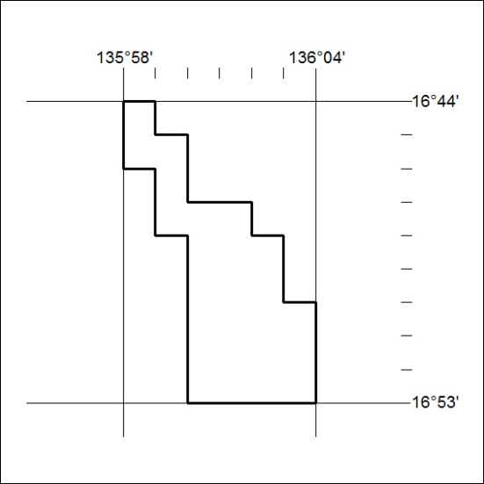

482/18

Mineral Titles Act
NOTICE OF LAND CEASING TO BE A MINERAL TITLE AREA
Title Type and Number: | Exploration Licence 31533
Area Ceased on: | 26 October 2018
Area: | 213 Blocks, 695.73 km²
Locality: | INVERWAY
Name of Applicant(s)/Holder(s): | 100% ARGYLE CORRIDOR RESOURCES PTY LTD [ACN. 610839775]
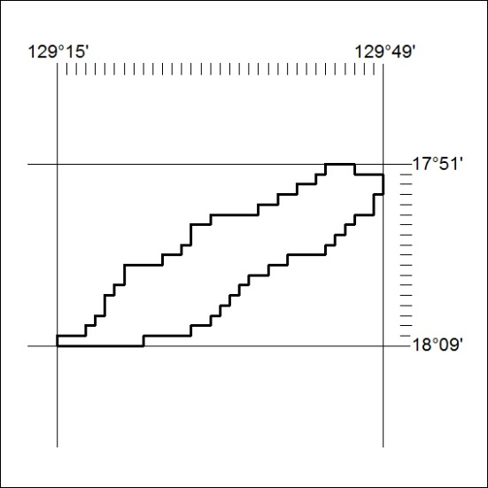

483/18

Mineral Titles Act
NOTICE OF GRANT OF A MINERAL TITLE
Title Type and Number: | Extractive Mineral Permit 31792
Granted: | 10 October 2018, for a period of 5 Years
Area: | 14.00 Hectares
Locality: | NOONAMAH
Name of Holder/s: | 100% KIGILIA PTY LTD [ACN. 113 822 343]
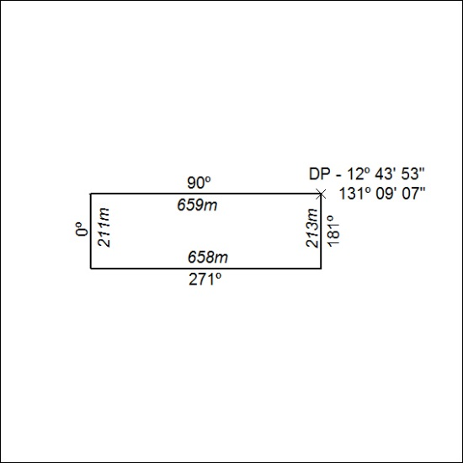

484/18

