Mineral Titles Act
NOTICE OF GRANT OF A MINERAL TITLE
Title Type and Number: | Extractive Mineral Permit 31056
Granted: | 25 October 2018, for a period of 5 Years
Area: | 13.54 Hectares
Locality: | BYNOE
Name of Holder/s: | 100% SETH PTY LTD [ACN. 062 084 119]
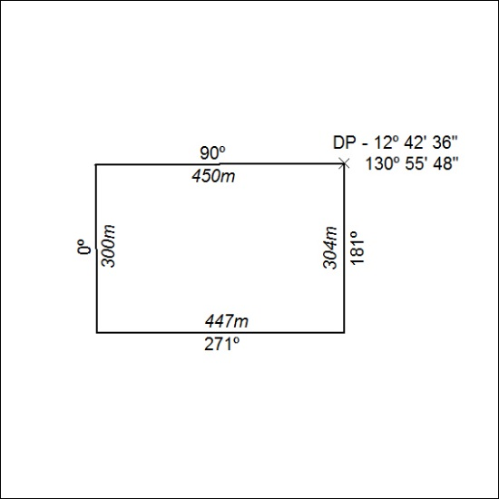

481/18

