Mineral Titles Act
NOTICE OF LAND CEASING TO BE A MINERAL TITLE AREA
Title Type and Number: | Exploration Licence 31478
Area Ceased on: | 20 September 2018
Area: | 60 Blocks, 194.98 km²
Locality: | EVA VALLEY
Name of Applicant(s)/Holder(s): | 100% BACCHUS RESOURCES PTY LTD [ACN. 606 340 872]
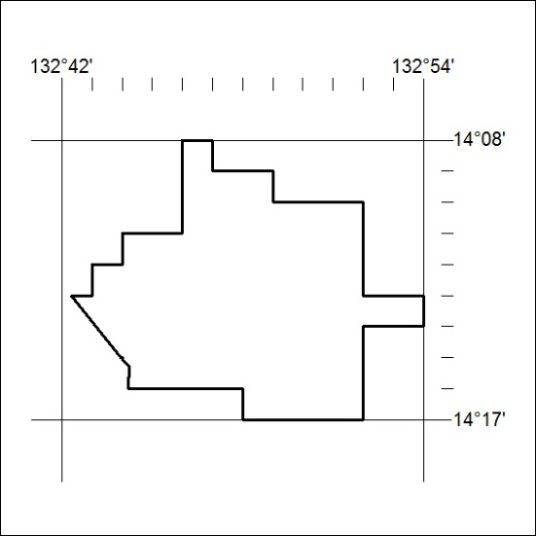

410/18

Mineral Titles Act
NOTICE OF LAND CEASING TO BE A MINERAL TITLE
Title Type and Number: | Mineral Lease (Northern) 411
Area ceased on: | 20 September 2018
Area: | 9.00 Hectare
Locality: | NOONAMAH
Name of Applicants(s)Holder(s): | 100% HY-TEC INDUSTRIES (NORTHERN TERRITORY) PTY LTD [ACN. 096 310 824]
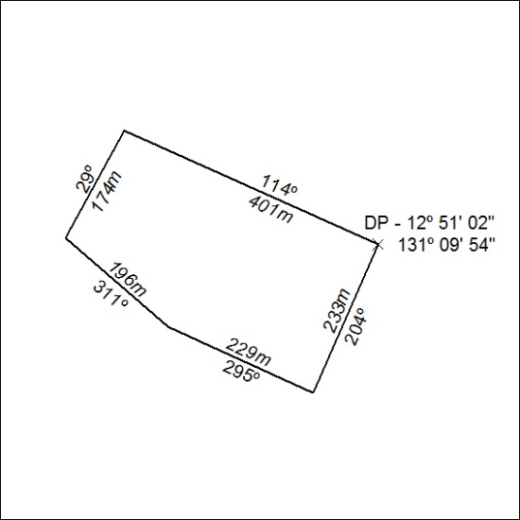

411/18

Mineral Titles Act
NOTICE OF LAND CEASING TO BE A MINERAL TITLE
Title Type and Number: | Mineral Lease (Northern) 412
Area ceased on: | 20 September 2018
Area: | 8.00 Hectare
Locality: | NOONAMAH
Name of Applicants(s)Holder(s): | 100% HY-TEC INDUSTRIES (NORTHERN TERRITORY) PTY LTD [ACN. 096 310 824]
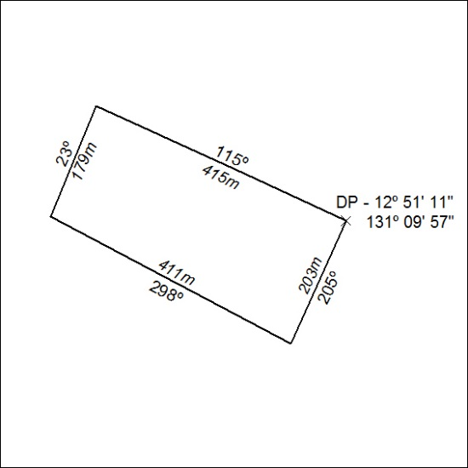
412/18

Mineral Titles Act
NOTICE OF LAND CEASING TO BE A MINERAL TITLE
Title Type and Number: | Mineral Lease (Northern) 413
Area ceased on: | 20 September 2018
Area: | 5.00 Hectare
Locality: | NOONAMAH
Name of Applicants(s)Holder(s): | 100% HY-TEC INDUSTRIES (NORTHERN TERRITORY) PTY LTD [ACN. 096 310 824]
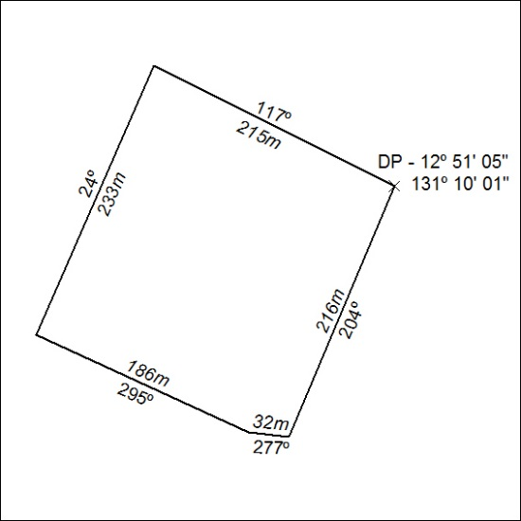

413/18

Mineral Titles Act
NOTICE OF LAND CEASING TO BE A MINERAL TITLE
Title Type and Number: | Mineral Lease (Northern) 424
Area ceased on: | 20 September 2018
Area: | 13.00 Hectare
Locality: | NOONAMAH
Name of Applicants(s)Holder(s): | 100% HY-TEC INDUSTRIES (NORTHERN TERRITORY) PTY LTD [ACN. 096 310 824]
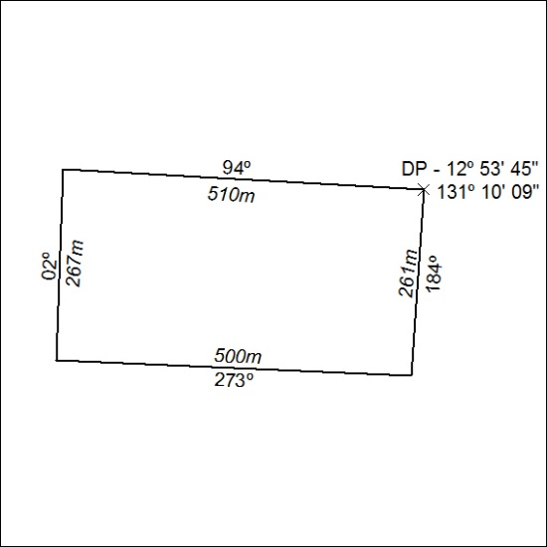

414/18

Mineral Titles Act
NOTICE OF GRANT OF A MINERAL TITLE
Title Type and Number: | Exploration Licence 31692
Granted: | 21 September 2018, for a period of 6 Years
Area: | 31 Blocks, 101.22 km²
Locality: | MALLAPUNYAH
Name of Holder/s: | 100% CERBERUS RESOURCES PTY LTD [ACN. 615 192 535]
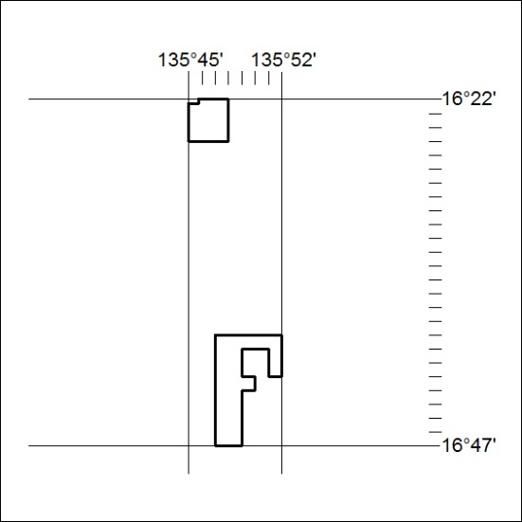
Area granted is indicated above. The titleholder is not permitted to exercise occupational rights on any land that is subject to a development title, or an application for a development title. Any land the subject of a Reserved Land gazettal under the Mineral Titles Act and all land vested in the Commonwealth of Australia is also excluded by description but not excised from the grant area.
415/18

Mineral Titles Act
NOTICE OF GRANT OF A MINERAL TITLE
Title Type and Number: | Exploration Licence 31784
Granted: | 21 September 2018, for a period of 6 Years
Area: | 36 Blocks, 114.37 km²
Locality: | VAUGHAN
Name of Holder/s: | 100% CERBERUS RESOURCES PTY LTD [ACN. 615 192 535]
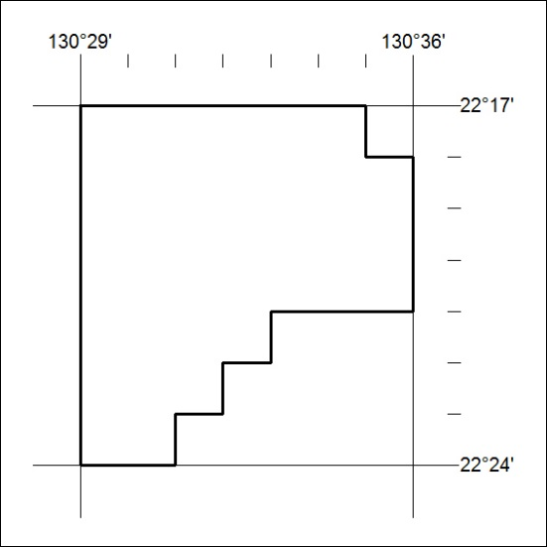
Area granted is indicated above. The titleholder is not permitted to exercise occupational rights on any land that is subject to a development title, or an application for a development title. Any land the subject of a Reserved Land gazettal under the Mineral Titles Act and all land vested in the Commonwealth of Australia is also excluded by description but not excised from the grant area.

416/18

