Mineral Titles Act
NOTICE OF GRANT OF A MINERAL TITLE
Title Type and Number: | Exploration Licence 31574
Granted: | 30 August 2018, for a period of 6 Years
Area: | 61 Blocks, 202.32 km²
Locality: | MARANBOY
Name of Holder/s: | 100% FIDDLER'S CREEK MINING COMPANY PTY LTD * [ACN. 099 215 648]
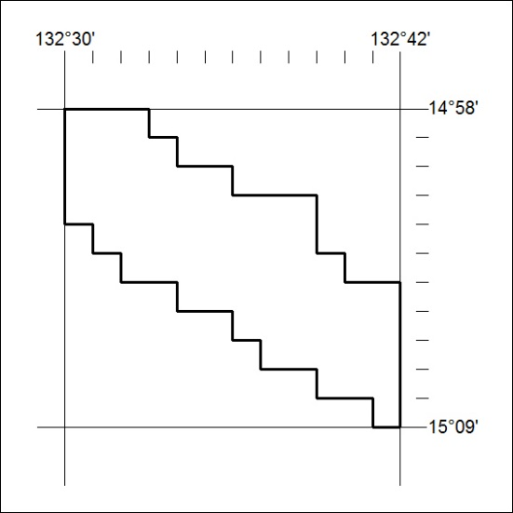
Area granted is indicated above. The titleholder is not permitted to exercise occupational rights on any land that is subject to a development title, or an application for a development title. Any land the subject of a Reserved Land gazettal under the Mineral Titles Act and all land vested in the Commonwealth of Australia is also excluded by description but not excised from the grant area.
375/18

Mineral Titles Act
NOTICE OF GRANT OF A MINERAL TITLE
Title Type and Number: | Exploration Licence 31575
Granted: | 30 August 2018, for a period of 6 Years
Area: | 62 Blocks, 204.54 km²
Locality: | ELSEY
Name of Holder/s: | 100% FIDDLER'S CREEK MINING COMPANY PTY LTD * [ACN. 099 215 648]
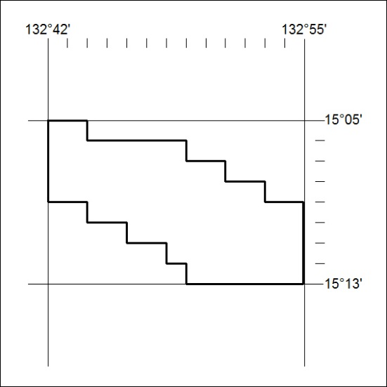
Area granted is indicated above. The titleholder is not permitted to exercise occupational rights on any land that is subject to a development title, or an application for a development title. Any land the subject of a Reserved Land gazettal under the Mineral Titles Act and all land vested in the Commonwealth of Australia is also excluded by description but not excised from the grant area.
376/18

