Mineral Titles Act
NOTICE OF LAND CEASING TO BE A MINERAL TITLE AREA
Title Type and Number: | Exploration Licence 27538
Area Ceased on: | 05 June 2018
Area: | 2 Blocks, .29 km²
Locality: | TENNANT CREEK
Name of Applicant(s)/Holder(s): | 100% GIANTS REEF EXPLORATION PTY LTD* [ACN. 009 200 346]
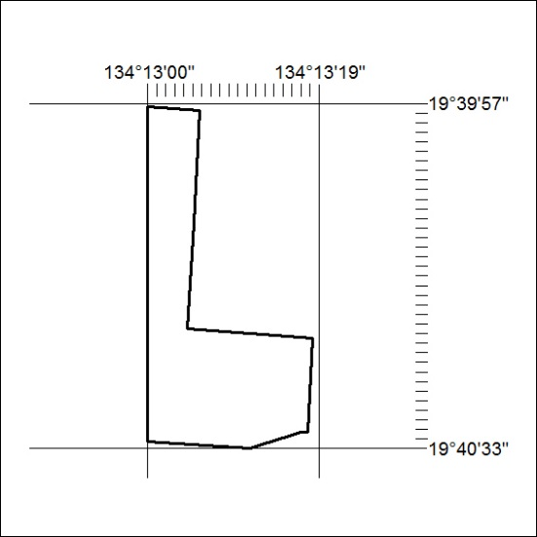

230/18

Mineral Titles Act
NOTICE OF LAND CEASING TO BE A MINERAL TITLE AREA
Title Type and Number: | Exploration Licence 30167
Area Ceased on: | 05 June 2018
Area: | 1 Block, .79 km²
Locality: | TENNANT CREEK
Name of Applicant(s)/Holder(s): | 100% GIANTS REEF EXPLORATION PTY LTD* [ACN. 009 200 346]
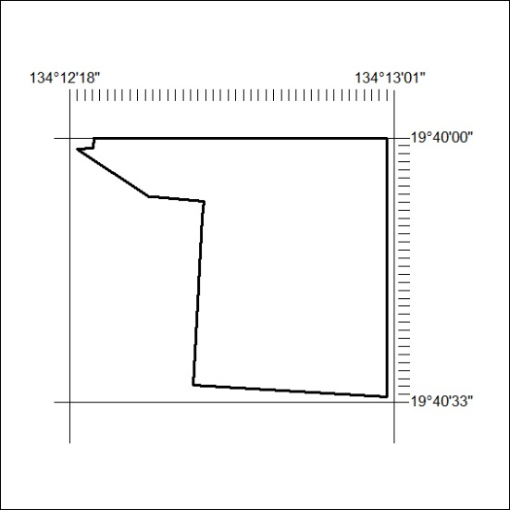

231/18

Mineral Titles Act
NOTICE OF LAND CEASING TO BE A MINERAL TITLE AREA
Title Type and Number: | Exploration Licence 30748
Area Ceased on: | 05 June 2018
Area: | 1 Block, .13 km²
Locality: | TENNANT CREEK
Name of Applicant(s)/Holder(s): | 100% GIANTS REEF EXPLORATION PTY LTD* [ACN. 009 200 346]
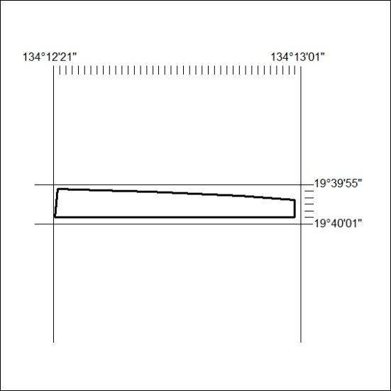

232/18

Mineral Titles Act
NOTICE OF LAND CEASING TO BE A MINERAL TITLE
Title Type and Number: | Extractive Mineral Permit 27484
Area ceased on: | 04 June 2018
Area: | 24.00 Hectare
Locality: | RANFORD HILL
Name of Applicants(s)Holder(s): | 100% A AND SF MADDALOZZO PTY. LIMITED [ACN. 009 624 015]
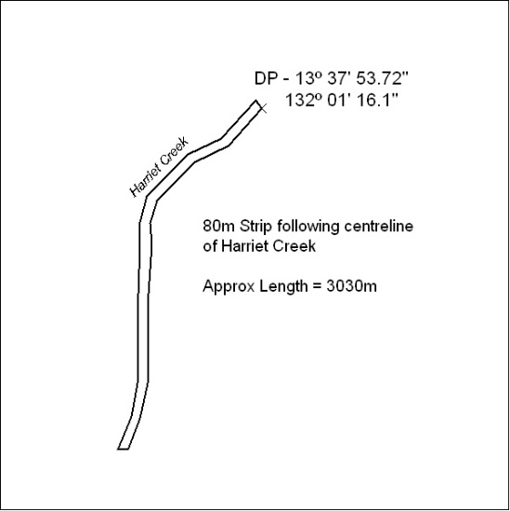

233/18

Mineral Titles Act
NOTICE OF LAND CEASING TO BE A MINERAL TITLE
Title Type and Number: | Extractive Mineral Permit 27485
Area ceased on: | 04 June 2018
Area: | 24.00 Hectare
Locality: | RANFORD HILL
Name of Applicants(s)Holder(s): | 100% A AND SF MADDALOZZO PTY. LIMITED [ACN. 009 624 015]
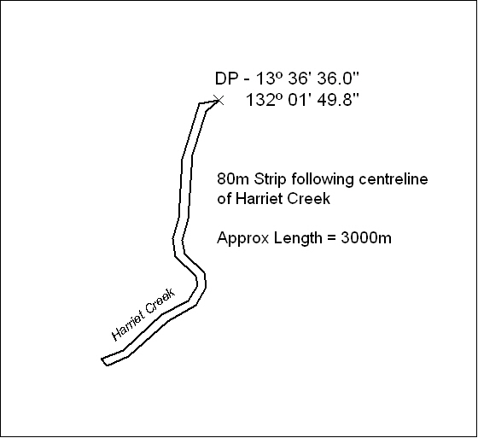

234/18

Mineral Titles Act
NOTICE OF LAND CEASING TO BE A MINERAL TITLE
Title Type and Number: | Extractive Mineral Permit 27487
Area ceased on: | 04 June 2018
Area: | 14.00 Hectare
Locality: | RANFORD HILL
Name of Applicants(s)Holder(s): | 100% A AND SF MADDALOZZO PTY. LIMITED [ACN. 009 624 015]
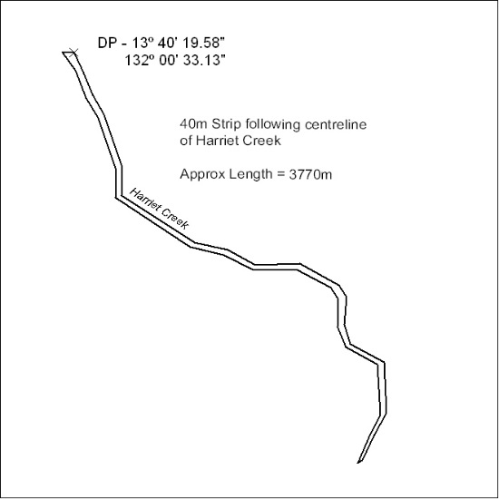

235/18

Mineral Titles Act
NOTICE OF LAND CEASING TO BE A MINERAL TITLE
Title Type and Number: | Extractive Mineral Permit 27488
Area ceased on: | 04 June 2018
Area: | 5.00 Hectare
Locality: | PINE CREEK
Name of Applicants(s)Holder(s): | 100% A AND SF MADDALOZZO PTY. LIMITED [ACN. 009 624 015]
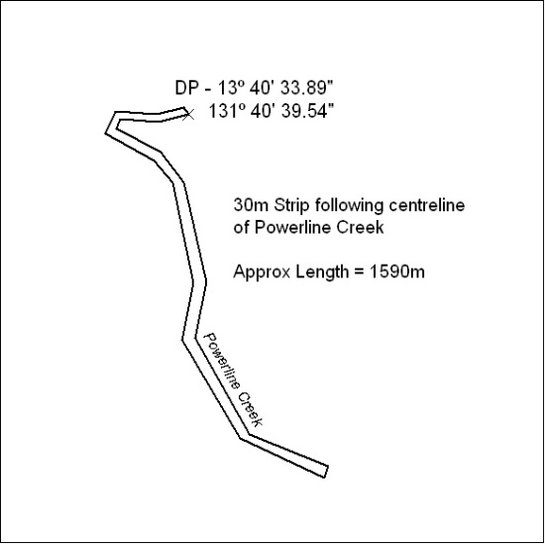

236/18

Mineral Titles Act
NOTICE OF LAND CEASING TO BE A MINERAL TITLE
Title Type and Number: | Extractive Mineral Permit 27489
Area ceased on: | 04 June 2018
Area: | 58.00 Hectare
Locality: | RANFORD HILL
Name of Applicants(s)Holder(s): | 100% A AND SF MADDALOZZO PTY. LIMITED [ACN. 009 624 015]
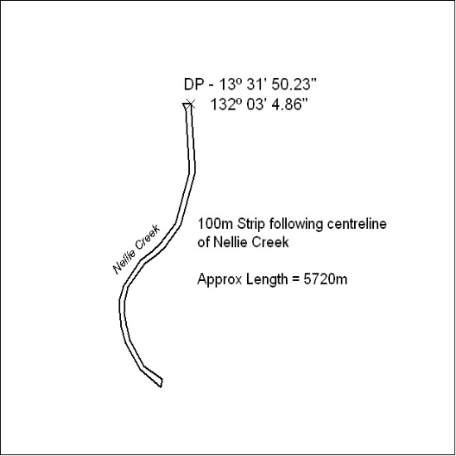

237/18

Mineral Titles Act
NOTICE OF LAND CEASING TO BE A MINERAL TITLE
Title Type and Number: | Extractive Mineral Permit 27490
Area ceased on: | 04 June 2018
Area: | 3.00 Hectare
Locality: | PINE CREEK
Name of Applicants(s)Holder(s): | 100% A AND SF MADDALOZZO PTY. LIMITED [ACN. 009 624 015]
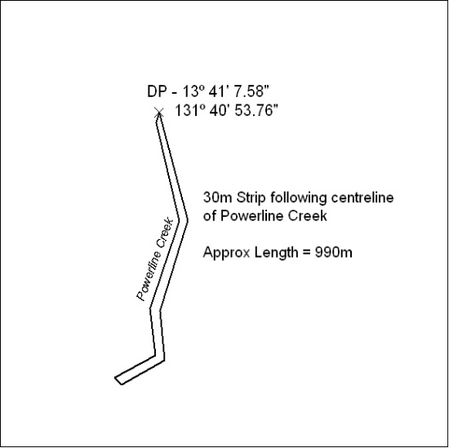

238/18

Mineral Titles Act
NOTICE OF LAND CEASING TO BE A MINERAL TITLE
Title Type and Number: | Extractive Mineral Permit 27491
Area ceased on: | 04 June 2018
Area: | 6.00 Hectare
Locality: | PINE CREEK
Name of Applicants(s)Holder(s): | 100% A AND SF MADDALOZZO PTY. LIMITED [ACN. 009 624 015]
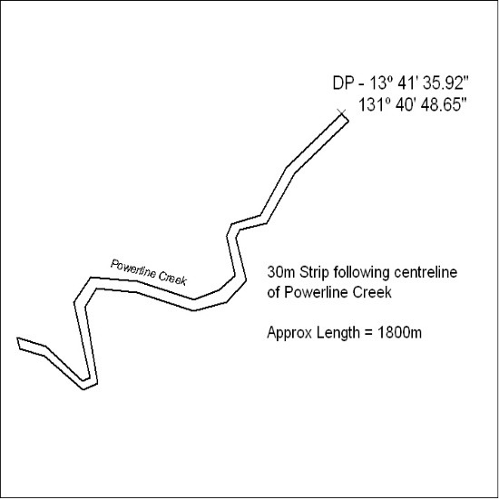

239/18

Mineral Titles Act
NOTICE OF LAND CEASING TO BE A MINERAL TITLE
Title Type and Number: | Extractive Mineral Permit 27492
Area ceased on: | 04 June 2018
Area: | 43.00 Hectare
Locality: | PINE CREEK
Name of Applicants(s)Holder(s): | 100% A AND SF MADDALOZZO PTY. LIMITED [ACN. 009 624 015]
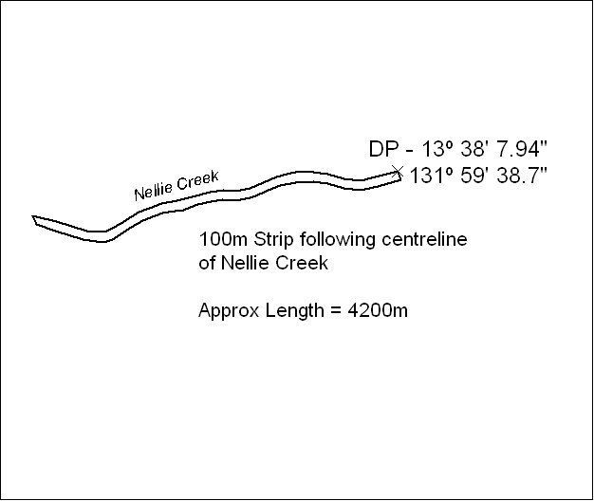

240/18

Mineral Titles Act
NOTICE OF LAND CEASING TO BE A MINERAL TITLE
Title Type and Number: | Extractive Mineral Permit 27493
Area ceased on: | 04 June 2018
Area: | 55.00 Hectare
Locality: | RANFORD HILL
Name of Applicants(s)Holder(s): | 100% A AND SF MADDALOZZO PTY. LIMITED [ACN. 009 624 015]
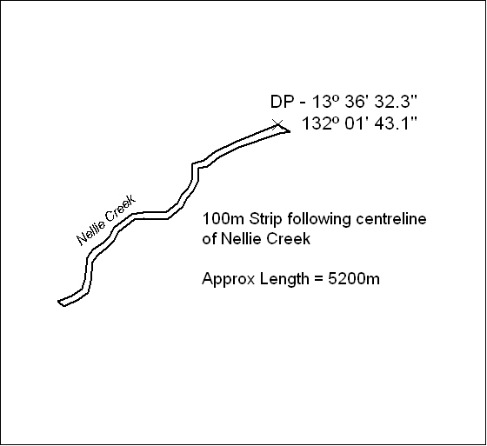

241/18

Mineral Titles Act
NOTICE OF LAND CEASING TO BE A MINERAL TITLE
Title Type and Number: | Extractive Mineral Permit 27494
Area ceased on: | 04 June 2018
Area: | 45.00 Hectare
Locality: | RANFORD HILL
Name of Applicants(s)Holder(s): | 100% A AND SF MADDALOZZO PTY. LIMITED [ACN. 009 624 015]
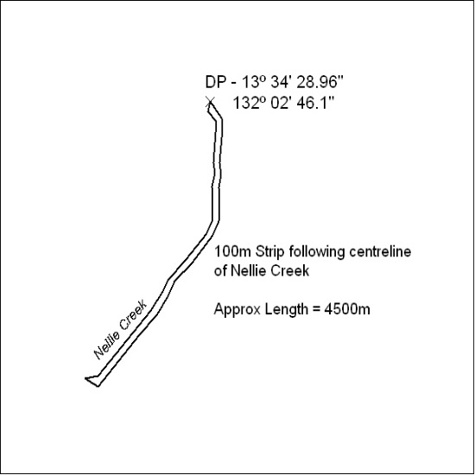

242/18

Mineral Titles Act
NOTICE OF GRANT OF A MINERAL TITLE
Title Type and Number: | Extractive Mineral Permit 31483
Granted: | 01 June 2018, for a period of 5 Years
Area: | 21.49 Hectares
Locality: | NOONAMAH
Name of Holder/s: | 100% GOSSAN RESOURCES PTY LTD [ACN. 161 395 964]
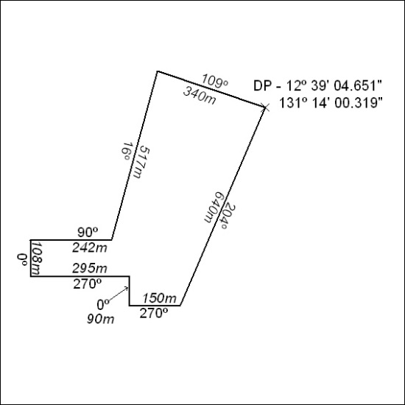

243/18

Corrigendum
Notice number 227/18 appearing in MN73/18 on 4 June 2018 is hereby cancelled.

