Mineral Titles Act
NOTICE OF LAND CEASING TO BE A MINERAL TITLE AREA
Title Type and Number: | Exploration Licence 29690
Area Ceased on: | 28 March 2018
Area: | 85 Blocks, 267.73 km²
Locality: | RIDDOCH
Name of Applicant(s)/Holder(s): | 100% BARFUSS CORPORATION PTY. LTD. [ACN. 006 917 666]
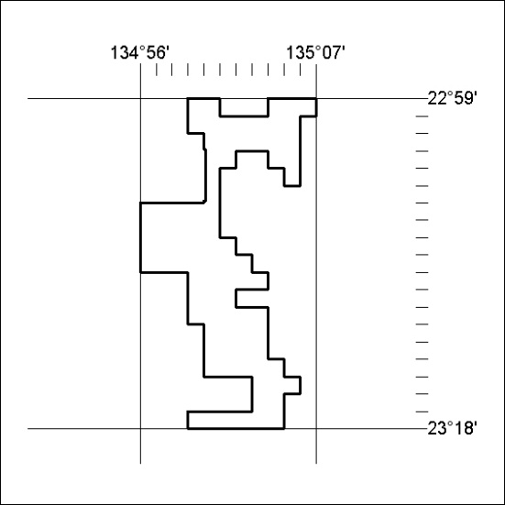

123/18

