Mineral Titles Act
NOTICE OF LAND CEASING TO BE A MINERAL TITLE AREA
Title Type and Number: | Exploration Licence 27526
Area Ceased on: | 26 February 2018
Area: | 10 Blocks, 31.89 km²
Locality: | OORATIPPRA
Name of Applicant(s)/Holder(s): | 100% CKA RESOURCES PTY LIMITED [ACN. 152 797 503]
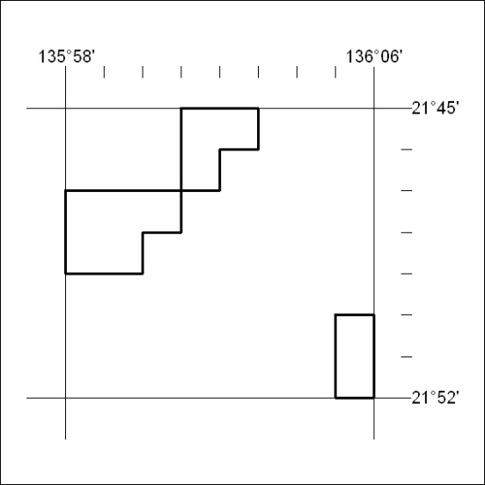

83/18

